Fofa:fid="29g2UElhp8+IZ3VB7EVlbg=="

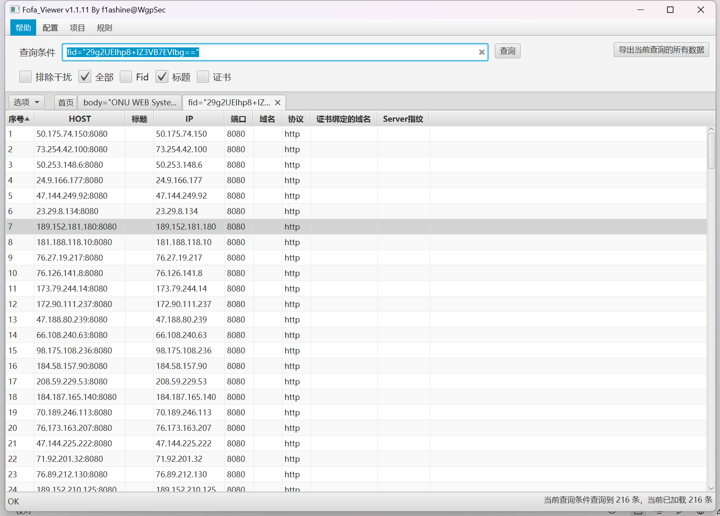

<http://50.253.148.6:8080/>

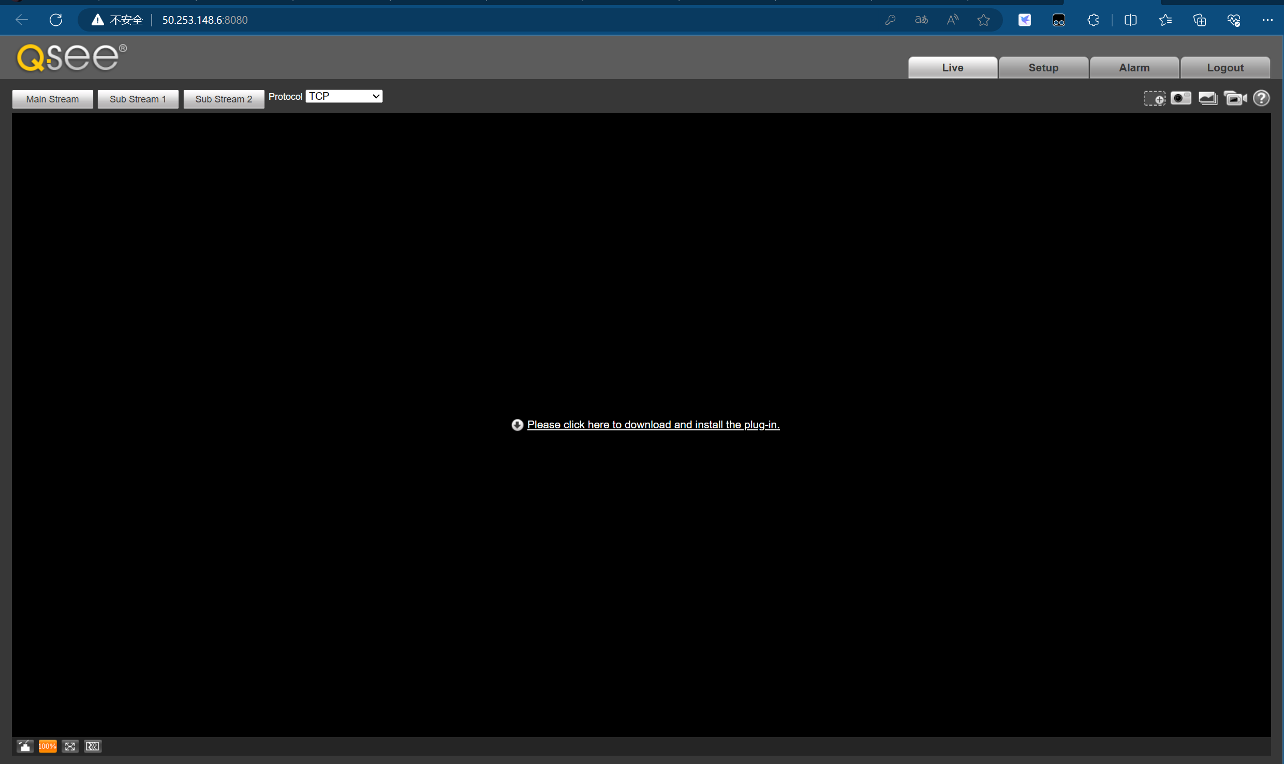

<http://73.254.42.100:8080/>

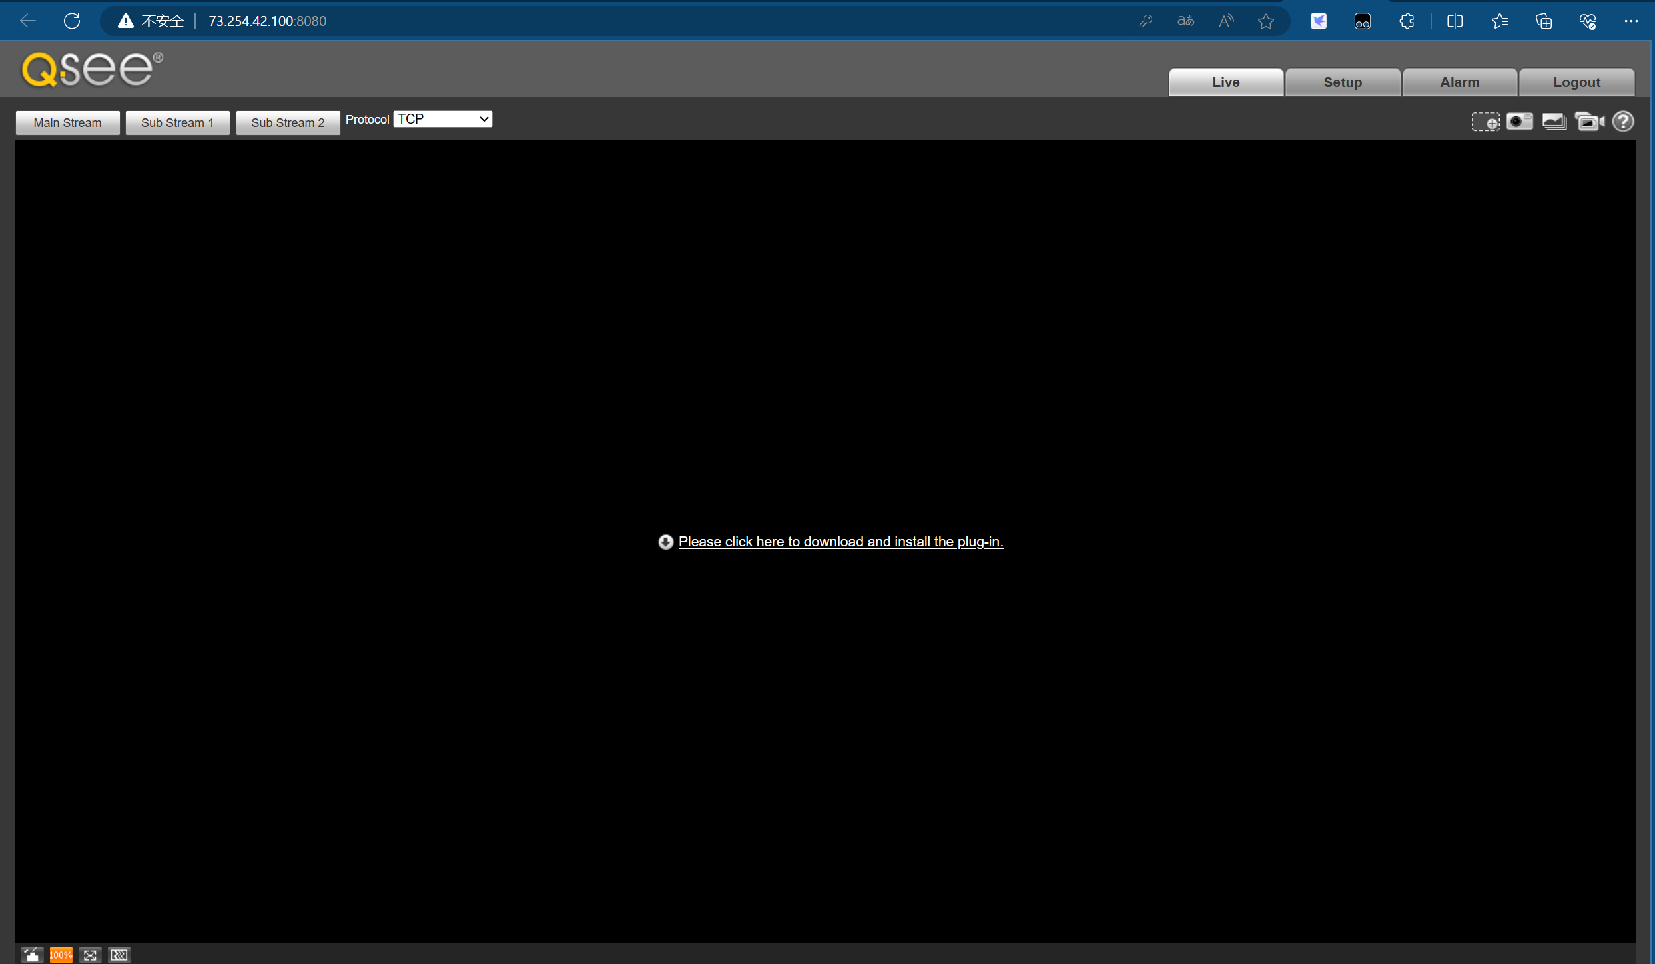

<http://173.79.244.14:8080/>

