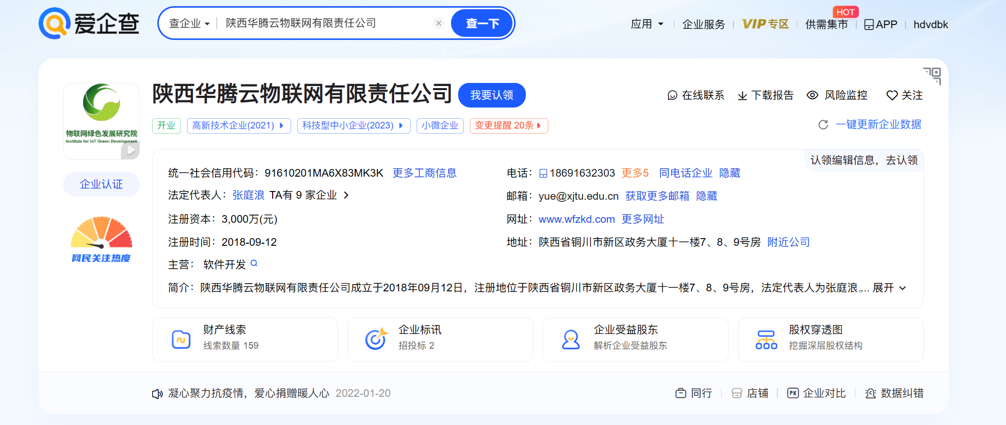

[https://demo.huatengkz.com/api/actuator/env](https://demo.huatengkz.com/api/actuator/env、)

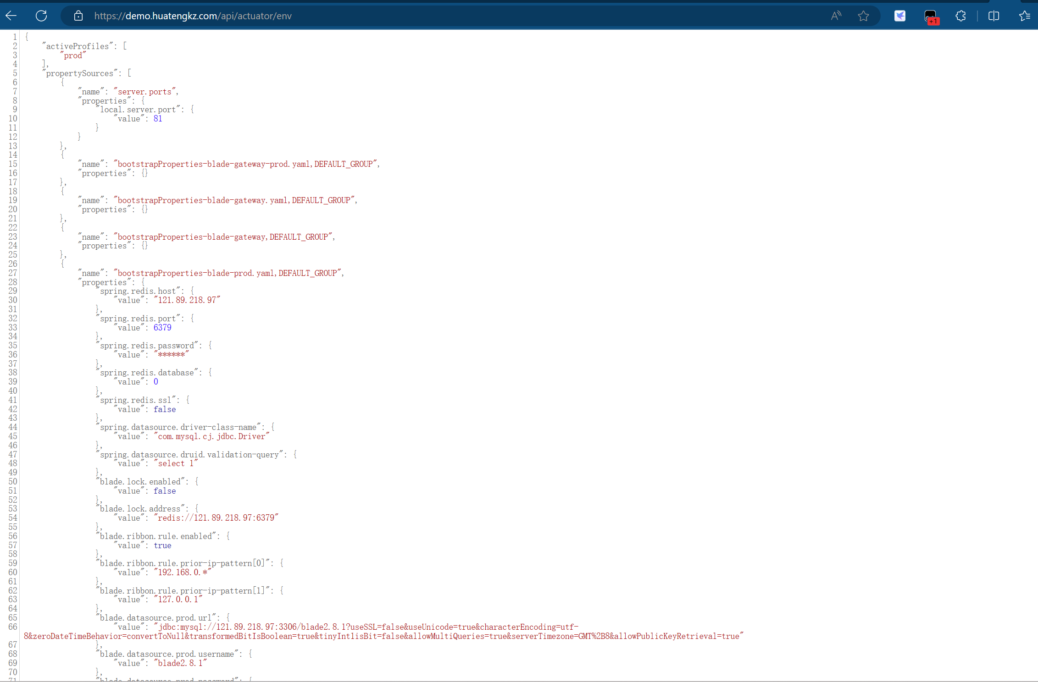

<https://demo.huatengkz.com/api/actuator/heapdump>

