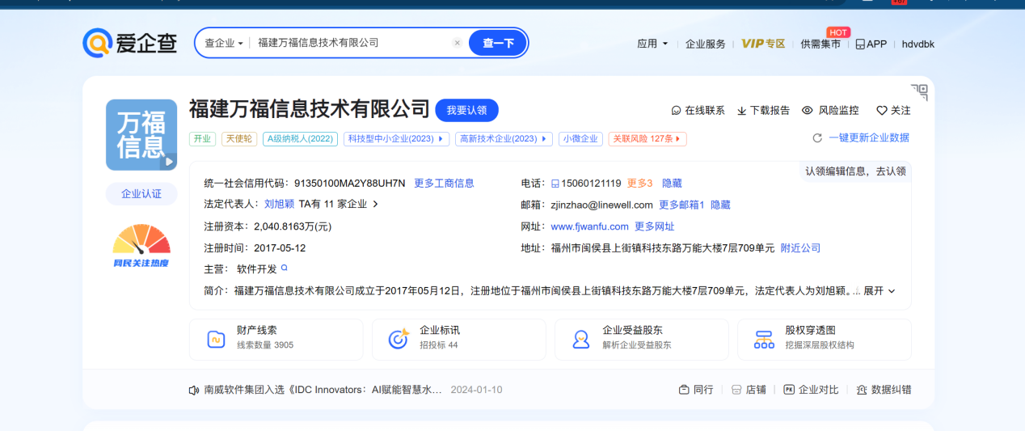

资产一:http://112.111.28.148:6969/login

<http://112.111.28.148:6969/api/actuator/env>

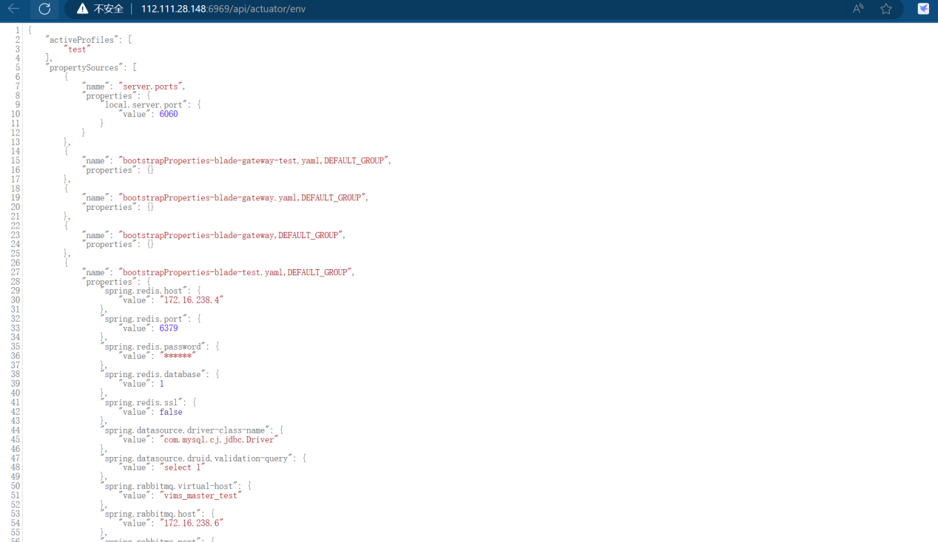

<http://112.111.28.148:6969/api/actuator/heapdump>

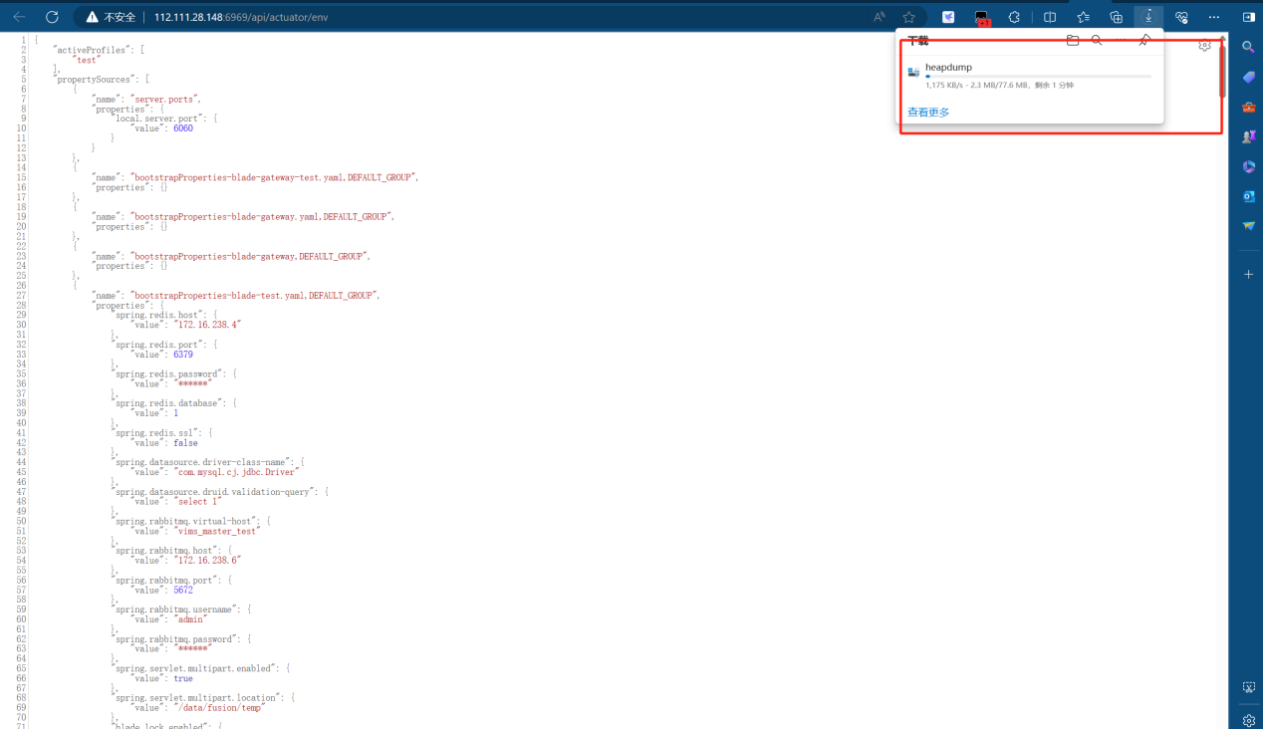

资产二:http://47.122.57.88:6969/login

<http://47.122.57.88:6969/api/actuator/env>

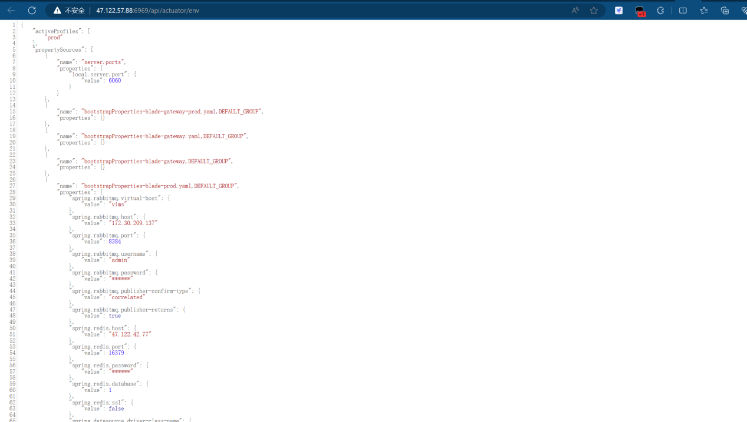

http://47.122.57.88:6969/[api/actuator/heapdump](http://112.111.28.148:6969/api/actuator/heapdump)

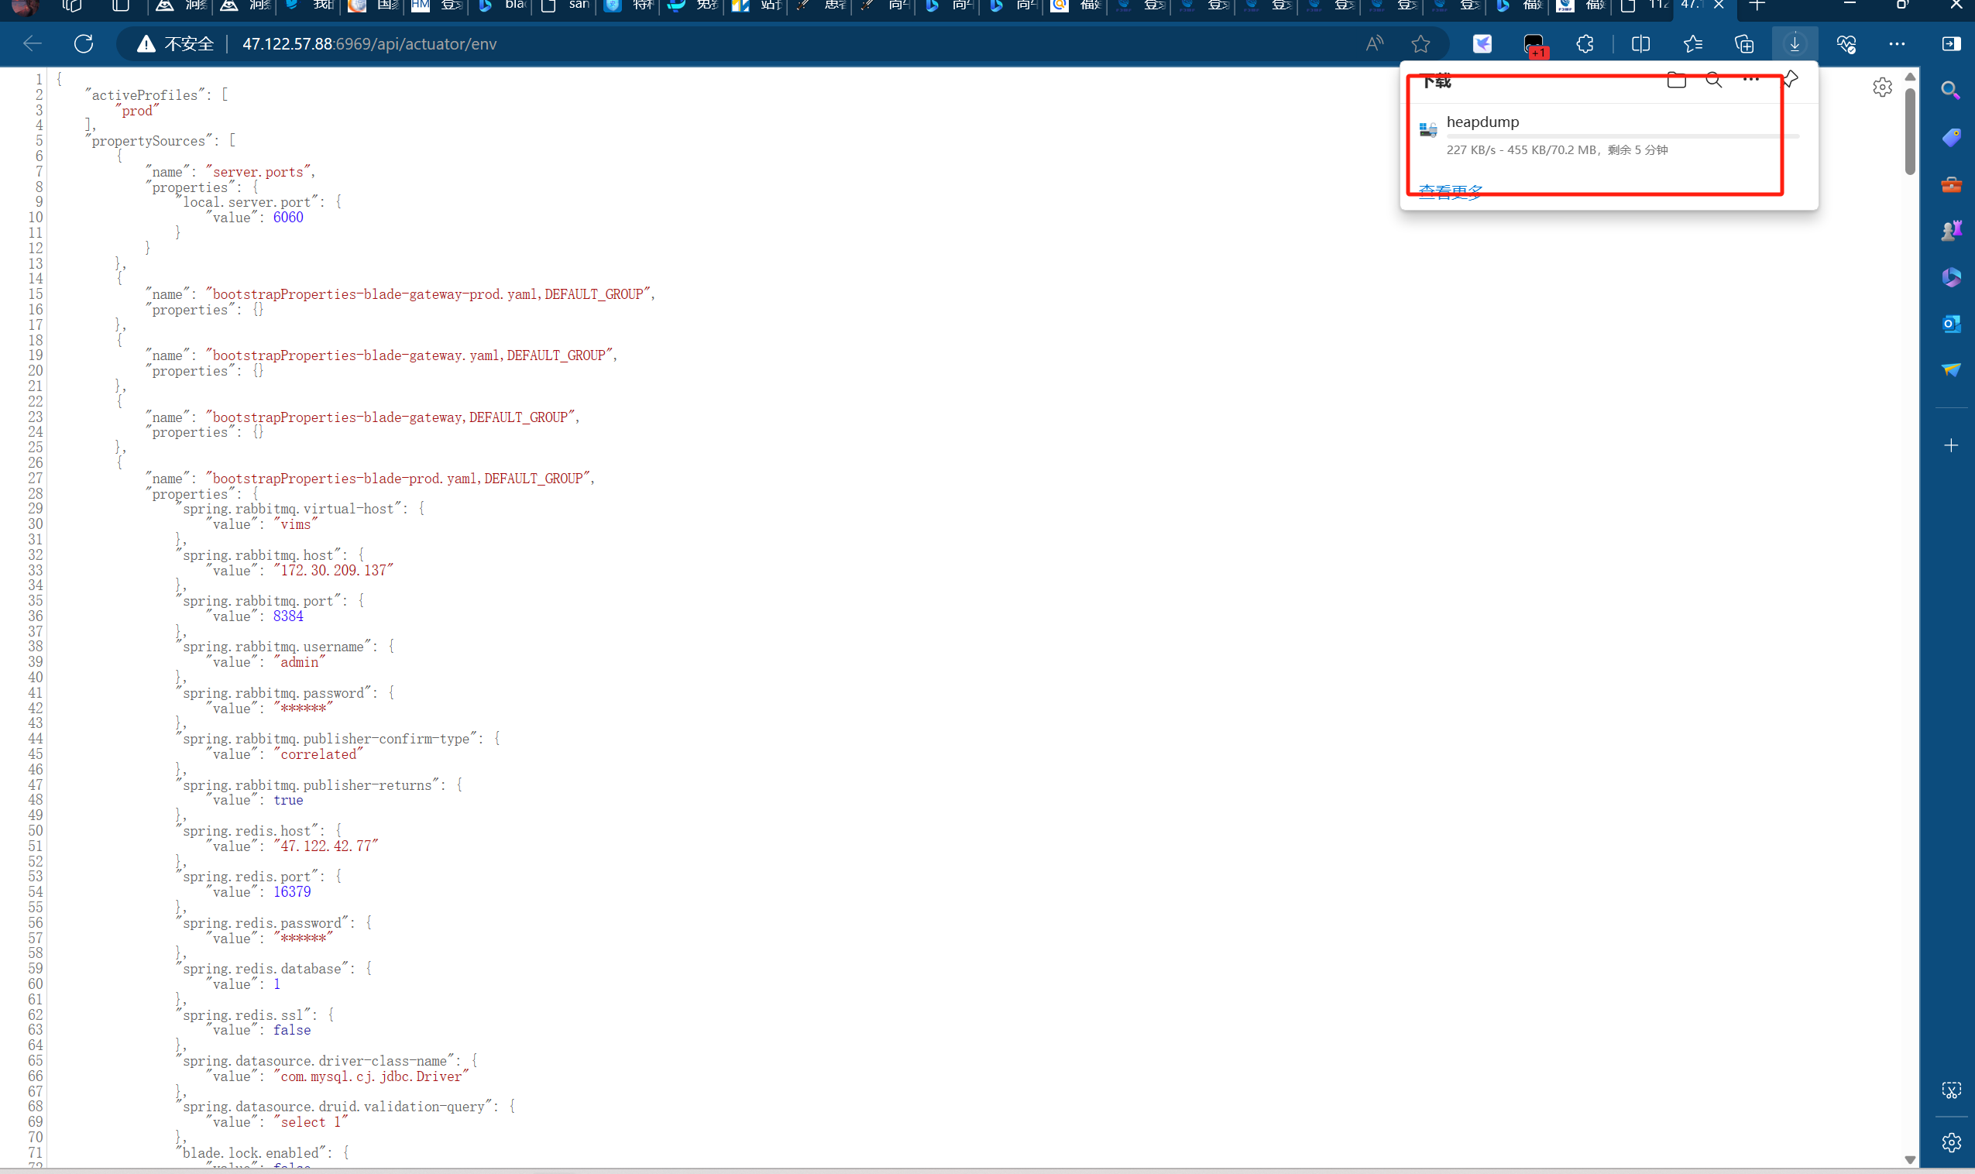

资产三:http://110.83.230.27:6969/login

<http://110.83.230.27:6969/api/actuator/env>

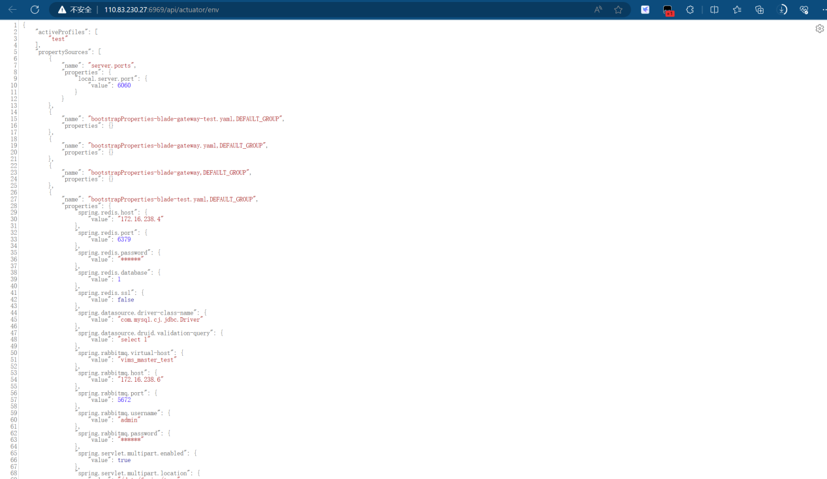

<http://110.83.230.27:6969/api/actuator/heapdump>

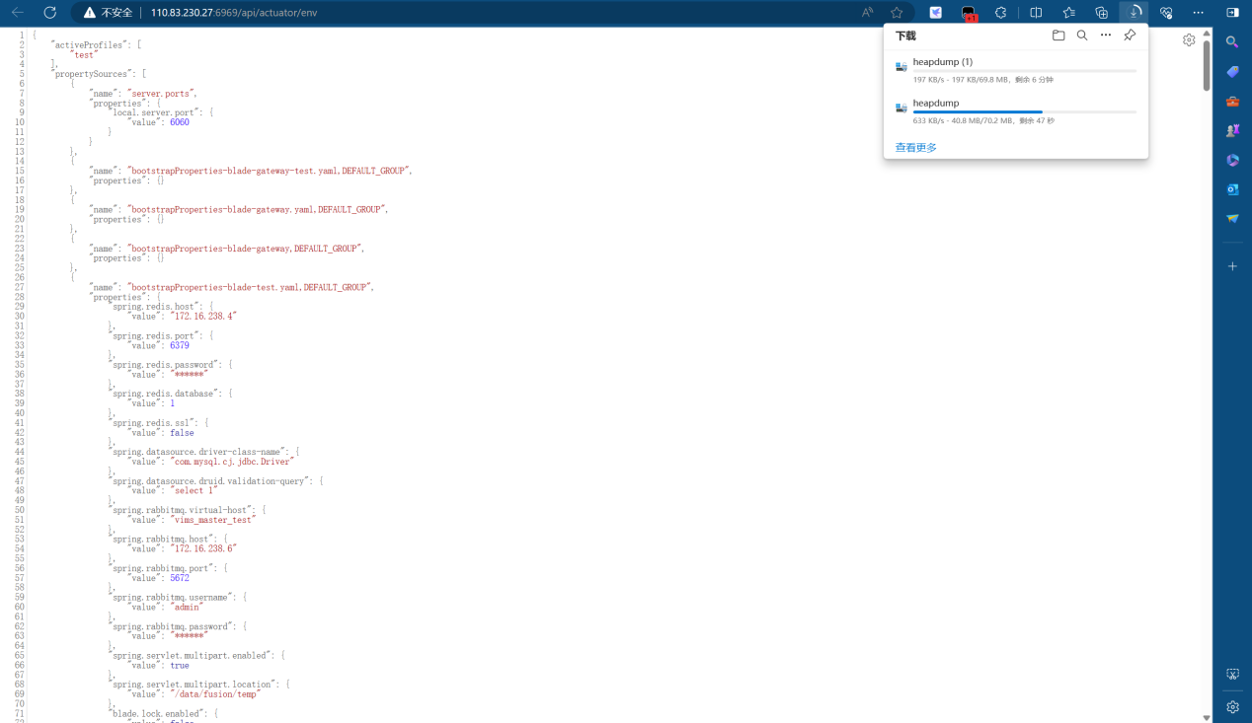

资产四http://fjvims.fjwanfu.com:13084/login

<http://fjvims.fjwanfu.com:13084/api/actuator/env>

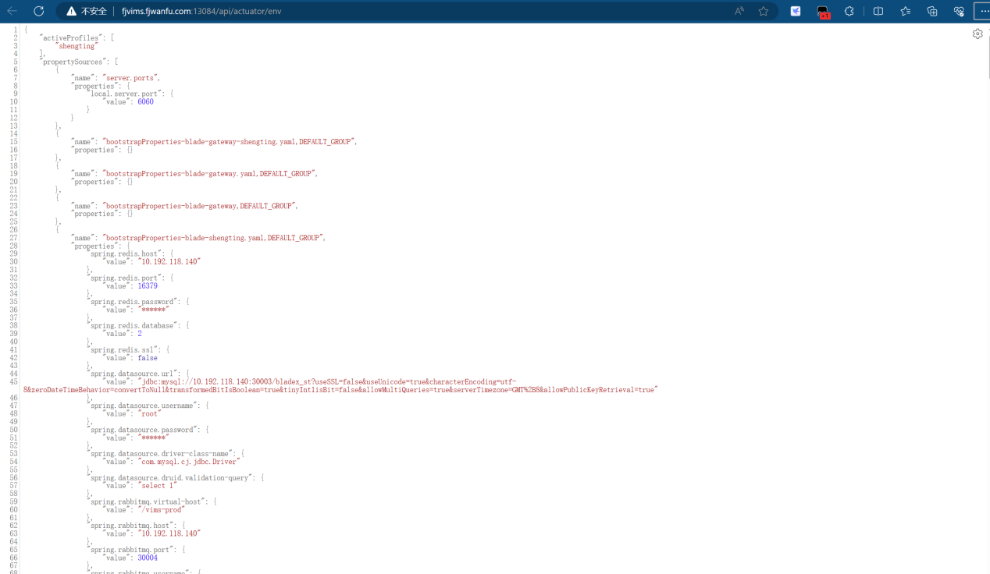

<http://fjvims.fjwanfu.com:13084/api/actuator/heapdump>

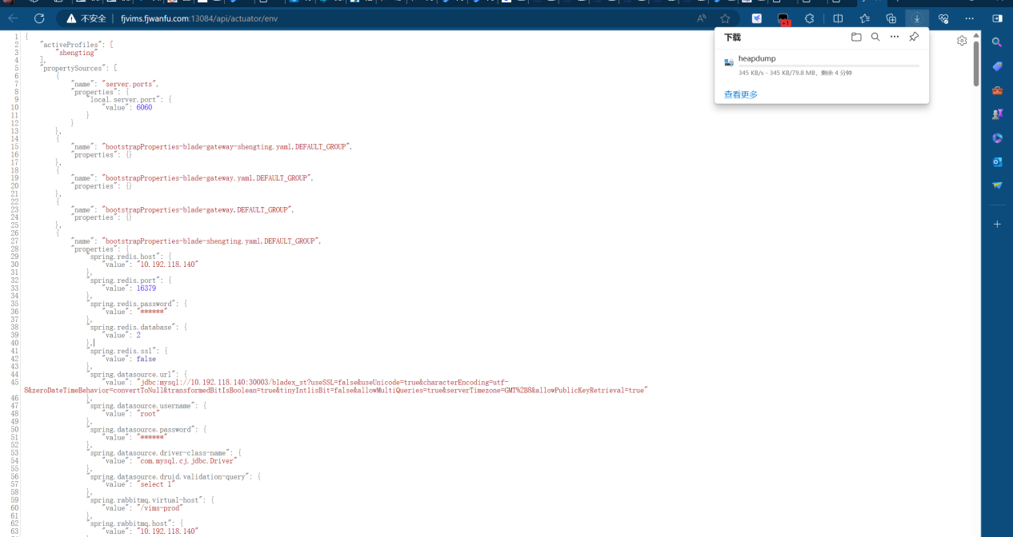

资产五:http://58.22.5.36:13084/login

<http://58.22.5.36:13084/api/actuator/env>

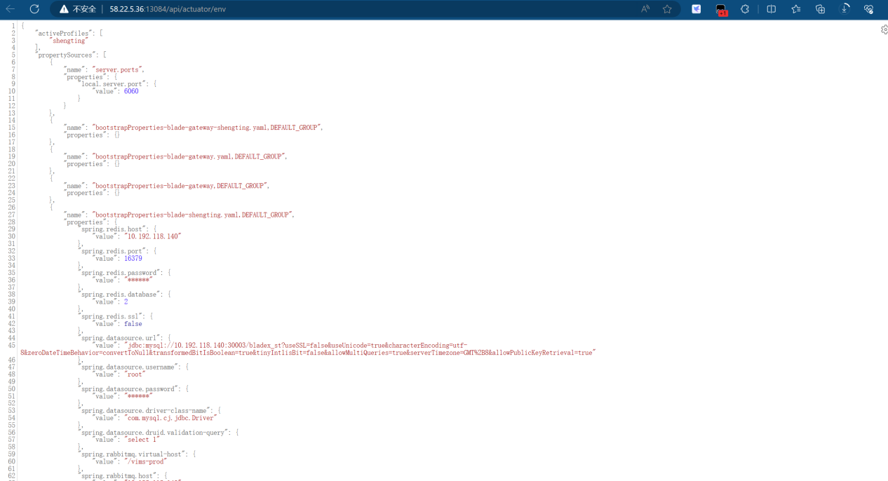

<http://58.22.5.36:13084/api/actuator/heapdump>

