深圳市道尔智控科技股份有限公司 云智慧停车系统v5.0存在弱口令

资产确认

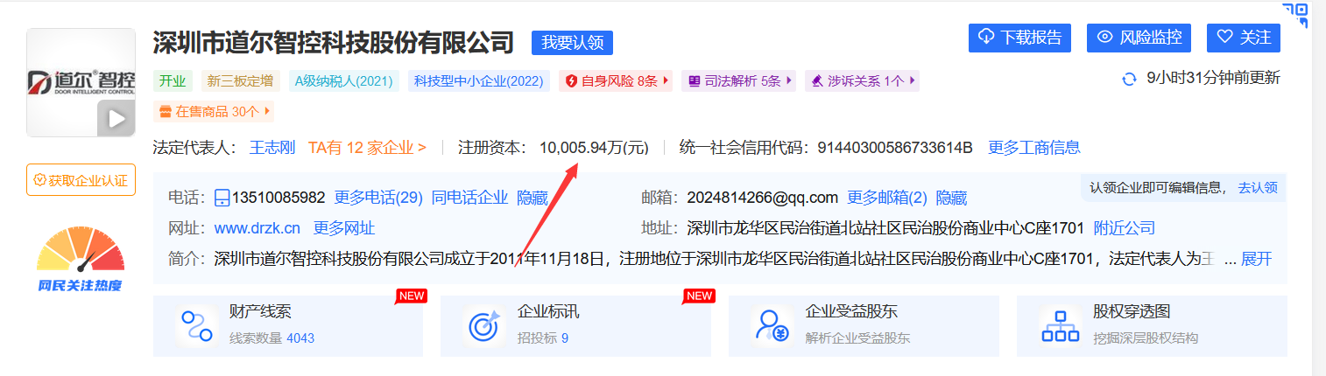

Fofa语句 app="DOOR-云智慧停车系统"

弱口令账号 admin

弱口令密码 123456

案例1

url <https://14.18.56.162/#/login>

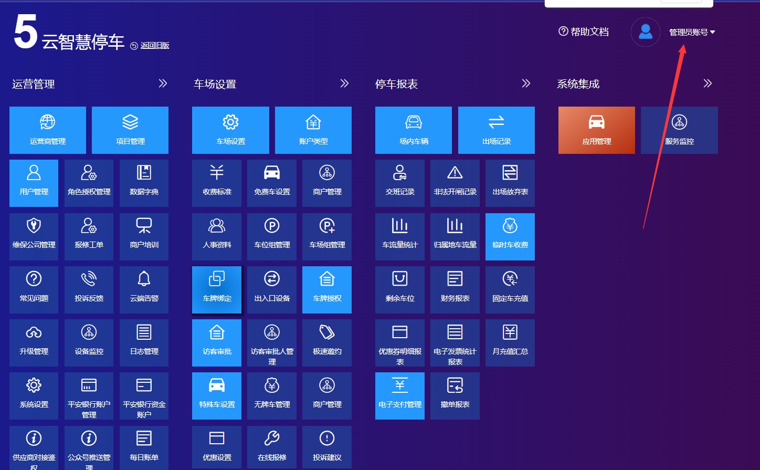

管理员权限

案例2

url <https://39.98.187.212/#/login>

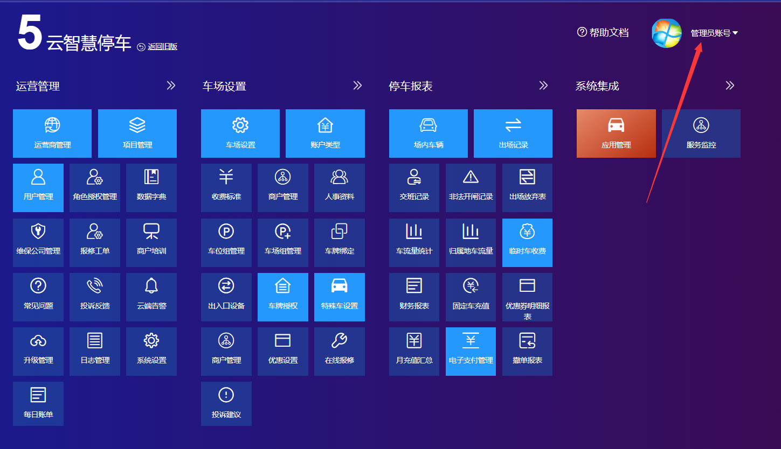

管理员权限

案例3

url https://124.71.18.95/#/login

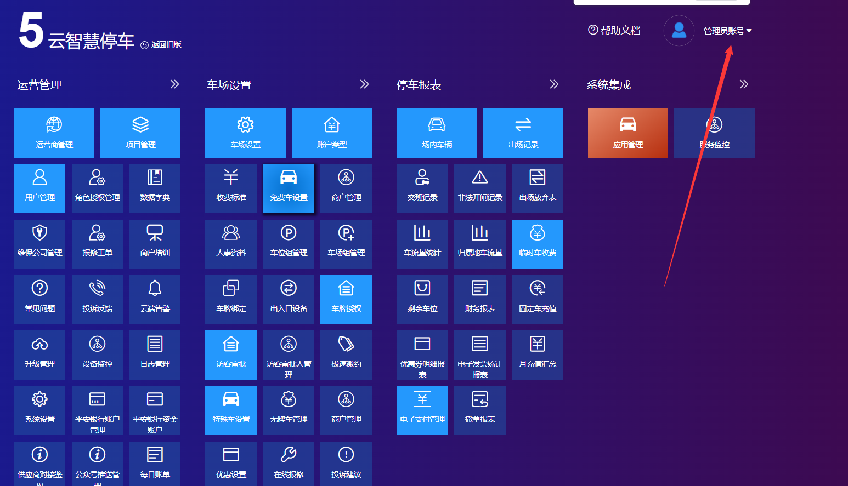

剩余案例

<https://tcxt.huaxinpark.com>

<https://lxt.danyum.com>

<https://120.25.223.172:81>

<https://139.196.9.65>

42.248.131.10

<https://124.71.18.95>

<https://114.67.123.18>

<https://114.67.123.11>

<https://47.101.219.254>

47.102.105.34

<https://106.14.221.89>

<https://120.25.223.172>

<https://47.100.66.251>

14.18.56.162:8888

<https://test-zhzm-parking.yunmaolink.com>

<https://c.drzk.cn>

<https://daoer.yunmaolink.com>

vending.shimaoiot.com

谢谢审核大大审核