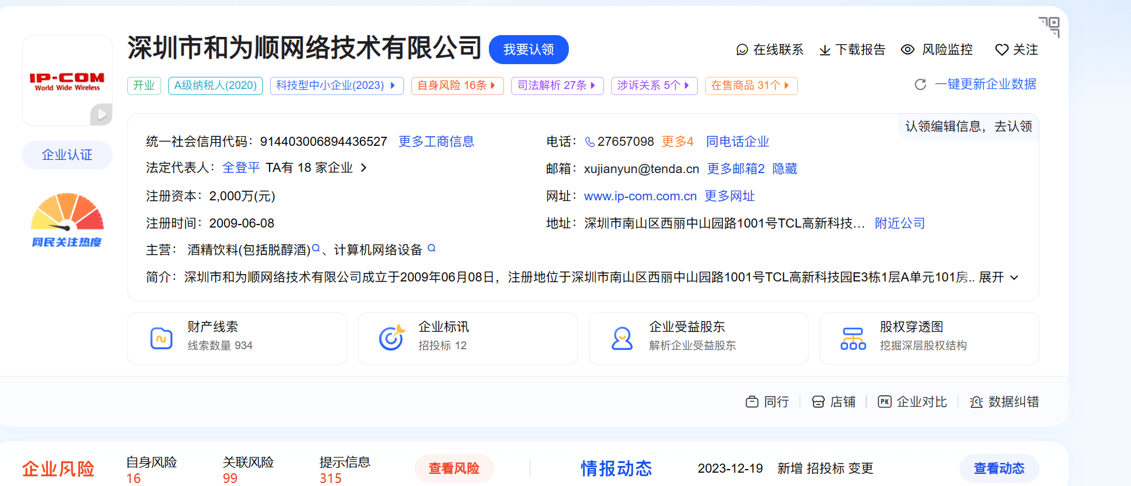

<https://crm.ip-com.com.cn/api/actuator/env>

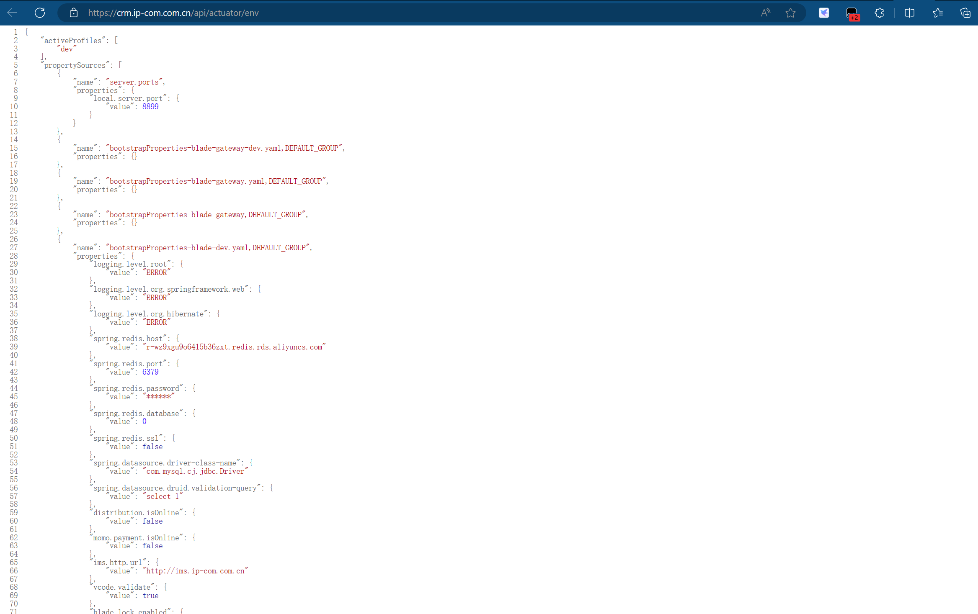

<https://crm.ip-com.com.cn/api/actuator/heapdump>

