<http://222.240.1.5:8190/api/actuator/env>

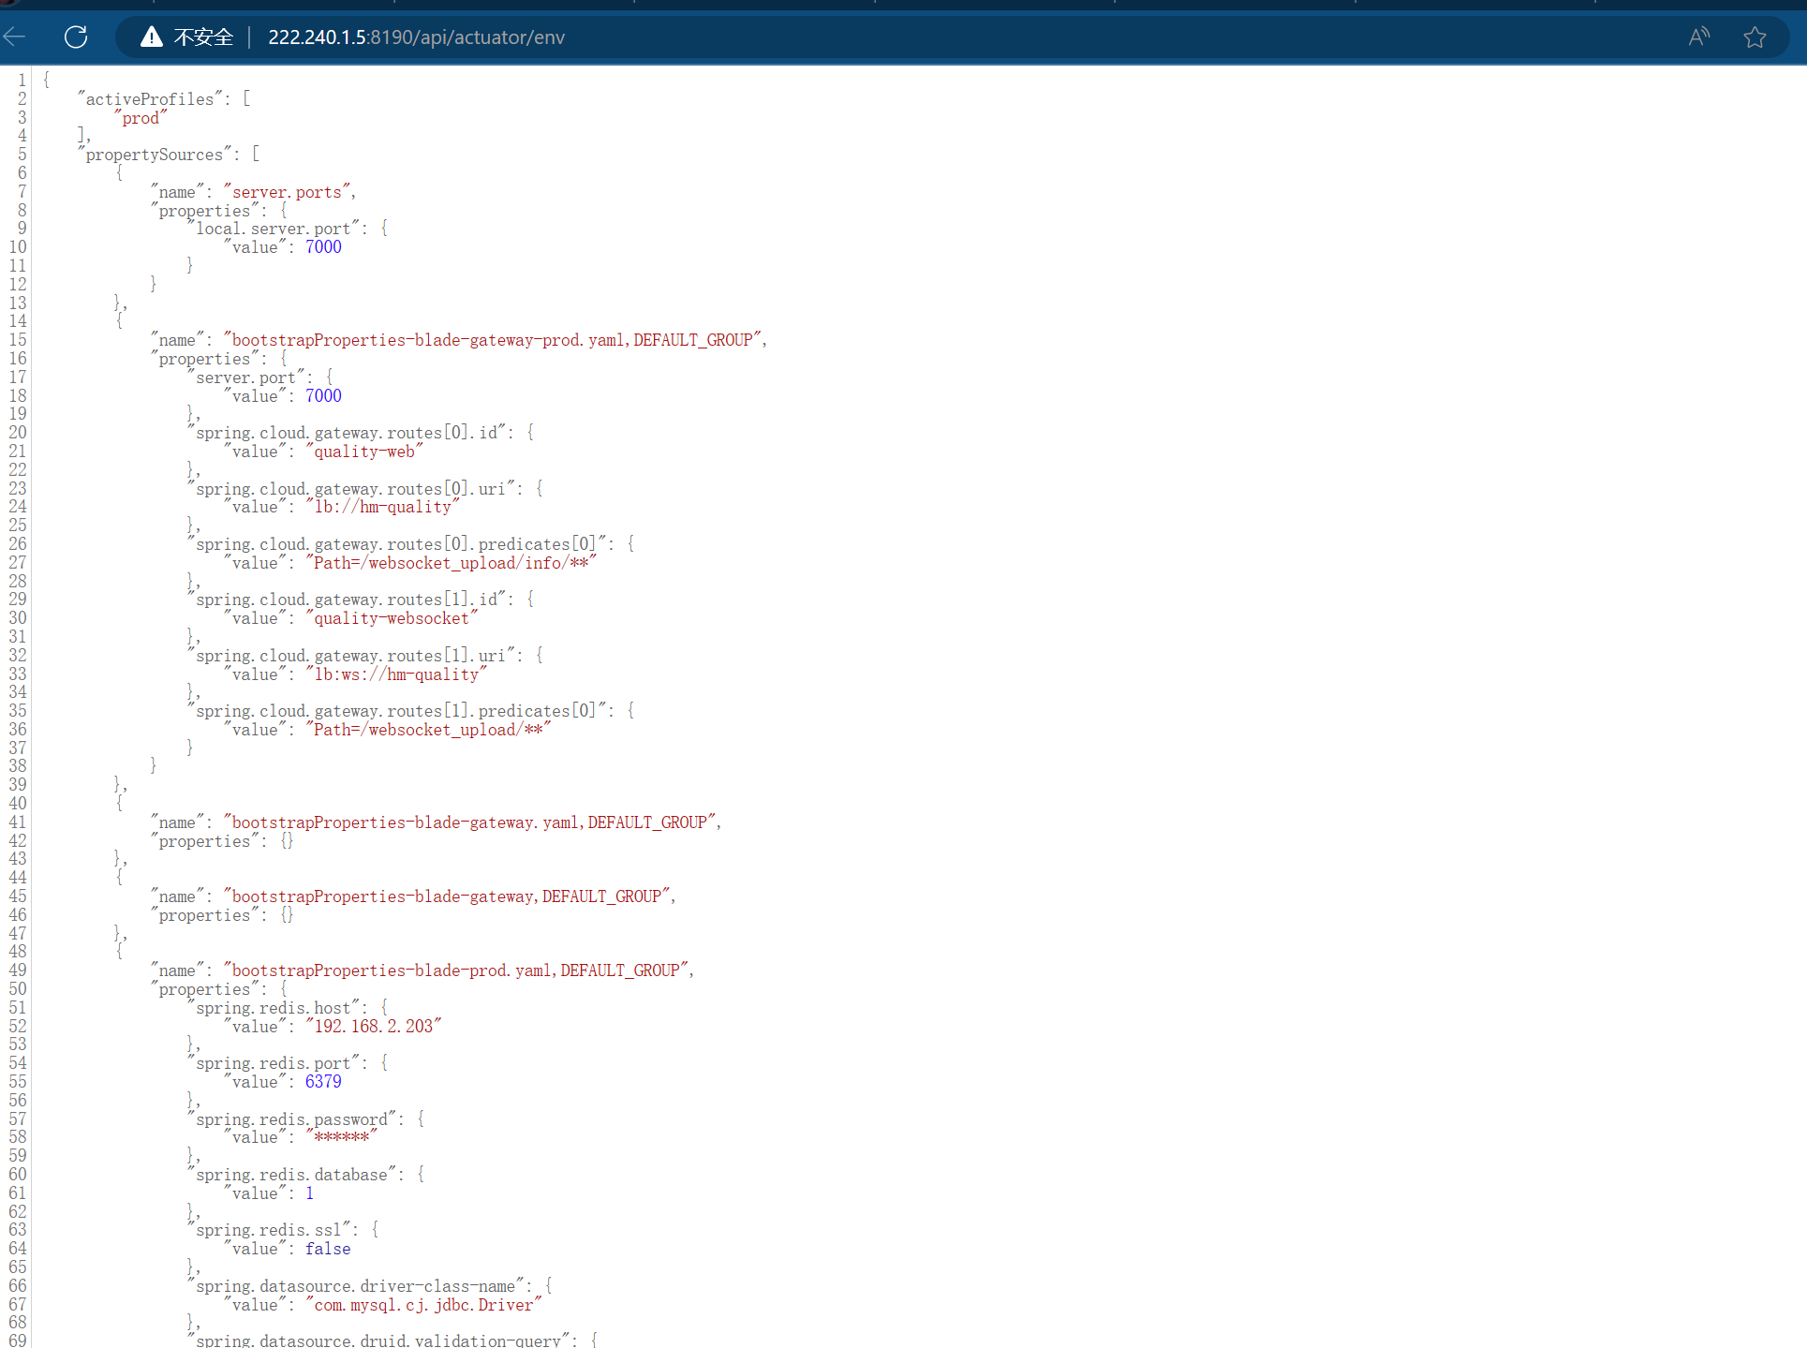

<http://222.240.1.5:8190/api/actuator/heapdump>

