Fofa:body="ONU WEB System"

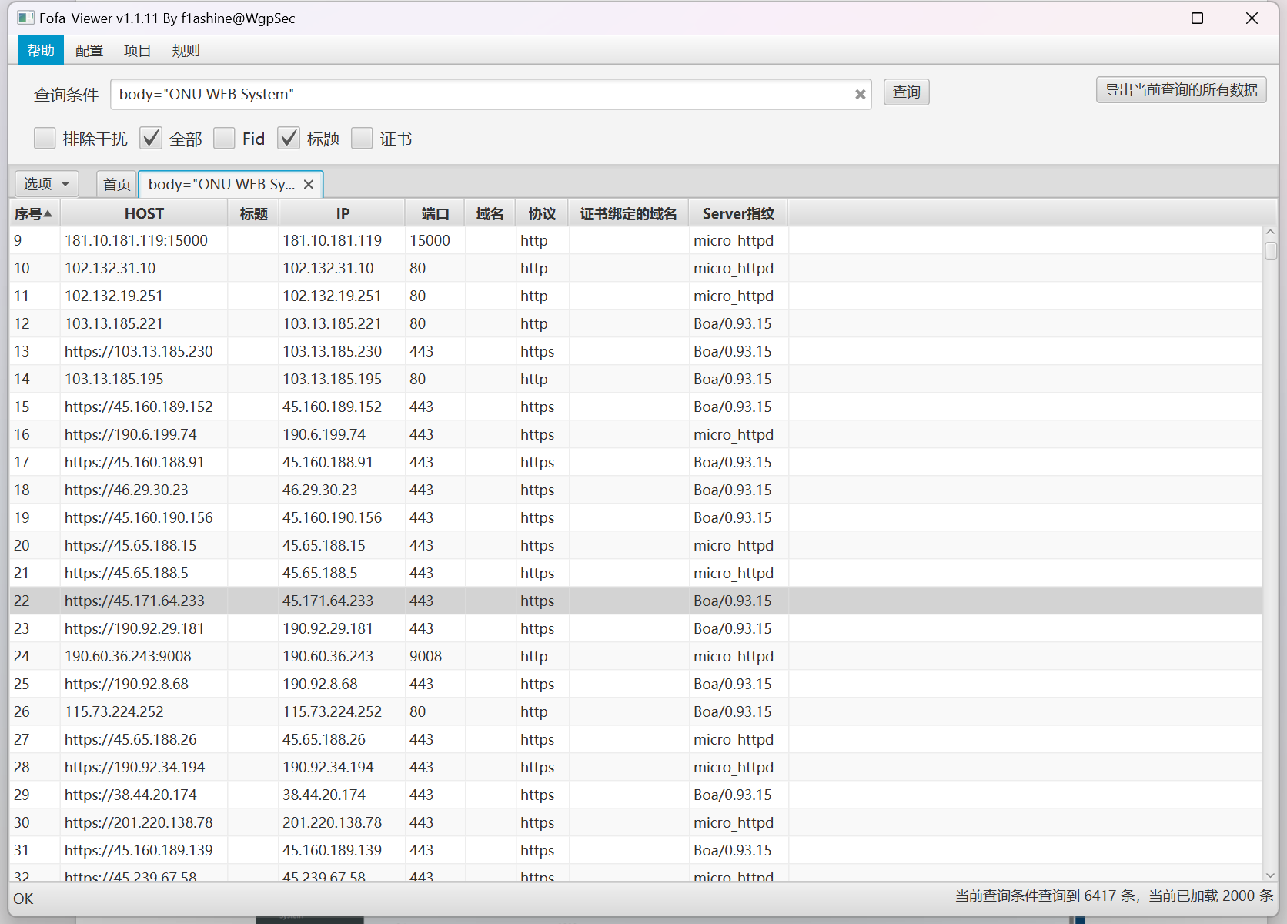

<https://45.65.188.15/index.html>

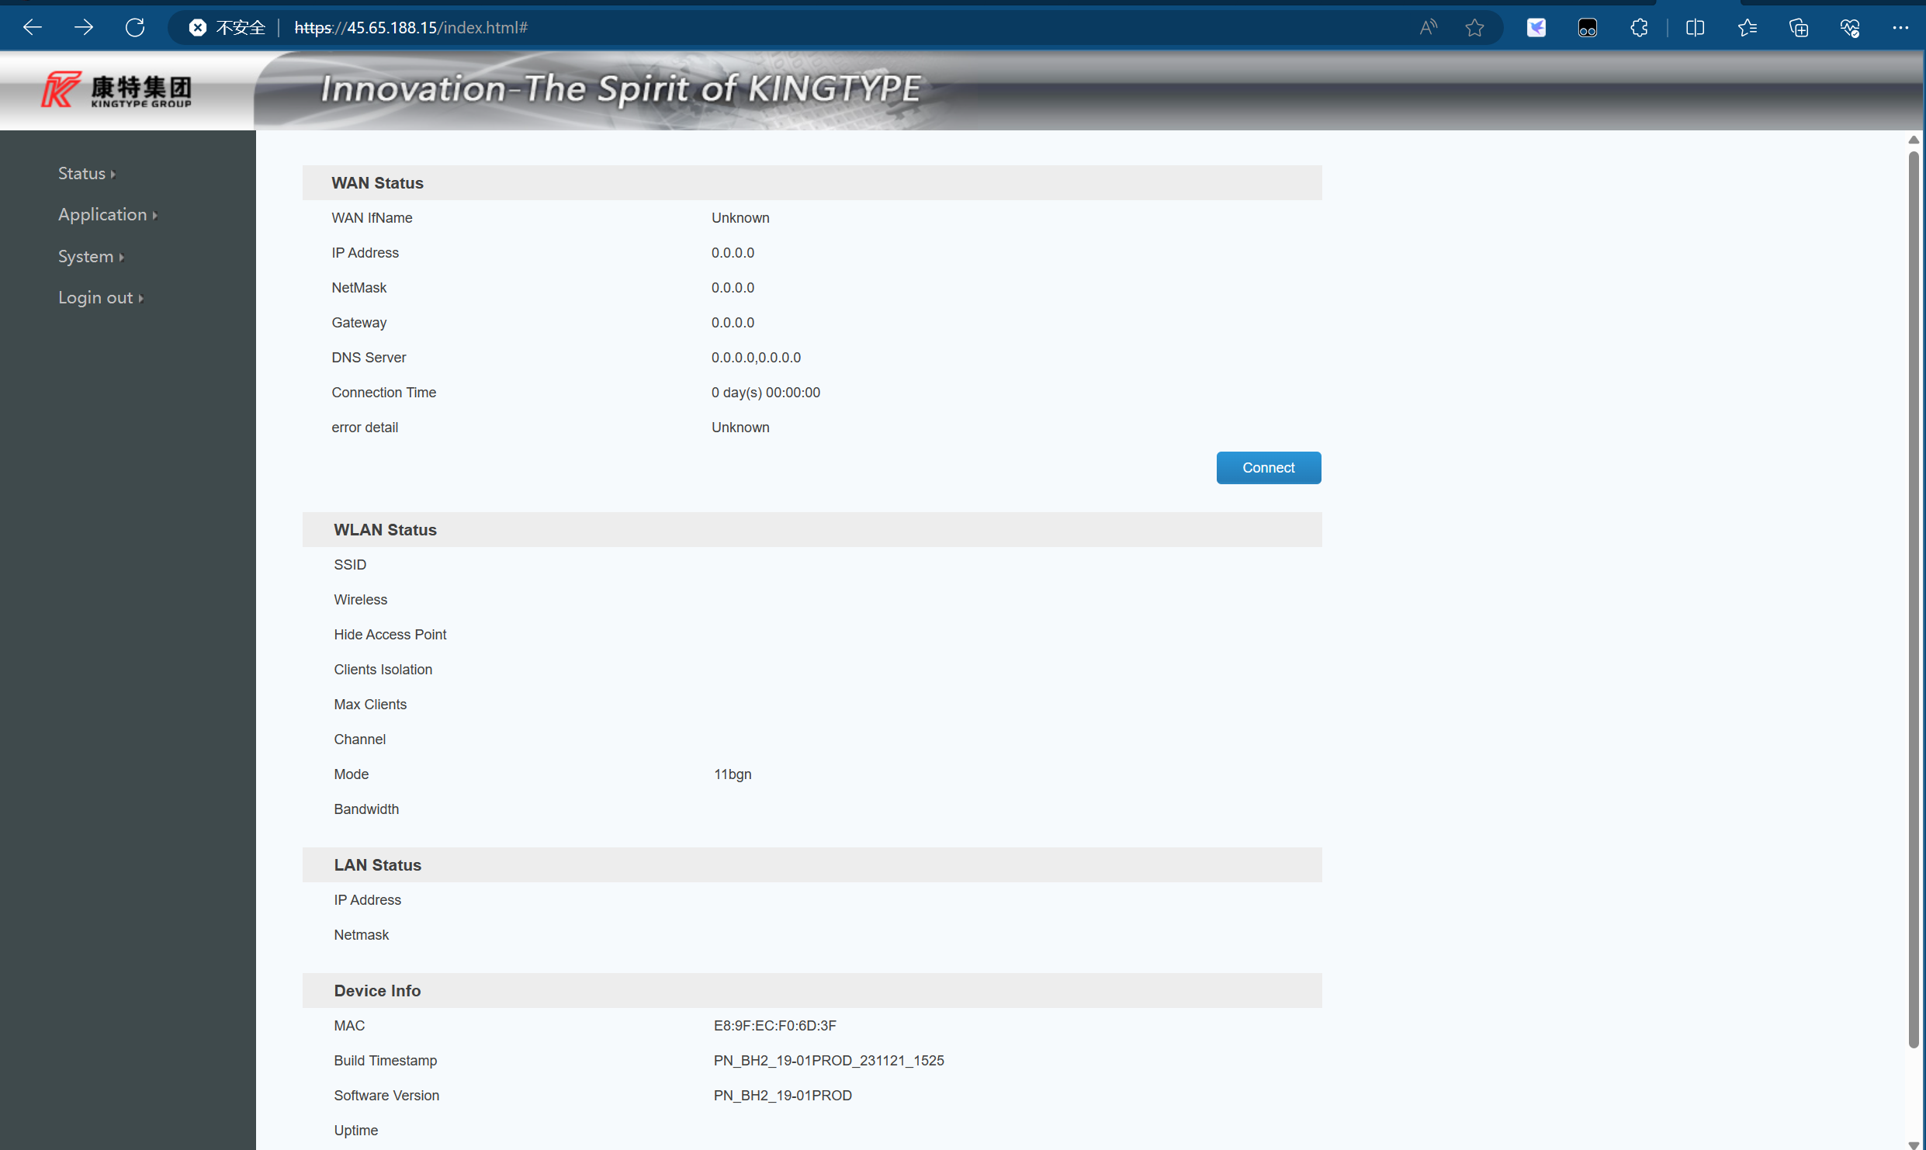

<https://45.65.188.26/index.html>

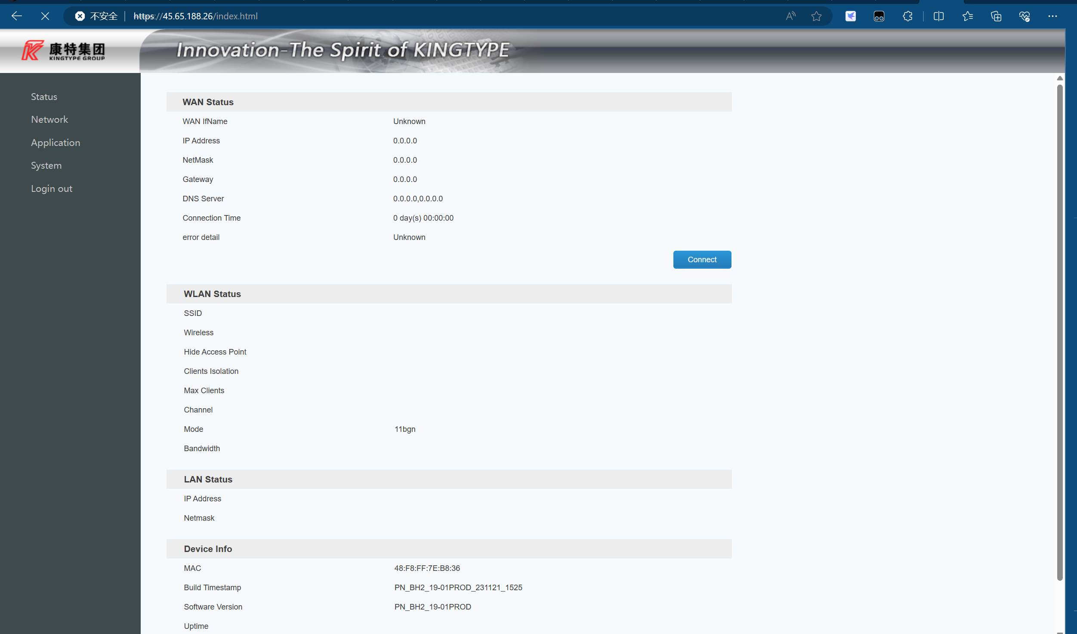

https://45.65.188.5/index.html

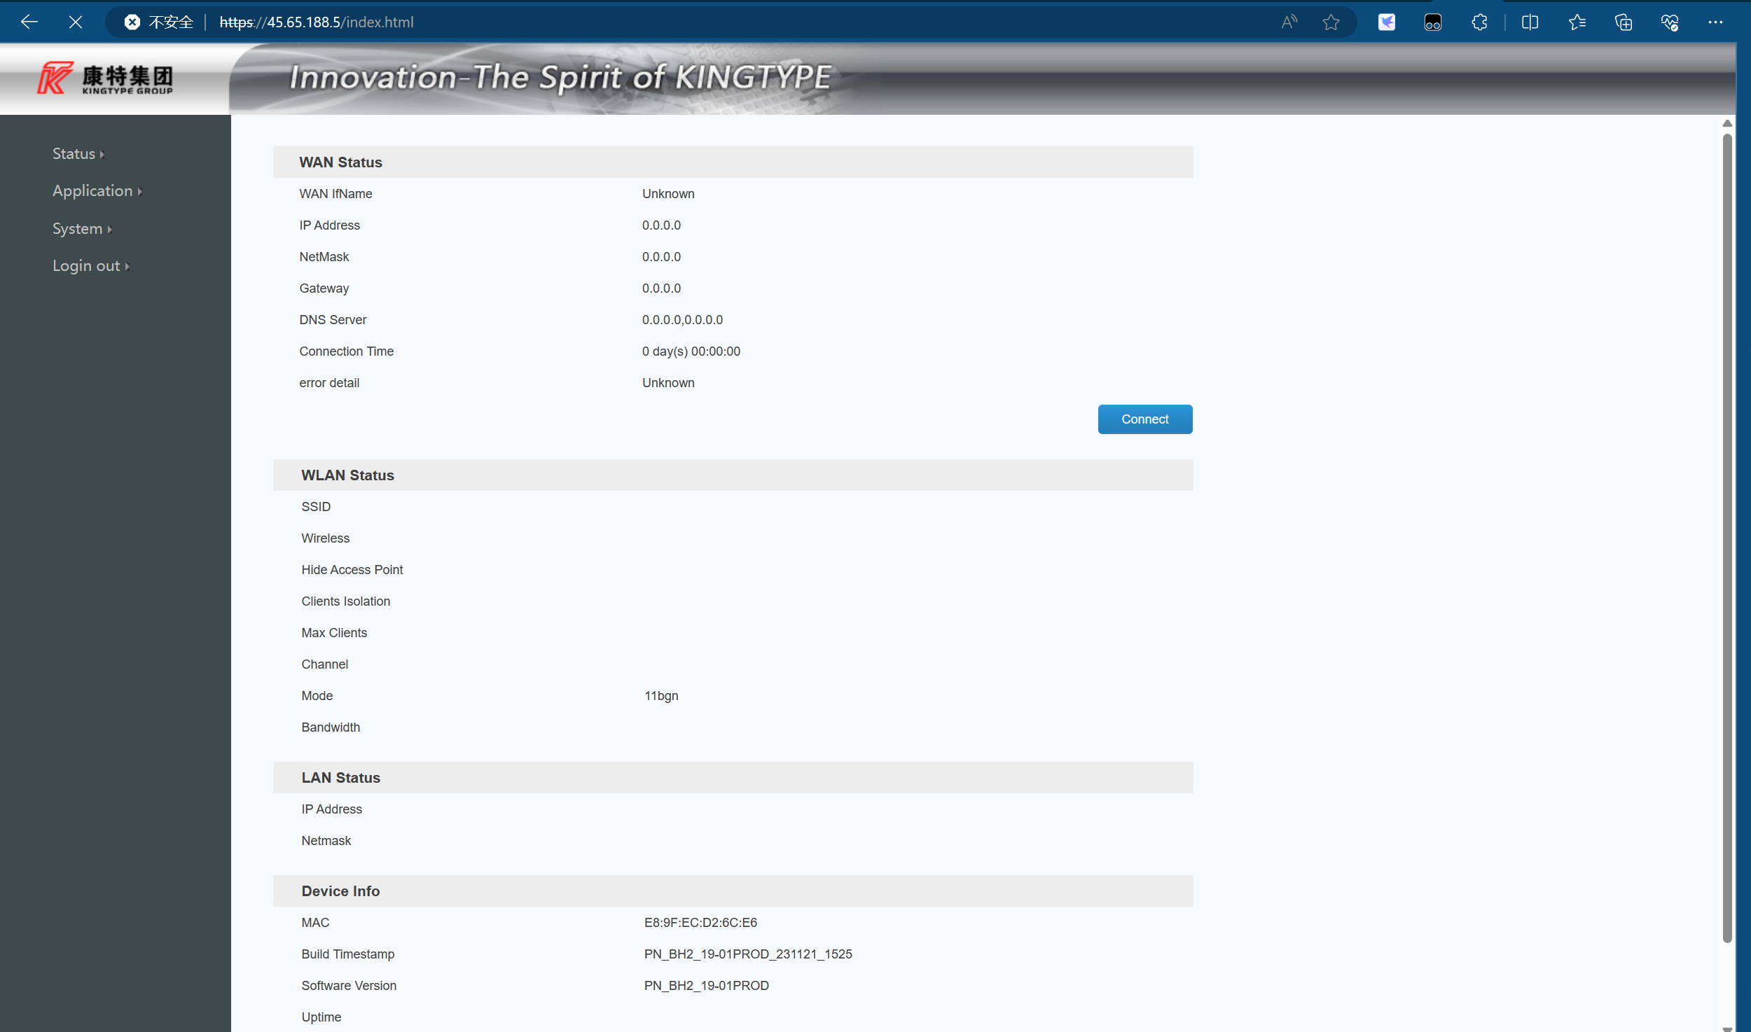

[45.171.64.233/index.asp](https://45.171.64.233/index.asp)

