47.101.134.139/



[http://47.101.134.139//api/actuator/env](http://47.101.134.139/api/actuator/env)

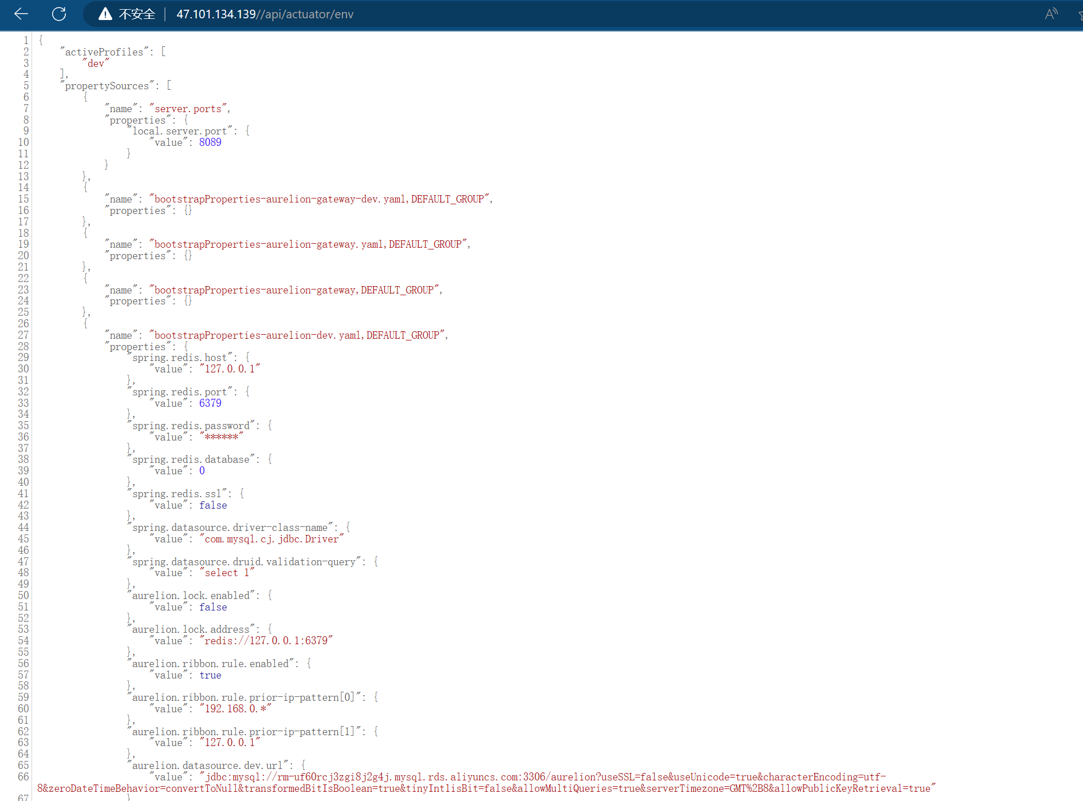

http://47.101.134.139/api/actuator/heapdump

