资产：<http://nyrd.hongdachip.com/a/login>

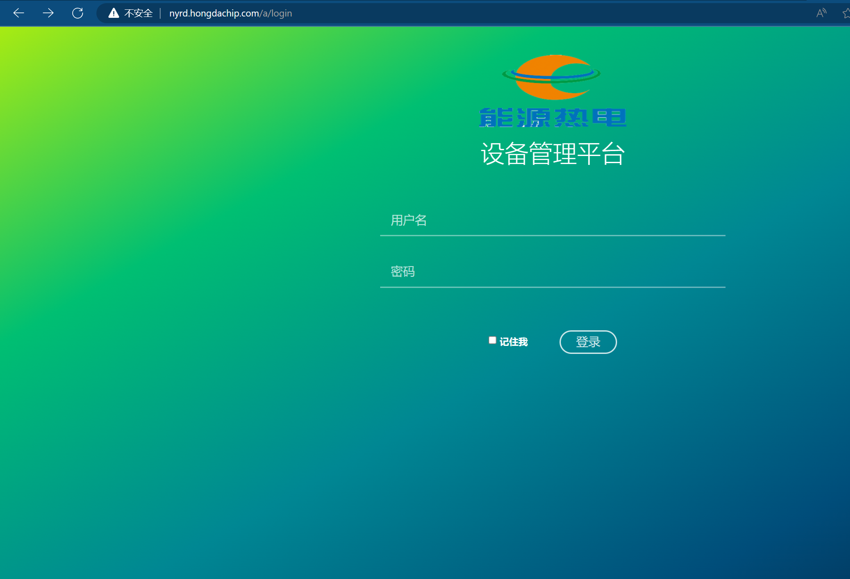

Poc：<http://nyrd.hongdachip.com/a/sys/register/registerUser?&mobile=18888888888%27>

